

Evaluation of the National Sports Tribunal Pilot

Final Evaluation – Final Report

Prepared for **Department of Health and Aged Care**

22 July 2022



**Urbis staff responsible for this report were:**

Director: Julian Thomas, Richard Gibbs

Expert Advisor: Dean Brostek

Associate Director: Christina Bagot

Consultant: Jayde Grisdale, Ryan Bondfield, Matthew Boyd

Research Analyst: Sabina Krslovic

Project Code: P0016868

Report Number: Final

**Urbis acknowledges the important contribution that Aboriginal and Torres Strait Islander people make in creating a strong and vibrant Australian society.**

**We acknowledge, in each of our offices, the Traditional Owners on whose land we stand.**

All information supplied to Urbis in order to conduct this research has been treated in the strictest confidence.

It shall only be used in this context and shall not be made available to third parties without client authorisation.

Confidential information has been stored securely and data provided by respondents, as well as their identity, has been treated in the strictest confidence and all assurance given to respondents have been and shall be fulfilled.

© Urbis Pty Ltd

ABN 50 105 256 228

All Rights Reserved. No material may be reproduced without prior permission.

You must read the important disclaimer appearing within the body of this report.

[urbis.com.au](http://www.urbis.com.au)

Contents

Acronyms and definitions 1

Executive summary 2

Background 2

Evaluation approach 2

Key findings 2

Focus areas 4

Chapter 1: Introduction 5

Evaluation purpose and objectives 5

Key evaluation questions 5

Methodology 5

This report 9

Chapter 2: Origins of the National Sports Tribunal 10

Legislative instruments 10

Scope and structure of the NST 11

Fees for service 11

Resourcing to implement the NST and complaints handling 11

Enlivening the NST’s jurisdiction 12

Chapter 3: Key findings 13

Design on the National Sports Tribunal 13

Implementation of the National Sports Tribunal 17

Outcomes delivered by the National Sports Tribunal 23

Value delivered by the National Sports Tribunal 28

Chapter 4: Future focus areas 33

Clear, coordinated communication 33

Ensuring readiness for scale 33

Providing accessible services for everyone 33

Disclaimer 34

Appendix A – Evaluation framework 35

Appendix B – Program logic 49

Appendix C – Integrity in sport: Overview 51

Appendix D – Economic Analysis and case studies 58

Appendix E – Survey results 68

Tables

Table 1 Acronyms 1

Table 2 Definitions 1

Table 3 Evaluation phases and primary data collection 6

Table 4 Finalised and active matters by NST Division, March 2020- May 2022 20

Table 5 Number of case enquiries by level, 19 March 2020 – 18 May 2022 21

Table 6 Number of validated matters, 19 March 2020 – 18 May 2022 22

Table 7 Expected outcomes of the NST and respective extent of achievements 24

Table 8 Average case length for resolved matters (days), 19 March 2020 – 18 May 2022 25

Table 9 Cost efficiency summary 29

Table 10 Qualitative benefit assessment 30

Table 11 Quantitative benefits of the NST 31

Table 12 Sustainability summary: Net cost comparison 32

Table 13 Sustainability summary: total administered costs 32

Table 14 Key evaluation question 1: How appropriate is the design of the NST to meet the needs of sports and athletes? 36

Table 15 Key evaluation sub-question 1a: What are the drivers for demand for the NST? 37

Table 16 Key evaluation sub-question 1b: To what extent does the NST complement/ replicate existing sports dispute resolution processes? 38

Table 17 Key evaluation sub-question 1c: What changes or improvements could be made to the design of the NST? 39

Table 18 Key evaluation question 2: How well has the NST been implemented? 39

Table 19 Key evaluation sub-question 2a: What is working well/less well and why? 40

Table 20 Key evaluation sub-question 2b: What are the enablers/ barriers to effective implementation of the NST? 41

Table 21 Key evaluation sub-question 2c: What improvements could be made to the implementation of the NST? 42

Table 22 Key evaluation question 3: To what extent have the expected outcomes of the NST been achieved? 42

Table 23 Key evaluation sub-question 3a: In what context has the NST been more/ less successful? 44

Table 24 Key evaluation sub-question 3b: Have there been any unintended outcomes/consequences associated with NST? 45

Table 25 Key evaluation question 4: How efficiently has the NST funding been used? 45

Table 26 Key evaluation question 5: How cost effective is the NST for government, sports and participants? 46

Table 27 Key evaluation question 6: How sustainable is the NST? 47

Table 28 Key evaluation sub-question 6a: How can the funding model be improved to ensure the financial sustainability of the NST? 47

Table 29 Scope of each division of the NST 53

Table 30 NST service fees: Anti-Doping Division 55

Table 31 NST service fees: General Division 56

Table 32 NST service fees: Appeals Division 56

Table 33 Number of respondents associating with each sporting bodies 74

Figures

Figure 1 NST and evaluation timeline 6

Figure 2 Sport sector interactions with the NST via website, email, presentation or phone 18

Figure 3 Number of enquires to NST and validated matters since establishment (quarterly intervals) 21

Figure 4 NST Pilot Program logic 50

Figure 5 NST’s divisions, types of dispute and methods 54

Figure 6 Role in NST matter (n=23) 69

Figure 7 Division of matter (n=23) 69

Figure 8 Age of respondents (n=15) 70

Figure 9 Location of respondents (n=14) 70

Figure 10 Annual household income (n=14) 71

Figure 11 Feedback on NST registry staff (n=4) 71

Figure 12 Feedback on NST components (n=23) 72

Figure 13 Role within sporting body (n=66) 75

Figure 14 How respondents heard about the NST (n=66, multiple responses) 75

Figure 15 Types of rules, laws and policies that adopt the NST as mechanisms for resolving disputes (n=66) 76

Figure 16 Percentage of sporting bodies who have adopted the National Integrity Framework (n=66) 77

Figure 17 Likelihood to adopt the National Integrity Framework in the next 12 months if not already adopted (n=25) 77

Figure 18 Types of interactions with the NST (n=66, multiple responses) 78

Figure 19 Nature of the disputes (n=15) 79

Figure 20 Familiarity with NST dispute resolution services (n=66) 79

Figure 21 Satisfaction with most recent NST matter (n=15) 80

Figure 22 Satisfaction with overall experience of NST (n=59) 80

Figure 23 NST services 80

Figure 24 NST’s administration staff and information 81

Figure 25 NST fees 81

Figure 26 Views of NST 82

Figure 27 Likelihood to recommend the NST (n=56) 84

Figure 28 Likelihood to use NST services in the next 12 months 85

Figure 29 Likelihood to use other services in the next 12 months 86

Figure 30 Expertise brought to the NST (n=15, multiple responses) 88

Figure 31 Number of matters allocated to NST members (n=15) 88

Figure 32 Experience with NST (n=15) 89

Figure 33 Satisfaction with overall experience of the NST (n=15) 90

Figure 34 Involved in any other sport dispute resolution services other than the NST (n=15) 91

Figure 35 Comparison of NST services with other sport dispute resolution services (n=13) 92

# Acronyms and definitions

Table 1 Acronyms

|  |  |
| --- | --- |
| Acronym | Full title |
| ADR | Alternative Dispute Resolution |
| ADRV | Anti-doping rule violations |
| ASADA | Australian Sports Anti-Doping Authority |
| ASC | Australian Sports Commission |
| CAS | Court of Arbitration for Sport |
| CEO | Chief Executive Officer |
| COMPPS | Coalition of Major Professional and Participation Sports |
| GA | Gymnastics Australia |
| NIF | National Integrity Framework |
| NSO | National Sporting Organisation |
| NST | National Sports Tribunal |
| NSTLAP | National Sports Tribunal Legal Assistance Panel |
| SIA | Sport Integrity Australia |

Table 2 Definitions

|  |  |
| --- | --- |
| Name | Definition |
| COMPPS Sports | Comprises seven NSOs: Australian Football League, Rugby Australia, Cricket Australia, Football Federation Australia, National Rugby League, Netball Australia and Tennis Australia |
| NST Members | Independent appointees by Minister for Sport to hear matters at the NST |
| NST Registry | The CEO and Staff employed by the Department of Health and Aged Care to manage functions of the NST |
| Party/Parties | The person(s) and sporting body involved in the dispute being heard before the NST |

# Executive summary

## Background

This report presents the evaluation of the National Sports Tribunal (the NST) and examines the first two years and two months of the NST’s operation. The NST was established by legislation in 2019, having been a key recommendation of the Review of Australia’s Sports Integrity Arrangements (Wood Review, 2018). The NST comprises three divisions, dealing with general sporting disputes, anti-doping violations, and appeals. To help Parties resolve their disputes as efficiently as possible, the NST is able to provide four different methods where mediation, conciliation and case appraisal is available for matters in the general division, and arbitration is used across all three divisions. The NST has been accepting matters since March 2020.

The NST was commissioned as a pilot, initially with a two-year period of operation and subsequently extended by 12 months in response to the challenges of COVID-19. The Department of Health and Aged Care commissioned Urbis to undertake an evaluation of the NST’s implementation and operation to inform decisions on the future operation of the NST after the pilot period.

## Evaluation approach

The aim of the evaluation was to:

* assess the design and implementation of the NST to identify lessons and opportunities for improvement
* assess the extent to which the NST achieved its expected outcomes
* inform on the sustainability and future operation of the NST.

The evaluation employed a mixed-methods approach to collect and triangulate evidence including analysis of: NST case and enquiry data; relevant documentation; survey data from NST users (n=27), NST Members (n=15) and the sport sector (n=66); and consultations with key stakeholders including NST users, national sporting organisations (NSOs), peak bodies and NST staff. An assessment of the NST’s efficiency, value for money and sustainability drew upon qualitative and quantitative data from six NSOs.

The first two years of the NST pilot period has coincided with the onset of the COVID-19 pandemic, causing significant disruption to the sport sector. Over this period, the number of cases referred to the NST has been low and subsequently the data available to the evaluation has been limited. There was also limited data available on the costs of dispute resolution borne by NSOs, and fees were initially waived for parties during the early stages of the pandemic. These factors limit the robustness of the efficiency and value for money assessments, particularly in long-term projections.

## Key findings

This section presents key findings towards the six areas of evaluative inquiry.

### Design

The NST meets a need for independent, consistent processes for the resolution of disputes in sport. Stakeholders value the consistency that the NST brings through its professionalised and centralised services. The combination of structural independence and NST Member credibility and expertise supports the perceptions among NSOs and users of the NST of procedural fairness. NST services complement or replace existing intra-sport mechanisms for dispute resolution and are not duplicative in any substantive way. The NST’s jurisdiction is broader than integrity issues and the early signs are that this helps address a gap for many NSOs not addressed through the National Integrity Framework (NIF). The user experience of the NST Registry and services are very positive, and fee structures are generally accepted to be reasonable.

### Implementation

Core elements of the NST are well established and operating effectively. The NST has adopted a culture of continuous improvement and refined operations to improve the user experience. Engagement and promotional activities appear to be effective in raising awareness of the NST and promoting its services, however many NSOs have expressed confusion about the broader integrity landscape including the role of the NST and Sport Integrity Australia (SIA). As more NSOs adopt the NIF, the NST, in collaboration with sport agencies, will need to continue implementing a targeted and proactive communications campaign.

Throughout 2020 and 2021, COVID-19 has had a significant impact upon the sport sector disrupting competition and events, and throwing many NSOs into financial crisis as they navigated unprecedented upheaval. While the caseload remained relatively low over the first two years of operation, demand for the NST’s services has risen significantly in 2022. The number of enquiries and NSOs accessing the NST shows a strong upward trend including those in the Coalition of Major Professional and Participation Sports (COMPPS). Since the NST’s establishment to 20 May 2022, 39 NSOs have accessed the NST’s services and 32 matters have been finalised.

### Outcomes

There is emerging evidence that the NST is achieving intended outcomes for NSOs and participants as outlined in the NST’s program logic model. Consultations with NSOs and other NST users, including athletes, found that the NST is valued as an independent, fair and easy to access service. Overall, there is a high level of satisfaction with the NST and strong sector support for the NST as a core pillar in the sport integrity landscape. The NST is providing an avenue to professional dispute resolution services for athletes, participants and support personnel. While user feedback indicated mixed satisfaction with the outcome of their matter, (given the contested nature of disputes this is to be expected), a higher proportion of users considered the process and outcome fair. NST users were generally positive about the interactions with the NST Registry and the timeliness and cost of services. As the NST continues to refine its practices, attention should focus on increasing the support and guidance for unrepresented individuals and young people.

### Efficiency

NSOs confirmed that the NST is able to provide a more efficient means of resolving disputes compared with internal processes managed by individual sports. Efficiency is attributed to the NST’s clear and accessible process that delivers closure on disputes at a fair and reasonable cost to NSOs and other Parties. This indicates that the NST delivers a streamlined process and that higher quality outcomes are accessible to NSOs and other Parties. Low case volume makes robust estimates difficult, however, based on consultations with six NSOs about their internal processes, Urbis has estimated the NST’s cost-efficiency (in terms of savings to NSOs) is at between $2,041 and $3,657 on a per case basis.

### Value for money

From both qualitative and quantitative perspectives, the NST is assessed as generating net benefits for government, NSOs and participants that range from reduced administrative burden to increased community participation and engagement with sports. These net benefits are projected to exceed $6 million over the next 20 years when accounting for growth of 4% in cases per annum and discounted to present-value terms at a 3% discount rate. Urbis consider this a conservative estimate based only on opportunity costs associated with both the internal and external resources NSOs require to manage cases (less average NST costs). It should be noted that it is difficult to make robust long-term projections about value for money and efficiency at this time, based on the sample of completed cases and the limited cost data available for analysis.

### Sustainability

While the NST is still in the early stages of maturity, experience from other comparable international tribunals suggests that case numbers and processes stabilise over a longer timeframe and even decades. Structurally and operationally, the NST is well-placed to sustain its services based on a cost-effective model that reasonably shares costs with parties accessing the services. Noting the above data limitations, over the next 20 years, the average total cost per case is expected to reduce, as increased efficiency follows from greater caseloads.

Importantly, the NST’s costs are both more manageable and more efficient than if individual NSOs were to be undertaking the same tasks. Overall, this represents a more sustainable whole-of-government (and in fact whole of sector) model of funding. Savings will be realised amongst NSOs due to the external resources provided by the NST. Ultimately, these savings are a net saving to government, given NSOs’ higher internal resourcing costs are ultimately a cost burden to the Australian Sports Commission (ASC) funding.

## Focus areas

Over the first two years of operations, the NST made significant steps towards becoming a well-known and well-regarded feature of the sport integrity landscape. Based on survey and interview data from NSOs and sporting representatives, there is evidence that the NST has already gained a reputation for being an independent and fair dispute resolution service. As the NST moves into the third year of operations, there are opportunities to consolidate its position into the integrity landscape.

The following three areas were identified throughout the course of the evaluation as key opportunities to further strengthen the NST’s role and effectiveness.

### Clear, coordinated communication

Within the sport sector, there remains considerable uncertainty about roles, responsibilities and pathways generally. The NST (in concert with other actors) will need to build and deliver a cohesive narrative about new integrity arrangements and interrelationship between the NIF (managed by SIA) and the NST services, as well as the ASC’s role.

### Ensuring readiness for scale

A key change for the NST over the near term is expected to be significant growth in caseloads that will test the NST’s processes. The NST will need to ensure that systems and processes are in place that maintain quality and timeliness of services as demand ramps up. Enhanced scalability will be needed to manage peak demand periods including selection disputes for major sporting events such as the Commonwealth Games.

### Providing accessible services for everyone

As the reach of the NST grows, the diversity of NST users will require specific attention to ensure the NST is accessible and its processes equitable for people with specific needs. This will include younger people and unrepresented Parties.

# Chapter 1: Introduction

The NST provides independent dispute resolution services to sporting bodies, athletes and support personnel. The NST was established by legislation in 2019, having been a key recommendation of the Review of Australia’s Sports Integrity Arrangements (Wood Review, 2018). The NST comprises three divisions, dealing with general sporting disputes, anti-doping violations, and appeals, and has been accepting matters since March 2020. The NST was initially commissioned as a pilot with a two-year period of operation. The pilot period was subsequently extended by 12 months in response to the challenges of COVID-19.

The Australian Government Department of Health and Aged Care commissioned Urbis to undertake an evaluation of the NST’s implementation and operation to inform decisions on the future operation of the NST after the pilot period. This is the third and final report of the evaluation of the NST, following on from an implementation report delivered in September 2021 and an interim report delivered in April 2022. This report examines the first two years and two months of the NST’s operation.

## Evaluation purpose and objectives

The evaluation of the NST pilot focused on the first two years and two months of operation, and aims to:

* assess the design and implementation of the NST to identify lessons and opportunities for improvement
* assess the extent to which the NST achieved its expected outcomes
* inform on the sustainability and future operation of the NST.

The evaluation is intended to inform government on the establishment, implementation and delivery of sports dispute resolution services through the NST and inform the design and delivery of future services.

## Key evaluation questions

Evaluative inquiry is guided by six key evaluation questions (KEQs):

* How appropriate is the design of the NST to meet the needs of sports and athletes?
* How well has the NST been implemented?
* To what extent have the expected outcomes of the NST been achieved?
* How efficiently has the NST funding been used?
* To what extent does the NST provide value for money for government, sports and participants?
* How sustainable is the NST?

These KEQs were used to develop an evaluation framework, including sub-questions and data collection strategies. The evaluation framework and program logic model for the NST is presented in Appendix A – Evaluation framework.

## Methodology

The evaluation was conducted over three phases and captures the first two years and two months of the NST pilot period. The evaluation employed a mixed-methods approach to collect and triangulate evidence. This included:

* analysis of NST case and enquiry data, and relevant documentation
* analysis of survey data from NST users, NST Members and the sport sector
* consultations with key stakeholders including NST users, NSOs, peak bodies and NST Registry staff.

The methodology and timing of data collection activities was revised in response to the significant disruption caused by COVID-19 to the sporting sector. Primary data collection with NST users, the sport sector and key informants was undertaken in the second year of the pilot in line with increased usage of the NST (September 2021 to April 2022). Table 3 below presents each phase, focus areas and data collection activities, while Figure 1 provides a timeline of key NST and evaluation activities.

Table Evaluation phases and primary data collection

| Phase | Focus areas | Primary data collection activities |
| --- | --- | --- |
| **Implementation Report**  November 2019 – September 2021 | * Activities and refinements implemented in the first 15 months of operation | * Semi-structured interviews with:   + NST staff (n=5)   + NSOs (n=10) * Semi-structured interviews with Gymnastics Australia and Equestrian Australia to develop case studies of promotion and engagement |
| **Interim Report**  October 2021- April 2022 | * Early outcomes * Implementation and operational lessons learnt | * NST user survey (n=27) * Semi-structured interviews with NST users (n=8) |
| **Final Report**  November 2019 – June 2022 | * Case studies of six sports’ dispute resolution costs * Lessons from implementation/operation * Outcomes over the first 26 months * Value for money and sustainability assessment | * Sport sector survey (n=66) * NST Member survey (n=15) * Semi-structured interviews with:   + NSOs (n=9)   + Peak sporting bodies (n=5)   + NST Registry staff (n=5)   + NST Members (n=2) * Cost case studies with NSOs (n=6) |

Figure NST and evaluation timeline

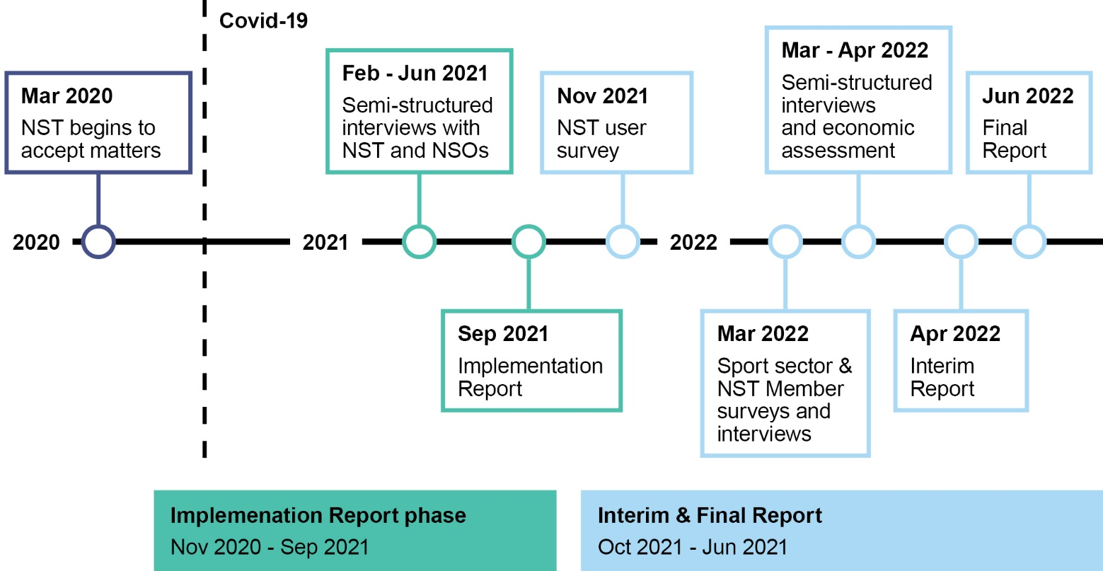

Based on international best practice, the Australia and New Zealand Tribunal Excellence Framework sets out the following eight areas of tribunal excellence: independence; leadership and effective management; fair treatment; accessibility; professionalism and integrity; accountability; efficiency; and client needs and satisfaction.[1] Evaluation data collection activities explored stakeholder experiences of the NST that align with the framework’s areas of excellence. In particular, the perception of the NST’s: independence, fair treatment, accessibility, professionalism and integrity, efficiency and client needs and satisfaction. Relevant aspects of the framework measures were incorporated into the surveys (NST user, sport sector and NST Member) and discussion guides. The framework provides a comprehensive set of excellence areas and measures for a tribunal to assess its own performance.

### NST User survey and interviews

The Bellberry Human Research Ethics Committee reviewed and approved the research protocol regarding consultation with NST users through a survey and interview.

The NST user satisfaction survey was launched in November 2021 and was sent to 54 contacts (Parties) involved in 24 finalised matters between March 2020 and November 2021. For all arbitrated matters, the appeals period had elapsed when the survey was launched. To maximise the response rate, two reminder emails were sent out. In total, 27 responses were received and the response rate was 50%. While respondents were not asked specific or identifying information about their matter with the NST, approximately half of respondents interacted with the NST in 2020 and the other half in 2021. Respondents comprised of:

* 52% individuals including those supporting an individual
* 31% representatives from sporting bodies
* 17% legal representation.

While the response was positive for a voluntary survey (50% of the population of 54 individuals), the relatively small population and number of respondents (n=27) limits the analysis and the extent to which findings can be generalised. Full results of the NST user survey are presented in Appendix E – Survey results.

Among the survey respondents, six individuals elected to participate in a short phone interview. Invitations to participate in a short interview were also sent to all 54 parties who received the survey and an additional nine key informants from sporting bodies as identified by the NST. In addition to the six survey respondents, two individuals agreed to participate in an interview.

### Sport Sector survey and interviews

In March 2022, this survey was sent to 299 national and state sport sector representatives including CEOs and integrity managers of 96 NSOs. Among the emails sent out 16 were not delivered, bringing the total number of recipients to 283. In total, 66 respondents participated in the survey and the response rate was 23%. Among the respondents:

* 89% represented NSOs and the remaining 11% were representatives of state sporting bodies.
* 23% of respondents had accessed NST services for dispute resolution, 68% had some interaction with the NST and 9% had no interaction with the NST.
* 40% held a role as CEO; 22% as an Integrity Manager; 9% as Legal Counsel and 29% holding roles in operations, administration or as a Board Member.

Among the 66 survey respondents, nine individuals participated in a short phone interview. Full results of the sport sector survey are presented in Appendix E – Survey results.

### NST Member survey and interviews

This survey was conducted in March 2022 and 15 NST Members participated in the survey among the population of 39 NST Members who were appointed in 2020 (tranche 1). The response rate was 38%. Almost all of the respondents (14 of 15) had been allocated at least one matter since the NST’s establishment. Among the survey respondents, two individuals participated in a short phone interview. Full results of the NST Member survey are presented in Appendix E – Survey results.

### Key informant interviews

In March – April 2022, semi-structured interviews were undertaken with representatives from Commonwealth sport agencies (Sport Integrity Australia and the Australian Sports Commission). The evaluation team also consulted with representatives from the Sports Tribunal New Zealand and Japan Sports Arbitration Agency. Interviews were conducted with NST Registry staff, the NST CEO and Deputy CEO towards the end of each phase of the evaluation.

### Economic assessment

The relatively small number of cases completed in the two-year evaluation period, and the initial waiving of application and service fees for parties during the pandemic, make economic analysis of program performance more challenging. The evaluation undertook interviews with six NSOs to explore their perspectives on the costs and savings that accrued to NSOs as a result of engagement with the NST. All six NSOs have had some interactions with the NST through validated matters and/or enquiries. Interviewees were representatives of NSOs, that vary in size, and have experience in the dispute resolution and arbitration processes in their sport. The interviews explored the processes and costs associated with managing disputes pre- and post-NST, with insights summarised in Appendix D – Economic Analysis and case studies. Each case study was analysed and any relevant metrics or data used as outlined below:

#### NSO cost of resourcing

Representatives for Sport A indicated that the management of complaints accounted for 2.5% of two employees’ time; the CEO and another management-level staff member. ABS payroll data on the average weekly earnings of chief executives and human resource managers were used respectively as a proxy for the staff members’ wages to calculate the annual cost of managing complaints within the sport. The value was then annualised to 52 weeks and multiplied by the indicated 2.5%. The total was then divided by the number of cases seen by the NST for Sport A between March 2020 and April 2022. Due to the disruptive effects of COVID-19 on the operation of the sport, it is an assumption that the number of cases in this 2-year period would account for one regular year.

Sport B’s interviewee indicated that the NST saved approximately 10 hours per week of work. This would account for 27% of the Fair Work Commission’s 37.5-hour work week. ABS data for the average weekly income of professional, scientific and technical services workers was used to help estimate the value of savings per week following the implementation of the NST. These savings were annualised, and then divided by the number of cases that the interviewee indicated were able to be taken from the sporting body’s hands. This resulted in the per case cost saving due to the NST.

The assumptions for Sport C derive from the sport’s Government funding, as indicated in the ASC Annual Report. It was then assumed that 50% of this amount accounts for staff costs. The financial cost is limited to the value of one employee’s time, as noted during interviews with the sport’s representative. The staff cost figure was then proportioned by the number of full-time employees, also indicated during the interview. This value was then divided by the number of cases brought to the NST, resulting in the average per case cost saving.

Other sports indicated that there were efficiencies from the NST’s introduction, either through the improvement in impartiality or a more efficient way to triage and resolve cases – however limited quantitative data (about actual costs) was able to be gleaned from the interviews.

#### Volunteer and other resourcing costs

Where volunteer time was required to manage the resolution of a dispute, or where pro bono work was sought there was an approximate burden of eight days of time for 1.5 individuals. This includes where tribunals needed to be formed, legal advice was required and where information triage was needed. The elevated time requirement is indicative of the protracted nature of some disputes, as well as the inefficiencies of decentralised information and process systems. For volunteers, the required time cost has been multiplied by the minimum wage of $20.33 per hour (Fair Work Commission, 2022) to reflect the most conservative market rate for the services provided in-kind.

#### Cases

Due to the timing of the NST pilot during COVID-19, there have only been a small number of matters brought forward. As the cumulative assessment of expected value is based on the assumed number of cases over 20 years, Urbis has projected the case load. While 32 cases have been finalised, a further 22 are ongoing - a significant increase on prior caseload levels. Noting this recent growth in cases, Urbis has assumed a total of 50 cases being brought forward over 2022-23. Over the next 20 years to 2041-42, a growth rate of 4% has been applied following the historic trend in cases heard by tribunals in Australian sports.[2]

#### Benefits calculations over 20 years

Noting the data limitations of the evaluation, anticipated benefits have been amortised over 20 years using a social discount rate[3] of 3% to calculate the net present value (NPV) in 2022 terms. A 20-year period was selected in order to assess what future growth in caseloads might mean from an efficiencies and benefits perspective, and whether this would see an increase or decrease in relative benefits.

#### Costs

The marginal costs captured in the ‘administered cost’ line of the NST’s funding was analysed. This has been done to ensure that sustainability and costs are considered on the marginal, operational aspects, as opposed to those costs that were necessary to the establishment and housing of the NST. There was never an intent to cover the departmental costs of the NST, relating to staffing and corporate elements of delivering services. This is in line with similar programs when considering the ongoing ability to fund and to ensure costs rise in line with the benefits being delivered in a sustained way.

### Limitations

The following key limitations should be considered when reading this report.

* NST pilot period has been significantly disrupted by COVID-19, and the flow of cases and operations have not yet reached business as usual.
* A relatively small pool of cases limited the ability to engage directly with a diverse set of NST users.
* High probability of self-selection bias among NSOs and individuals willing to speak with the evaluation team.
* There is limited availability of quantifiable data for costs of dispute resolution for each NSO.
* Quantitative findings about the cost of dispute resolution have been based on a limited number of NSOs (n=6) and may not represent all perspectives and experiences.
* NST operating costs are not indicative of long-term costs given the tribunal is yet to be fully split to the per-case level or by type, and therefore cannot be analysed to this level.
* The time used by NSOs to engage in the NST process could not be gauged, and so the cost-benefit is not inclusive of the NST time cost to NSO staff.

## This report

This report is structured in the four chapters comprising:

* Chapter 1 – Introduction
* Chapter 2 – Origins of the National Sports Tribunal
* Chapter 3 – Key Findings
* Chapter 4 – Future Focus Areas

# Chapter 2: Origins of the National Sports Tribunal

The Review of Australia’s Sports Integrity Arrangements (the Wood Review)[4] was commissioned in 2017 as part of the work being done by the Australian Government to develop the National Sport Plan.[5] The Wood Review articulated a growing global threat to the integrity of sport – and recognised that a fair, safe and strong sport sector free from corruption is inherently valuable to sports participants, sporting organisations and the 14 million Australians who participate in sport annually.

Among the range of sports integrity threats identified by the Wood Review was the lack of consistency in dispute resolution arrangements across the sport sector, and a need for a clear, consistent and cost-effective forum for all sports. The Wood Review made 52 recommendations including 12 relating to the establishment and remit of an NST. The NST would provide an expert, central hearing body that can supplement the work of sports’ current internal dispute resolution arrangements and provide a dispute resolution forum for the smaller sports.[6]

The Australian Government agreed to establish a national sports tribunal, and allocated funding for an initial two-year pilot to ‘establish demand, costs, effective operations, and types of cases it will deal with.’[7]

The Wood Review also recommended the establishment of a National Sports Integrity Commission (to become Sport Integrity Australia (SIA)), to cohesively draw together and develop existing sports integrity capabilities, knowledge, and expertise, and to nationally coordinate all elements of the sports integrity threat response including prevention, monitoring and detection, investigation and enforcement and policy and program delivery (including education, outreach, and development). On 1 July 2020, SIA was established. Prior to this date the functions carried out by the new agency was done by the Australian Sports Anti-Doping Authority, the National Integrity of Sport Unit and parts of Sport Australia.

## Legislative instruments

The *National Sports Tribunal Act 2019* (the NST Act) was passed on 19 September 2019 with the purpose of providing “an effective, efficient, independent, transparent and specialist tribunal for the fair hearing and resolution of sporting disputes” (s3, cl1). The NST Act provides the statutory foundation for the NST. Operational aspects of the NST are guided by the National Sports Tribunal Rule 2020 (the Rule), as amended in 2021. The Rule prescribes matters required or permitted by the NST Act outlining the kind of disputes for which an application can or cannot be made, how a matter is suspended or terminated alongside details related to application fees, how the overall cost can be determined, and management of protected information.[8]

Additional administrative and procedural arrangements are also outlined in the National Sports Tribunal Practice and Procedure Determination 2021 which outlines (inter alia): the process for providing and requiring information; management of witnesses; NST Member allocation processes; hearing conduct and directions on how decisions are published.[9]

The mandate of the NST is to provide sports, athletes and athlete support personnel with a cost-effective, independent forum for the timely determination of disputes through private arbitration, mediation, conciliation or case appraisal.[10]

## Scope and structure of the NST

The NST is comprised of three divisions:

* **General:** Any dispute that may arise under the rules of a sport, or an agreement between a person and a sport where the person is bound by the rules of the sport.
* **Anti-doping:** Any breach of the anti-doping rules of a sport.
* **Appeals:** Any appeal from the General or Anti-doping Division of the NST or from a sporting body’s tribunal.

The NST can hear disputes that arise under the constituent documents of a sporting body. The Rule stipulates the kinds of disputes that must not be approved by the CEO, including ‘field of play’ and any disputes in which damages are sought.

## Fees for service

The NST may charge application and service fees based on the division and type of dispute resolution service. The costs can comprise of both an application fee and a service charge that are assessed at a rate that covers most of the cost of providing the service.[11] A summary of charges is outlined in Appendix D. The NST’s overall financial model is not intended to be fully cost recoverable and seeks to cover variable costs (such as fees for Panel Members). Costs may also be waived, as decided by the NST CEO, where a Party provides an application claiming circumstances of financial hardship.

## Resourcing to implement the NST and complaints handling

The NST is managed by a statutorily appointed CEO, supported by a Deputy CEO and NST Registry Staff (Department of Health and Aged Care employees) who have been incrementally on-boarded during the pilot period. NST Registry staff provide case management and administrative support to Parties and to NST Members.

In December 2020, the Australian Government announced the NST would receive $3.6 million to extend its pilot program for a further 12 months, until 18 March 2023, following the significant disruptions from the COVID-19 pandemic.[12]

The Australian Government also announced funding of $10.1 million to SIA to introduce an independent complaint handling process at all levels, as set out in the NIF, noting that *“this complaints handling process will be complemented by the independent dispute resolution mechanism provided by the NST…This investment in SIA and the NST underpins the implementation of this framework and continues the work towards a stronger and fairer sporting sector across Australia.”*[13]

SIA commenced implementation of an independent and cost-effective assessment and treatment model for integrity complaints from 2021 onwards. The funding will also support expanded SIA education and awareness work, policy development, coordination, and compliance programs. While it is anticipated that there may be additional NST caseload arising from the new complaints handling processes, the costs associated with this are being absorbed within the NST’s existing funding envelope.

## Enlivening the NST’s jurisdiction

The NST is an arbitral tribunal. Its jurisdiction (for arbitration and for other services like mediation and conciliation) is enlivened by agreement between the Parties that the NST will be the entity that resolves a dispute between them. The NST’s jurisdiction is most effective when it is ‘embedded’ in the rules of a sport – where, for anti-doping or disciplinary disputes for instance, the relevant rules, policy or by-law of a sport specifically provides that disputes will be managed by the NST. In these circumstances, the ‘agreement’ of the Parties required to enliven the NST’s jurisdiction is the membership agreement, or contract for services, that stipulates members’ (or contractors’) obligations to comply with relevant rules/by-laws of a sport.

Sporting organisations below the national level (for example, a state association) can only use the NST if the dispute arises under the rules of the national-level sporting body, and the national-level sporting body agrees to refer the dispute to the NST and to be a Party to the dispute.

# Chapter 3: Key findings

## Design on the National Sports Tribunal

### Key messages

* The NST meets a need for independent, consistent processes for the resolution of disputes in sport. Stakeholders value the consistency that professionalised and centralised functions bring.
* The combination of structural independence and NST Member credibility and expertise supports perceptions among NSOs and users of the NST of procedural fairness.
* NST services complement or replace existing intra-sport mechanisms for dispute resolution and are not duplicative in any substantive way.
* The NST’s jurisdiction is broader than integrity issues and the early signs are that this helps address a gap for many NSOs not addressed through the National Integrity Framework.
* The user experience of the NST Registry and NST services are very positive, and the fee structures generally accepted to be reasonable.

### Key evaluation question

“How appropriate is the design of the NST to meet the needs of sports and athletes?”

#### Sub questions

* What are the drivers for demand for the NST?
* To what extent does the NST complement/ replicate existing sports dispute resolution
* processes?
* What changes or improvements could be made to the design of the NST?

### Introduction

This section is focused on the design of the NST and the extent to which it has been established appropriately to address the needs of NSOs and athletes. We considered design elements to include those aspects of the NST that have been established to meet the purposes of the NST, including the jurisdiction afforded to the NST, the range of services offered, the design of NST Registry processes and appointment of NST Members, and the appropriateness of the fee structures from a user point of view.

### The NST meets a need for independence and consistency

The NST was established to address what the Wood Review described as “a fragmented approach” in the sporting landscape with respect to dispute resolution which risked “inconsistency and unpredictability” in outcomes across a range of issues.[14] While larger NSOs have the resources to establish and maintain internal dispute resolution processes, most smaller NSOs do not, and have relied upon ad hoc processes or have used the (international) Court of Arbitration for Sport (CAS). Both smaller and larger NSOs rely upon volunteers in many cases to support processes handling and supporting the resolution of disputes. The Wood Review also observed that an NST would also address perceptions of bias or conflicts of interest in sports, noting that perceived independence and impartiality were important characteristics of effective tribunals.[15]

The design of the NST effectively addresses these issues, through several means. First, the provision of a centralised, professionalised dispute resolution pathway that is accessible to all sports effectively ‘lifts the bar’ in terms of the dispute resolution services available, particularly for smaller sports without established internal tribunal processes. This observation is supported by feedback from many NSOs surveyed or interviewed that the services available through the NST are a marked improvement on what they might have been able to provide through internal processes.

Bringing more types of disputes into the jurisdiction of the NST over time is likely to continue to deliver increased consistency for Parties, and support pathways for the timely resolution of more complex or protracted disputes. This includes consistency in their experiences of process and of the support provided to the Parties to a matter, but also extends to the availability of non-arbitral services including case appraisal, conciliation and mediation.

Second, the NST design supports consistency of outcomes, and this should improve in the longer term. This is particularly the case for arbitrated matters, where the NST’s publication of decisions is building a body of case law. While not formally binding on future arbitrators, the publication of decisions is intended to support consistency of how similar matters are ultimately resolved. While the benefits of publishing decisions do need to be considered in light of any impacts on individuals’ privacy (and we note consultation with parties occurs prior to publication), this feature of how the NST operates is consistent with the Wood Review’s emphasis on the long term and systematic of decision transparency.[16] Some stakeholders also noted that published decisions were useful in developing a body of jurisprudence – ultimately enabling each case to contribute to better and more consistent decision making at the systemic level.

Finally, the NST is a statutory body whose independence is established within the Act,[17] and appoints expert and independent Members to specific matters. The independence of the process is particularly valued by stakeholders consulted as part of this evaluation. Even where pre-existing arrangements in NSOs involved the appointment of an independent mediator or arbitrator, the process of making those appointments might still be subject to perceptions of bias where processes for establishing a tribunal are led by one of the Parties (generally the NSO or sporting body). This is particularly the case where appointed individuals have been identified from within pre-existing networks or relationships. The independence of the panel of ministerially appointed NST Members, and the legislative and administrative independence of the NST Registry and the CEO (who appoints NST Members to individual matters) provides assurance to all Parties as to a chain of independence at all stages of a matter.

### The NST facilitates procedural fairness

One of the hallmarks of best practice tribunals is a focus on ensuring natural justice, including minimum expectations of procedural fairness. These include notice of proceedings affecting interest, adequate disclosure, and an opportunity for a substantive hearing before an impartial adjudicator.[18] The NST has a range of design elements which support procedural fairness, including the procedures for the giving of appropriate notice,[19] rules around evidentiary disclosure,[20] and appointment of independent Members to specific cases.[21] The NST’s Practice and Procedure Determination also allows for Parties to challenge appointment of specific NST Members where they allege actual or apprehended bias.[22]

While principles of natural justice do not always require that Parties be represented, the NST does have protective provisions which require that Parties who are legally incapacitated must be represented,[23] although there are no specific qualifications or standards required of the person representing a Party (excepting a prohibition on having any different interests to those of the Party).[24] The application form for the NST also includes a specific question on whether individuals may require support to participate in dispute resolution.[25] Sporting bodies surveyed held generally positive or neutral views on whether the NST was accessible for people with disability (57% agreement, 4% disagreement) and for those from non-English speaking backgrounds (48% agreeing, 11% disagreeing). The survey did not capture information about whether respondents themselves identified in these categories, which is a significant caveat on the validity of the data in representing actual experience as reported by the affected cohorts.

There is a small risk, highlighted by one stakeholder, that the introduction of more formalised or quasi-legalistic processes can also inadvertently create barriers for some individuals, particularly self-represented Parties. A number of strategies employed by the NST may mitigate this risk. These include a focus on conducting hearings in as informal a manner as is appropriate as outlined in the NST legislation, work to develop the NST Legal Assistance Panel (NSTLAP), and provision of NST Registry support and resources (e.g. the Bench Book).[26]

We also note that the NST is undertaking specific work to strengthen accessibility for potentially vulnerable Parties. These efforts include further development and refinement of the design and operation of the NSTLAP, and exploring development of potential ‘legal aid’ supports to defray costs and ‘level the playing field’ in terms of access to legal advice. Additionally, the NST has initiated a project focused specifically on strengthening the support it offers to potentially vulnerable Parties.

In practice, the reported experiences of NST users to date generally support a finding that the NST does meet standards of procedural fairness. Among NST users we surveyed, 57% agree their specific hearing or case was handled fairly (13% disagreement, the balance being neutral), and 91% of NSOs surveyed also indicate that in general the NST provides a fair process (the balance indicating neutrality on this question). Asked specifically about NST Members appointed to their matter, 56% of NST users agreed that those allocated to their matter were ‘independent experts’ (9% disagreement). When NSOs were asked in general about the NST Members appointed by the Minister for Sport, 87% agreed they have appropriate skills and experience, with the balance neutral in their response.

### The NST complements rather than duplicates existing structures

The Wood Review noted that larger NSOs had established dispute resolution tribunal processes that were tailored to the specific environments of sport,[27] but most NSOs operated with more ad hoc arrangements or utilised CAS as their first instance and appeals tribunal. The NST has been designed to provide for transitional arrangements which have allowed matters to be heard by consent of the Parties, while momentum has grown for the inclusion of the NST as the ‘default’ tribunal in sporting policies and rules, and through the NIF.

It is assessed the NST does not duplicate existing tribunals in a material way. The CAS continues to operate, and some NSOs (particularly those part of COMPPS) have continued their own tribunals and processes (at least for first instance hearings) while the NST has operated with case-by-case consensual jurisdiction. While some NSOs (who haven’t adopted the NIF or the NST as a default mechanism) can access the NST on a case by case basis, there will continue to be multiple processes available for the resolution of matters and associated fixed costs with sustaining each of these pathways.

However, as NSOs embed the NST in their rules and policies for first instance matters, appeals (or both), the NST will replace rather than duplicate existing mechanisms for dispute resolution. This includes for those NSOs which have elected to retain first instance dispute resolution jurisdiction ‘in house’ – the NST provides an independent appeals pathway to replace pre-existing options. By centralising dispute resolution, the NST will in the long run reduce the total number of separate dispute resolution or tribunal structures or services as sports ‘come on board’, particularly since the NST has been systemically integrated into the NIF, Anti-Doping and other policies.

Finally, it is noted some NSOs continue to manage their own internal tribunals for arbitrated processes, the NST offers an additional and generally broader set of alternative dispute resolution services (mediation, conciliation, case appraisal). Some NSOs described the NST as a valuable ‘second pillar’ to complement their own processes for managing disputes internally.

Makes us confident of when we can use our own strategies and that there are other options - and we know where to go. Sporting organisations need to deal with difficult matters… To know that a matter can be dealt with fairly is reassuring. (NSO representative, interview)

### The NST’s jurisdiction is appropriate

Under its own enabling legislation and Rule, the NST is able to consider a range of disputes, including those relating to anti-doping rule violations (ADRV), disciplinary matters, selection and eligibility issues, bullying, and harassment and discrimination. The NST is also ‘written into’ the NIF as the default body for hearings associated with prohibited conduct under the Complaints, Disputes and Discipline Policy, where a matter is an eligible matter under the NST’s enabling legislation. The four policy areas within the NIF include safeguarding children, member protection, competition manipulation and sports wagering and misuse of drugs and medicines.[28]

The NST’s jurisdiction is broader than the set of matters that fall within the NIF. This has caused some confusion for stakeholders in the understanding of the respective areas of interest for SIA (which only investigates matters that fall within the scope of the NIF or which are ADRVs), and the NST which arbitrates ADRVs and matters within the NIF, but also other matters outside the NIF. The most cited examples of the NST’s additional jurisdiction are eligibility and selection appeals, matters related to code of conduct/behaviour breaches, and some personal grievances that do not fit within the NIF.

During the implementation period, the NST has demonstrated a willingness to examine its jurisdiction, and revised the NST Rule in late 2021 to broaden and simplify the types of disputes under which an application can be made to the NST – specifically the removal of the prohibition on matters related to employment.[29]

Stakeholders in this evaluation were consulted on the appropriateness of the NST’s jurisdiction, and the uniform response has been in the affirmative. While noting the complexity present in the broader integrity landscape, stakeholders did not identify any specific areas where the NST held inappropriate jurisdiction, or conversely lacked jurisdiction. A small number of stakeholders made observations about hypothetical benefits of broadening the scope of matters to include those that were ‘sub-national’ or at state, regional or local level and did not require the NSO to be a Party to the matter. The extent of potential demand, nor the nature, complexity or significance/triviality of sub-national disputes, was not able to be assessed. Assessment of any potential constitutional impediments to sub-national jurisdiction also falls outside the scope of the evaluation. In this context we consider the national jurisdiction as conservative but appropriate, with pathways for elevation to the NST by NSOs who may join sub-national matters as a Party.

### Users are well supported, and costs appear reasonable

The NST is now well-established, with a range of information and published resources available to users to support them to access the NST, including the Bench Book, a reasonably ‘plain English’ application form, and a range of fact sheets and other resources (such as recorded webinars). Users generally report a positive experience of the process, signalling that the business process and consumer experience aspects of the NST are operating effectively from a user point of view. Further observations on the design and refinement of the NST’s operations and the impacts for users are discussed in the following section.

Analysis of the efficiency and value of the NST signals that costs and charges associated with the NST are reasonable in the context of the value perceived by users. This is broadly supported by the findings of the sector survey, with 62% of NSOs agreeing fees are ‘affordable’ (11% disagreeing). Those that did not consider the fees to be affordable were generally smaller NSOs for whom the prospect of a professionalised dispute resolution pathway through the NST raised their direct costs (e.g. application fees) and potentially other on-costs (e.g. concerns about the costs of legal advice associated with more ‘formal’ proceedings).

## Implementation of the National Sports Tribunal

### Key messages

* Core elements of the NST are well established and are operating effectively. The NST has adopted a culture of continuous improvement and refined operations based on user feedback and internal reviews.
* NST Members confirm that the NST is well run and report high levels of satisfaction with internal processes, communications and the provision of case information.
* The NST has engaged proactively with the sport sector and leveraged the reputation of the NST CEO and Deputy CEOs. Engagement and promotional activities appear to be effective in raising awareness of the NST and promoting its services, however NSOs continue to report confusion about roles of different sports services within the broader integrity landscape.
* NSOs have welcomed the NST’s supportive strategies to help sports adopt the NST and review integrity policies. Administrative and policy barriers to accessing the NST have reduced over time as more sports adopt the NIF.
* While the caseload has remained relatively low over the first two years of operation, demand has risen sharply in 2022. The number of enquiries and NSOs accessing the NST shows a strong upward trend including COMPPS sports.

### Key evaluation question

“How well has the NST been implemented?”

#### Sub-questions

* What is working well/less well and why?
* What are the enablers/ barriers to effective implementation of the NST?
* What improvements could be made to the implementation of the NST?

### Introduction

This section examines the activities to establish and support the NST’s implementation including actions associated with setting up and operating the NST. The extent and achievement of implementation activities has been an area of ongoing focus throughout the evaluation and this section provides a summation of these, while more detail can be found in earlier evaluation reports.

### Core elements of the NST are well established

As documented through the course of the evaluation, the NST was effectively established in early 2020. The operation of the NST was enlivened through the website, appointment of the first tranche of NST Members, application documents, recruitment of NST Registry staff and development of internal processes for the administration of cases. Shortly after COVID-19 restrictions were imposed across Australia, the NST successfully pivoted hearings and mediations to an online format. NST Members and Parties reported that NST Registry staff effectively supported them to navigate through the novel technology and format. In the first year of operation, the NST established the NSTLAP to support unrepresented Parties to access pro bono legal assistance.

Through 2021, the NST continued to refine its operations, case management processes and data collection practices. A second tranche of NST Members was appointed in late 2021 and provides a diversity of expertise, skills and backgrounds. Revisions were also made to the NST Rule in 2021 to expand the remit. Over the first two years of operation, NST Registry staff have been recruited on an as-needed basis and in line with changes to the caseload.

### Sport sector engagement has been broadly effective in raising awareness and promoting the NST’s services

The NST has proactively engaged with the sport and legal sector through ongoing and targeted engagement activities. Despite the challenges of COVID-19 restrictions, the NST ran a comprehensive promotional campaign in the first six months of operation, conducting over 50 individual online sessions with NSOs, sporting and legal bodies, and player representative groups. As travel restrictions have eased in 2022, the NST is conducting more face-to-face meetings and presentations to engage NSOs, individuals, and representative groups.

Awareness and promotion activities have been largely led by the NST CEO and Deputy CEOs. This strategy has been an effective way to leverage the reputation and credibility of those individuals as well-known and respected figures within the sport sector. Interviews with NSOs confirmed that the high standing of the CEO has helped to build awareness and engagement with the NST. Many interviewees described productive discussions with the CEO, where they were able to ask questions and receive tailored advice. The NST has used resources across the existing NST Registry to design and deliver communication and engagement activities.

There is evidence that these activities have raised awareness of the NST and assisted to promote the NST’s dispute resolution services and role in the integrity landscape. Over three quarters (76%) of sport sector survey respondents indicated that they heard about the NST directly from the NST and over half of respondents have attended a presentation by the NST, had contact through email or accessed the NST website (see Figure 2). Many respondents also noted that they had received an electronic newsletter from the NST (in March 2022) and feedback on the newsletter has been very positive. Interviews with NSOs confirmed that sport representatives generally find the NST Registry staff to be responsive, helpful and provide a practical approach.

Figure Sport sector interactions with the NST via website, email, presentation or phone

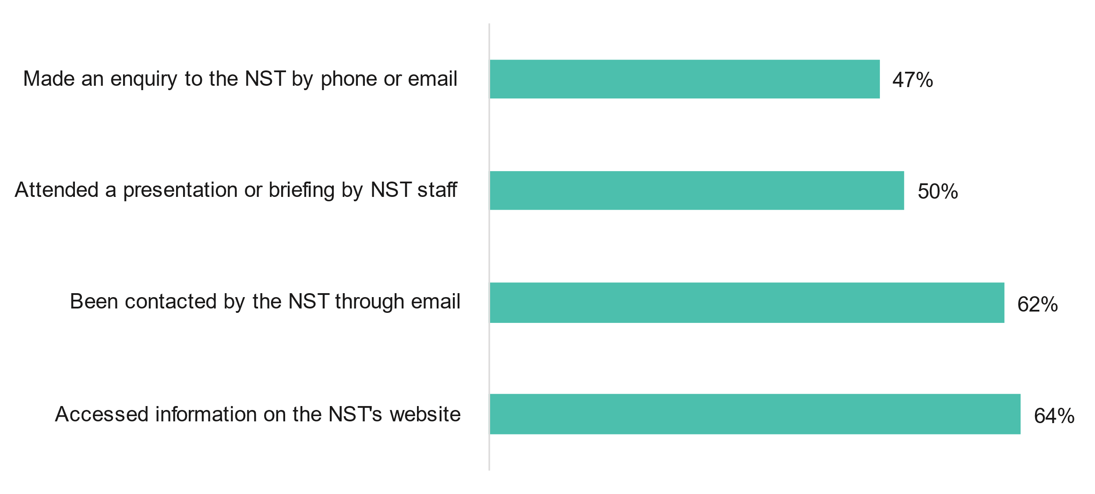

Source: NST user satisfaction survey, n=66

Website analytics indicate access to the NST website and resources has been relatively steady through 2020 and 2021 with 20 and 23 average daily users, respectively. Over this period there are several notable spikes in website visitors arising from sport sector presentations. In 2022, however, website visitation shows as strong upward trend with a three-fold increase in average daily visitors to 60.

### Amidst significant change in the sport integrity landscape, there is some confusion about the roles of Government integrity bodies

Since the Government response to the Wood Review, Australia’s sport integrity landscape has undergone significant change with the establishment of SIA and the NST, and more recently the launch of the NIF. These changes have been implemented incrementally by the responsible Government agencies who have also been responsible for the promotion and communication of their new functions. Over this period, the sport sector has been significantly disrupted with COVID-19, and sport administrators have been focusing on their response to these challenges, with less time and resources to invest in understanding the introduced changes to sport integrity.

NST Registry staff believe that while promotional activities have been effective, there is an ongoing need to communicate and promote the NST among NSOs and athletes, recognising the importance of coordination with other organisations to streamline messaging about the role of the NST in relation to the role of SIA and the ASC. This was confirmed through sport sector consultations, where NSO representatives expressed confusion regarding the respective roles and remit of SIA and the NST.

### NSOs are increasingly adopting the NST’s jurisdiction and the NIF

Activities to support adoption of the NST have been welcomed by NSOs who have appreciated the NST’s flexible and facilitative approach. Throughout 2020 and 2021, the NST provided bespoke support to NSOs and in some instances supported NSOs experiencing urgent integrity issues to review and revise policies. In 2022, under the NST Policy Adoption Project, 53 NSOs accessed small grants to procure legal advice on how to adopt the NST’s complementary template policies (for code of conduct, review and appeals). Following the completion of this project, the NST intends to undertake a comprehensive evaluation of the inclusion of the NST in NSO policies later in 2022.

As expected almost all NSOs have adopted the Australian National Anti-Doping Policy or an approved version, which embeds the NST’s jurisdiction.[30] At least 60 NSOs are anticipated to adopt the NIF in full and it is currently expected that many of the remaining NSOs will adopt the NIF, or have minimum standards approved by SIA which may include the NST. Peak sporting bodies, including the Australian Olympic Committee and Paralympics Australia, have endorsed the NST. Commonwealth Games Australia are utilising the NST for all non-nomination and non-selection appeals for the upcoming Birmingham Games in July 2022.

### NST Members confirm the NST is operating effectively

NST Members report high levels of satisfaction with the NST processes and confirm it is operating effectively to provide a fair process. Survey results from NST Members appointed in 2020 (tranche 1) were very positive in relation to communications and internal processes including support provided by NST Registry staff. Training and induction processes are considered appropriate and relevant to their role. NST Members were generally happy with timeliness and format of case information. Overall satisfaction with operation of the NST is high and on average NST Members rated the NST 8.2 of 10. Survey responses are presented in full in Appendix E – Survey results.

Most surveyed NST Members confirmed that they are also involved with other sport dispute resolution services, and among those respondents (ten of the thirteen NST Members) reported that the NST compares favourably with other services. This was attributed to the NST’s timeliness and independence, and the professionalism of the NST Registry staff. When asked how the NST could further improve its operations, a small number of suggestions were made including: improving the transparency of NST Member remuneration, increasing the publication of outcome summaries and rectifying minor IT issues.

### Early momentum slowed by the pandemic, but demand is growing steadily

Over the first two years of operation, demand for the NST remained relatively low and over that period 26 matters were finalised. Nearly two-thirds of these matters reached a resolution through NST processes (16 matters) while six matters were withdrawn by the applicant (some being resolved out of session),[31] and four matters (mediations and conciliations) were terminated by the NST Member due to an assessment that a resolution between Parties would not be possible.[32] These matters were largely in the General Division (24 matters) with one appeal and one anti-doping case, see Table 4 overleaf.

More recently, the NST has seen a significant and rapid increase in enquiries and active matters. In the two-month period from mid-March to mid-May 2022 the NST had 28 validated matters. Six matters have been finalised and 22 matters are before the NST as of 18 May 2022.

Table Finalised and active matters by NST Division, March 2020- May 2022

| Division | 19 Mar 20 – 18 Sep 20 | 19 Sep 20 – 18 Mar 21 | 19 Mar 21 – 18 Sept 21 | 19 Sep 21 – 18 Mar 22 | 19 Mar 22- 18 May 22 | Active at 18 May 22 |
| --- | --- | --- | --- | --- | --- | --- |
| General | 4 | 6 | 12 | 2 | 2 | 15 |
| Appeals | 0 | 1 | 0 | 0 | 4 | 6 |
| Anti-doping | 0 | 1 | 0 | 0 | 0 | 1 |
| ****Total**** | **4** | **8** | **12** | **2** | **6** | **22** |

Source: NST

The NST’s commencement coincided with the onset of the COVID-19 pandemic, which caused unparalleled disruption to the sport sector due to government-imposed restrictions and health orders. This resulted in lower demand for the NST services than originally expected. The impact of COVID-19 on sport in Australia was significant and highly disruptive to all levels of federated sports and all sizes of sports throughout much of 2020 and 2021. Over the first two years to the NST’s operation demand for NST services was impacted by: COVID-19 induced inactivity of sporting competition and events; significantly less activity resulting in less matters relating to selection disputes; and some NSOs experienced considerable financial stress, governance challenges and were generally pre-occupied with the unprecedented restrictions without capacity to consider changes to rules or policies.

Similar international tribunals, in New Zealand and Japan, have indicated it can take years, even upwards of a decade, to reach a business-as-usual caseload. Established in 2003, both of these tribunals recorded a gradual increase in case numbers over the first few years of operation and a significant drop in caseload over the 2020 and 2021, due to COVID-19 disruption to their sporting sector.

Beyond COVID-19, a range of other factors impeded access to the NST over the first two years of operation. Throughout 2020 and 2021, many NSOs reported that they delayed updating their policies, including incorporating the NST’s jurisdiction, as they were waiting for the new NIF to be released by SIA. Some NSOs noted that they did not have the internal capacity to update their policies, which requires Board approval, and to run a communication campaign to accompany the policy changes. In 2021, some NSOs indicated that they were occupied with preparing for the Tokyo Olympics (2021) and did not have the time to consider and implement policy changes. As noted earlier, while most NSOs have adopted the Australian National Anti-Doping Policy (which took effect on 1 January 2021[33]) there is expected to be significant time delay before anti-doping matters were referred to the NST. Registry staff expect that the number of anti-doping matters referred to the NST will increase substantially throughout 2022 and beyond.

Where a NSO has not yet embedded the NST’s jurisdiction in their rules, the NST can also deal with disputes where all the Parties to the dispute specifically agree. This way of enlivening the NST's jurisdiction requires all Parties to agree on utilising the NST after the dispute has arisen. NST Registry staff and NSOs’ representatives commented that a range of factors contribute to Parties not agreeing to use the NST, primarily that some NSOs would like to retain control and management of the dispute or grievance. NSOs also have responsibility for enforcing any sanctions applied during the dispute resolution and in some cases NSOs have a strong interest in being actively involved in the dispute resolution process. In other instances, interviewees commented that some Parties were reluctant to take their dispute to an external legal body, while in other instances it is inherently difficult to get Parties of a dispute to agree even on a mechanism or processes for resolution.

While case numbers have remained relatively steady, the number of enquires made to the NST has shown a steady upward trend since March 2020 and is increasingly resulting in validated matters as shown in Figure 3. Enquiry data also demonstrates that the number of NSOs accessing the NST is increasing over time. Since the NST’s establishment, 39 different NSOs have made enquiries to the NST, including four (of the seven) COMPPS sports.

Figure Number of enquires to NST and validated matters since establishment (quarterly intervals)

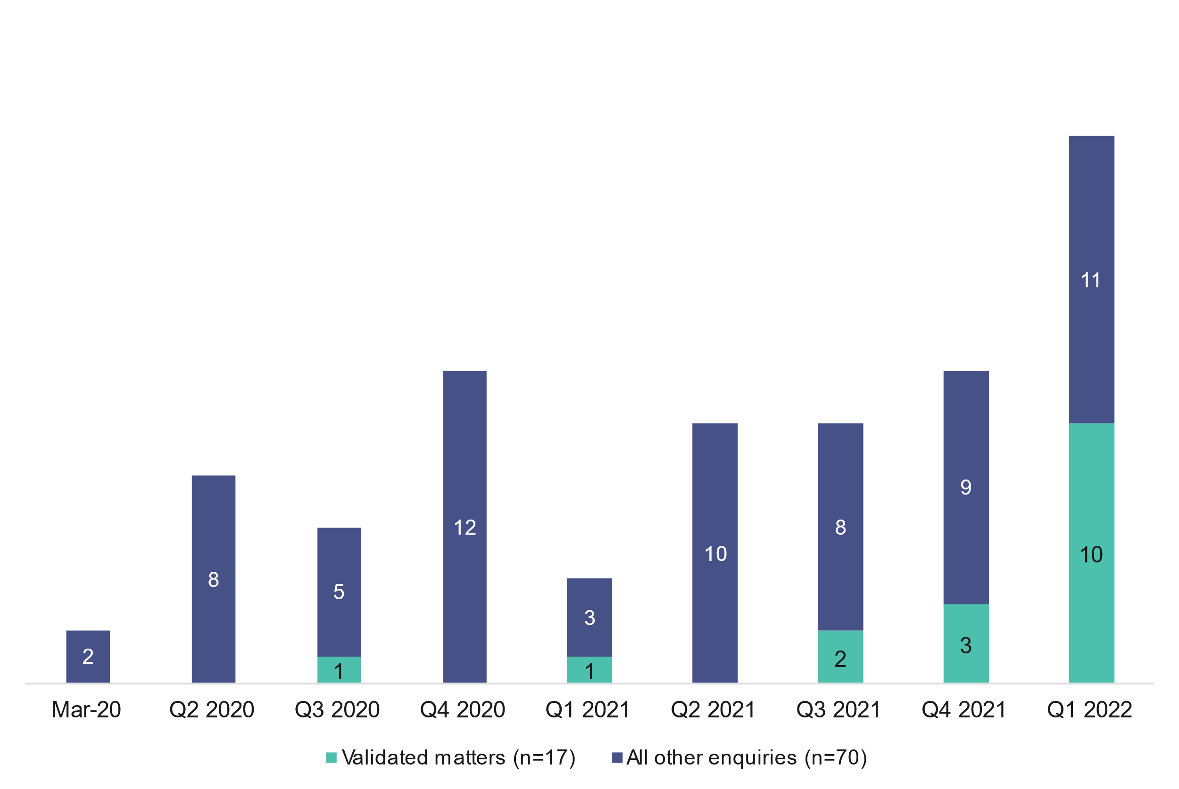

Source: NST data

Note: Complete quarterly data for Q2 2022 (April to June 2022 inclusive) was not available at the time of writing, and so has been excluded from this chart. At the time of writing there were n=4 enquiries in this period.

As outlined in Table 5, these enquiries have been made from all levels of the federated sports (national, state and clubs). Data is presented in six-month intervals for the first two years of operation and the latest two months of available data.

Table Number of case enquiries by level, 19 March 2020 – 18 May 2022

| Level | 19 Mar 20 – 18 Sept 20 | 19 Sept 20 – 18 Mar 21 | 19 Mar 21 – 18 Sept 21 | 19 Sept 21 – 18 Mar 22 | 19 Mar 22- 18 May 22* | Total enquiries |
| --- | --- | --- | --- | --- | --- | --- |
| National | 4 | 3 | 4 | 8 | 5 | 24 |
| State | 4 | 7 | 3 | 18 | 1 | 33 |
| Club | 6 | 5 | 8 | 4 | 1 | 24 |
| Unknown | 1 | 2 | 4 | 1 | 0 | 8 |
| Total | 15 | 17 | 19 | 31 | 7 | 89 |

Source: NST data

Note: Enquiries are categorised according to the date they were received.

Table Number of validated matters, 19 March 2020 – 18 May 2022

| Case enquiries | 19 Mar 20 – 18 Sept 20 | 19 Sept 20 – 18 Mar 21 | 19 Mar 21 – 18 Sept 21 | 19 Sept 21 – 18 Mar 22 | 19 Mar 22- 18 May 22* | Total enquiries |
| --- | --- | --- | --- | --- | --- | --- |
| Total | 15 | 17 | 19 | 31 | 7 | ****89**** |
| Validated matters | 1 | 1 | 2 | 11 | 2 | ****17**** |

Source: NST data

Note: Enquiries are categorised according to the date they were received.

There are a range of reasons why an enquiry doesn’t progress to a validated matter, including a lack of agreement from the Parties to bring the matter to the NST, the complaint was withdrawn, the matter was resolved internally, Parties did not respond beyond the initial reply from the NST or the type of dispute wasn’t within the NST’s jurisdiction.

### The NST has adopted a continuous improvement culture

As a new tribunal and administrative function, it is important that the NST is responsive to early feedback about its services and acts decisively to iron out any shortcomings in the start-up phase. Over the first two years of operation the NST has adopted a commitment to ongoing improvement and the slower than expected caseload has given the NST an opportunity to implement a range of refinements to its processes. Refinements to processes have largely been driven by feedback from Parties (through debriefing sessions and feedback emails) and NST Registry staff regularly reviewing processes and procedures. Over this period, case management practices have been documented and data collection practices have improved. Building upon work undertaken in early 2021 with an independent business support team that mapped the user experience of the NST, NST Registry staff are continuously refreshing guidance material, including a handbook as a reference for Parties through the process. The NST has also consulted with other tribunals and sport dispute resolution agencies in New Zealand, Japan and the United Kingdom as well as the CAS to learn from these long-standing tribunals.

To improve the accessibility of the NST, and in response to feedback from Parties, the NST has begun playing a more facilitative role in connecting Parties to the NSTLAP. The NST continues to explore the application of restorative engagement principles into mediation services and has commissioned advice from academics working in this specialist area. Other strategic priorities over the next phase of implementation will focus on:

* providing more support for vulnerable individuals and exploring access to legal aid;
* establishing the NST as the ‘forum of choice’ for sport dispute resolution in Australia, including via embedding the NST in sports’ rules and by-laws;
* establishing proof of concept and developing an activity-based costing model; and
* continuing to drive whole of Australian government sport portfolio agency collaboration through sharing of information and developing coordinated approaches and messaging.

## Outcomes delivered by the National Sports Tribunal

### Key messages

* Users generally report a positive experience of NST processes. NSOs and individuals found NST Registry staff to be helpful, professional and responsive through phone and email assistance.
* The NST is providing an avenue to professional dispute resolution services for athletes, participants and support personnel.
* While there was mixed satisfaction with the decision (or outcome) of the matter, most users generally considered the process to be fair and informed by qualified experts in the field.
* The NST is considered independent and fair by users and more broadly by the sporting sector.
* There is a high level of satisfaction with the NST and strong sector support for the NST as a core pillar in the sport integrity landscape.
* Stakeholders did not identify any perverse impacts relating to the operation of NST, while some NSOs reported that their interactions with the NST assisted to build their internal capacity in governance and administration.
* As the NST continues to refine its practices, attention should focus on increasing the support and guidance for unrepresented individuals and young people.

### Key evaluation question

“To what extent have the expected outcomes of the NST been achieved”

#### Sub questions

* In what context has the NST been more or less successful?
* Have there been any unintended outcomes or consequences associated with NST?

### Introduction

This section examines the extent to which expected outcomes have been achieved in the first 26 months of the NST’s operation. Intended outcomes for NSOs and participants include increased availability, flexibility and use of dispute resolution services. In the medium term, the NST aims to reduce the barriers and provide more timely, transparent and cost-effective services. This section also explores outcomes that were either unexpected or highlighted by stakeholders.

This section draws upon analysis of primary data collected for the user experience and satisfaction with the NST, and the broader sector perception of the NST. Full results of the NST user survey (n=27) and sport sector survey (n=66) are presented in Appendix E – Survey results.

### There is emerging evidence that the NST is achieving the intended outcomes for the sport sector

The evaluation has found emerging evidence that the NST is achieving intended outcomes for NSOs and participants as outlined in the NST’s program logic model. The following table presents a summation the extent to which these outcomes have been achieved to date.

Table Expected outcomes of the NST and respective extent of achievements

| Expected outcomes | Extent of achievement |
| --- | --- |
| NSOs and participants have increased availability and flexibility of dispute resolution services | **Good progress** – All NSOs, consulted towards the end of the evaluation, value the NST and intend to use the NST as needed |
| NSOs and participants have increased use of the NST for dispute resolution | **Achieved** – Uptake and adoption of the NST has increased steadily since establishment |
| NSOs and participants have increased timeliness of sport dispute resolution | **Good progress** – NSOs report that some historical disputes can go on for years through non-NST processes |
| NSOs and participants have reduced barriers to access sports disputes resolution services | **Good progress** – Growing evidence of uptake and access to the NST but more work needed to further reduce barriers for individuals |
| NSOs and participants have increased value for money | **Good progress** – Most NSOs consider the NST to provide good value for money |
| Outcomes released/ communicated | **Achieved** – NST is publishing decisions of finalised matters on the website |
| Increased transparency of dispute resolution process | **Good progress** – Sector stakeholders welcome the transparency provided by the NST |
| Sporting and broader community has reduced perception of bias in dispute resolution process | **Good progress** – Sector feedback to date indicates that NST is largely perceived as independent and fair |
| NSOs, the sport community and the public have high regard and trust in the NST reputation for sports dispute resolution processes | **Good progress** – Feedback from the sport community indicates that there is strong support for the NST and it is held in high regard |
| NSOs and athletes have increased satisfaction and acceptability of the NST | **Good progress** – Feedback from the sport sector and NST users indicates a high level of satisfaction and acceptability |

### NST users generally report a positive experience

The NST users consulted towards the evaluation through a survey and follow up interviews indicate that they were generally satisfied with their experience of the NST. This was attributed to: their interactions with NST Registry staff; experiences during the hearing or mediation with the allocated NST Member; level of satisfaction with the outcome/decision; the timeliness of their matter proceeding; and the cost of the process. Most survey respondents (65%) indicated that their interactions with the NST Registry staff were professional and positive. This was related to the NST Registry staff being reliable and providing useful and timely information (typically by email or phone) about the process.

This finding was generally consistent with the interview data, where interviewees described feeling supported by the NST Registry staff through the novel process of dispute resolution. Depending upon their role in the dispute, some interviewees reported that they had a lot of contact with the NST Registry staff, particularly in the early stages of the process. Some interviewees had a dedicated case manager, while others described positive interactions with multiple staff that was facilitated through a joint email address.

The provision of clear and accessible information was particularly important for individuals and their supporters, who generally had no background or prior experience in dispute resolution and/or legal processes. Despite it being a new process for many individuals, very few respondents (13%) reported that they experienced issues lodging an application with the NST. Most survey respondents were positive or neutral confirming that the process was clear and straightforward. Five NST users who participated in an interview highlighted that the process was straightforward due to the assistance from NST Registry staff or legal professionals.

Prior to a hearing being scheduled, survey respondents reported that they were provided with the proposed NST Member’s curriculum vitae to review and were generally given an opportunity to comment on who heard their matter. Involvement in this process may have contributed to the relatively high level of satisfaction reported by respondents confirming that the NST Member allocated was an independent expert. While most respondents reported that their NST Member was appropriate and skilled, a small number of Parties felt that their allocated NST Member could have more expertise in the sporting matter.

When examining the experiences of NST users during their hearing or mediation, more than half of respondents (56%) were happy with the facilities and format of the hearing and nearly a third were neutral. The interviews highlighted that all but one hearing was held online (unsurprising given COVID-19), with NST users reporting this format reduced barriers to participation (e.g., when Parties were located in different states) and was convenient.

NST users were generally positive about the timeliness of NST services noting that the timelines for resolution vary across the methods of dispute resolution as listed in Table 8. Many representatives from NSOs agreed that the NST provides a much more timely and rigorous process than can be achieved by individual NSOs internally. Interviewees described that this is particularly the case for complex and vexatious disputes which can persist over several years without effective resolution.

Table Average case length for resolved matters (days), 19 March 2020 – 18 May 2022

| Method | Number of cases | Average (days) | Range (days) |
| --- | --- | --- | --- |
| Case appraisal | 2 | 85 | 57 – 113 |
| Mediation | 10 | 36 | 7 – 85 |
| Conciliation | 5 | 29 | 16 - 39 |
| Arbitration – Appeal | 2 | 11.5 | 8 – 15 |
| Arbitration – General | 4 | 111 | 74 - 163 |
| Arbitration – Anti-Doping | 1 | 104 | 104 |

Source: NST

### NST has a reputation for being fair and independent

Regarding satisfaction with the outcome of the matter, 39% of survey respondents were satisfied with the outcome of their matter, while a quarter (26%) were not satisfied with the outcome and about one-third (30%) were neutral (details included in Appendix E – Survey results). This result is unsurprising, given the nature of disputes and in many cases, respondents reported a long personal engagement with the dispute. Most respondents reported a positive response and acceptance of the NST decision (outcome) on their matter. Overall satisfaction with the NST among the sport sector is relatively high. On average, survey respondents rated the NST 8.2 out of 10 (n=59) and an even higher number are likely to recommend the NST to others scoring 8.7 of out 10 (n=66).

A small number of interviewees who were not satisfied with the outcome of their matter cited case specific reasons including: dissatisfaction that the process did not result in a clear decision (outcome), the sanctions applied were not considered harsh enough and uncertainty about the timeliness of the process.

Despite some level of dissatisfaction with the outcome of the matter, a higher proportion of survey respondents considered the process to be fair. Over half of respondents (57%) surveyed reported that the process was fair, which was also reflected in interviews with NST users. They valued having an independent process, especially for difficult matters that previously had been dealt with internally or for small sporting bodies who have little to no capacity to deal with these matters.

Especially for this case, the [...] team completely accepted the outcome, [and were] really positive about the process. While there was some disappointment in the outcome, they were accepting of the outcome and felt it was fair. (NSO representative, interview)

The NST was a lot fairer than what [the NSO] offered. (Individual, interview)

In addition, satisfaction with the NST may be attributed in part to the skills and communication of the NST Member. Most respondents reported that the NST Member appointed communicated their decision clearly. The high proportion of neutral responses (43%) may be attributed to the large variability in matters and in some cases survey respondents were not present or involved when the NST Member communicated their opinion, which is the case for arbitrations as the NST Member’s written determination is published after the proceedings have been finalised.

The interviews also highlighted that the NST is providing an avenue for individual justice for athletes, participants and support personnel. Several interviewees acknowledged that without the NST, the dispute would have continued without resolution or dragged on for a protracted period. Stakeholders emphasised that the impact of ongoing disputes is potentially very significant for both the NSO and individual, notably impacting upon time, resources and emotional energy of all involved.

[The dispute has] big personalities involved, and it would have lingered for a long term (years for it resolve) and had a good chance of escalating. [NST] really helped us put to bed the politics of the matter. (NSO representative, interview)

Since its establishment, the NST has gained a good reputation among those who have used the services and more broadly within the sport sector who perceive the NST to be independent and fair. Among the sport sector survey respondents, 95% agreed that the NST is independent and 91% agreed that the NST provides a fair process.

Due to the relatively small population of NST users and sample size of the survey and interviews, the evaluation was unable to undertake regression analysis to control for dissatisfaction with the outcome of the matter. Based on the small available survey and interview data, there is anecdotal evidence that a user’s experience of the NST is influenced by their role in the matter, the nature of the dispute and their prior experience in dispute resolution, as well as their level of satisfaction with the outcome of the dispute.

### There is strong sector support for the NST’s establishment

There is widespread support for the NST among NSOs, peak bodies and survey respondents. All NSOs consulted towards the evaluation welcomed the establishment of the NST, which gives sports more options and greater flexibility to handle disputes and complex matters. The sport sector recognises that the NST can provide services to a standard well beyond what can be delivered internally by sports. As more sports adopt the NIF and embed the NST’s jurisdiction through other policies, the NST is rapidly becoming a core function in the sport integrity landscape.

[The NST is] miles above anything we could do in-house or externally - very practical, timely and effective. A real fit for purpose for our industry. [The NST is a] scalable solution for any sport. (NSO representative, interview)

### Areas where accessibility to the NST could be improved

Parties accessing the NST services largely comprise three different types of users: sporting body representatives with mixed levels of prior experience in managing integrity or legal matters; legal representation with generally high capacity and comfort with tribunal processes; and individuals, such as athletes, coaches and sporting body staff with little to no prior experience with legal mechanisms or dispute resolution processes. Among these types of users, their needs for information and guidance will inherently vary and are also expected to range according to the nature and context of the dispute.

A small number of individuals who have accessed the NST services, as a Party or a support person to a Party, indicated that the process can be daunting for young people and unrepresented individuals. One interviewee provided an example of where a young person was asked to speak at a hearing they were involved in on short notice and on a school day. Suggested improvements to help increase accessibility of the NST were simplifying processes and resources so that they are less “legalistic.” For Parties with less experience in legal and governance processes, more support, guidance and explanation of the process and timeframes would be appropriate.

### NST has broader benefits to sporting organisations and builds capacity in NSOs

Several interviewees representing NSOs described a range of other benefits arising from their interactions with the NST. NSO representatives agreed that the services provided by the NST are significantly superior to what they can deliver internally. These interviewees expressed relief, gratitude and even confidence that the NST is now available as a specialist service to handle difficult disputes. Some NSO representatives described the NST documentation requirements as very rigorous, which prompted the NSO to improve their internal practices and processes.

Seeing how the NST works - there was benefit in taking a step back in processes and looking at them independently. It's hard to do that because things are passed on. [Using the NST is] almost like going through a performance audit from a due process point of view - for our complaint management procedures. (NSO representative, interview)

## Value delivered by the National Sports Tribunal

### Key messages

* NST funding has been utilised in an efficient way to deliver streamlined processes and higher quality outcomes for those NSOs accessing the services. Efficiency differences between internal resourcing and NST charges represent between $2,041 and $3,657 of value on a per-case basis.
* From both qualitative and quantitative perspectives, the NST is assessed as generating net benefits for government, NSOs and participants that range from reduced administrative burden in terms of non-sports related matters to increased participation and engagement with sports. These net benefits are projected to exceed $6 million over the next 20 years (noting that it is difficult to make robust long-term projections at this time, based on the sample of completed cases and the limited cost data available for analysis).
* Structurally and operationally, the NST is well-placed to sustain its services based on a cost-effective model that reasonably shares costs with the NSOs accessing the services. Over the next 20 years, this is predicted to reduce average total costs to around $3000 per case.

### Key evaluation questions

“How efficiently has the NST funding been used?”

“To what extent does the NST provide value for money for government, sports and participants?”

“How sustainable is the NST?”

### Introduction

In answering the key evaluation questions and analysing the value that the NST delivers, an efficiency and a value for money assessment have been undertaken. The data to inform this analysis has been collected through six case studies of NSOs of various sizes and one that was not a current user of the NST. The case studies (contained in Appendix D – Economic Analysis and case studies) were primarily qualitative and explored the processes and experiences of key NSO staff involved in dispute resolution pre- and post-implementation of the NST and NST processes. The operational costs of the NST have been compared to the burden of operating similar processes at the individual NSO level. This case study approach was adopted due to low numbers of cases and data and is intended to be a formative estimate of the economic impact of the NST.

Efficiency in this analysis has been defined as the net difference between the costs to NSOs of utilising the NST (based on the NST user charging policy [34]), and the internal resource costs NSOs would otherwise face to resource cases internally. In other words, the net savings that accrue to the NSOs using the NST (the consumer surplus) signal that it is more efficient for NSOs to use the NST than to operate their own separate processes. Where sports receive a substantial component of their operating funding from Australian Government funding, these efficiencies may also directly benefit the Australian Government.

A value for money assessment includes consideration of whether the NST represents an efficient use of resources in the context of the broader economy – not solely the value delivered to government. The quantitative value for money assessment considers the total estimated reduction in resources and time use by NSOs and their staff because of the NST. Qualitatively, the level to which outcomes are improved, and the practical effect of those improvements has also been considered. Benefits have been estimated on a per-case basis and projected over a 20-year period based on an expected ramp-up of caseload of the NST (noting that it is difficult to make robust long-term projections at this time, based on the sample of completed cases and the limited cost data available for analysis).

### The NST is an efficient alternative to internal dispute resolution

Following examination of data drawn from the six case studies sports against NST operational cost data, there are strong indications that the NST represents an efficient resource for NSOs to resolve disputes.

There were, however, some key differences in where the efficiencies were being created by the NST, depending on the pre-existing structure and dispute resolution processes of the NSO. Small NSOs tended not to have well developed (and resourced) triage processes, legal advice and establish panels; as a consequence some mixture of volunteer and non-specialised staff time needs to be deployed to manage and implement dispute resolution processes. Accessing the NST for these sports delivered primarily efficiencies that followed from professionalised services and established processes.

In contrast, larger NSOs tended to have in place conceptually similar processes to that of the NST. For these organisations, the inefficiencies resolved by the NST includes those arising from potential conflicts of interest and perceived lack of independence in processes. While these issues did not arise in many cases, they were reported to drive ‘vexatious’, persistent and drawn-out processes that created a significant burden for NSO staff. In the absence of a circuit breaker like the NST, could result in multiple claims on a single case, lengthening the complexity and time taken to resolve the matter.

As a result of the NST, there were common efficiencies that were reported through the case studies. These were:

* elimination of duplication of work due to a streamlined and clear NST process
* quality of triage, processes and outcomes is improved
* consistency of outcomes through the ongoing development of precedents and reporting of findings
* accessibility of experienced and qualified staff in a specialised organisation.

These qualitative reflections from case study sports (and which are consistent with reflections in the broader survey of sporting bodies) indicates that the NST is an efficient use of resources in the sport system as a whole and is likely to generate a consumer surplus (primarily through avoided internal costs) to NSOs.

To quantify this impact, an estimate of typical internal costs of NST-related matters were developed from a set of the case studies (Appendix D – Economic Analysis and case studies). The estimated cost through staff time to each sport for a similar process was estimated to be between $3,125 - $4,741. This compares favourably to an average application and service fee to NSOs of $1,084 over the 32 finalised cases to date. On this basis, the consumer surplus accruing to NSOs from engaging the NST is estimated to be between $2,041 and $3,657 per case.

Table Cost efficiency summary

| Internal labour costs to NSOs for matters they would now take to the NST | NST fees charged for standard arbitration |
| --- | --- |
| $3125 - $4741 | $1,084 |

### The NST delivers clear value and likely a net financial benefit to sport on several dimensions

Qualitatively, there is strong evidence to indicate that the NST is delivering a net-benefit to sports in Australia. Across case study participants, clear drivers of value were identified, each of which will be discussed below.

#### Independence of the process and staff

All NSOs reported that the value of the independence of the NST is very significant. Larger NSOs noted that independence brought by the NST is not something that can be replicated by an individual sport. This was particularly the case where parties to a dispute may not agree that the process is fair or believe that individuals involved in the process will be inherently biased in their decisions, where the process is directly managed by the sport.

Process independence was also greatly valued by smaller sports convening dispute resolution processes. These sports may have needed to rely upon pre-exiting networks and volunteers’ time, which increased the risk of actual or apprehended bias, more so where matters involved grievances being with individuals who may have some role in arranging the dispute resolution process (e.g. NSO staff or executives).

#### Reduction in burden of vexatious matters

It was reported by most interviewees that they had been a part of a case brought by an individual who is not, and cannot, be satisfied by internal processes resulting in a cycle of complaint and failed resolution. These ‘vexatious’ matters caused a disproportionate burden on the given NSO irrespective of organisation’s size and could take protracted periods of up to 24 months to resolve, often involving a significant financial and staff cost. The introduction of the NST as an external and independent process was reported to have been, at the very least, a significant second pillar of appeals processes that a NSO could engage in. Specifically, it was seen as being highly relevant to operating models of larger NSOs that may have an existing internal process. For these NSOs, it was of high value to have a tribunal that can be relied upon after an internal process may not reach an acceptable resolution for all Parties involved. It was reported that the protracted nature of these cases was likely to be greatly reduced.

#### Access to industry-leading case appraisal and deliberation resources

Smaller NSOs reported a current lack of access to resources of similar expertise and capacity to appraise and review applications, as well as to undergo the various functions of a tribunal. NSOs have historically had to incur a direct financial cost or significant staff time to engage in appeals processes. NSOs described that the nature and number of disputes is unpredictable and that managing several disputes at the same time can be extremely burdensome for smaller NSOs with limited staff and resources. Furthermore, when tribunals or mediation were required, NSOs often relied on pro-bono or volunteer time to fulfil the necessary roles and processes. It was reported that not only was reliance on volunteer resources not sustainable and open to accusations of bias, but that often those resources that could be found and applied to a matter were simply not as efficient and effective as those available through the NST. There was a consistent theme that the NST was ‘levelling the playing field’, in that it gave access to industry-leading resources and processes to sports of all sizes, where often this was increasingly unattainable for the smaller NSOs.

#### Centralised dispute resolution builds system capacity through better jurisprudence and process

The centralisation of dispute resolution ‘jurisprudence’ and practice in the NST were also seen to be of value to sports. The publication of determinations and matter summaries is building a body of ‘case law’ and precedent that can assist the more timely and predictable resolution of future cases. The embedding over time of the NIF, which has started to make pathways for dispute resolution clearer to sport administrators.

A primary benefit of these changes was seen as increased capacity for NSOs to resolve cases over the medium- to long-term, by leveraging the NST. Most poignantly, it was noted that now the NST and NIF processes were launched, the discontinuation of such bodies and processes would ‘cripple’ sports, particularly those sports that previously did not have access to similar procedures and resources.

Table 10 contains a qualitative assessment of the value-for-money drivers of the NST. Magnitude of impact has been assessed based on a 1 (minimal/no effect) to 5 (very high) impact and has been determined based on the importance placed on these value drivers through the primary research.

Table Qualitative benefit assessment

| Benefit | Magnitude of impact on a 1-5 scale | Benefit |
| --- | --- | --- |
| Independence of the process and staff | 5 | Short term |
| Reduction in the burden of vexatious matters | 3 | Medium term |
| Access to industry-leading case appraisal and deliberation resources | 4 | Medium term |
| Increased system capacity through better jurisprudence and process | 4 | Long term |

Source: Urbis analysis

### Quantitative assessment

The quantitative assessment of the NST’s value for money combines the consumer surplus of the efficiency of the NST with additional cost-reductions through reduced use of volunteer time and the cost effectiveness of the legal advice that the NST provides. This will give a holistic account of the total economy-wide effect of the NST’s operations.

Volunteer/external resource requirements was estimated based on the average number of volunteers per tribunal (1.5 people), the average hours required by volunteers (60 hours) and this was multiplied by the minimum wage to give an opportunity cost for their time ($20.33[35]). This avoided cost has been added to the avoided cost through the efficiency of the NST. This has then been calculated over the 20-year horizon based on an assumed rate of case growth of 4% per annum, and then discounted and summed to a present-value at a 3% social discount rate. However, as noted above, it is difficult to make robust long-term projections about value for money and efficiency at this time.

Table Quantitative benefits of the NST

| Benefit | Description | Value per case | Amortised (20 year NPV) |
| --- | --- | --- | --- |
| Volunteer/external resource requirements | Opportunity cost for external resources NSOs require to arbitrate, triage or form findings. | $1,830 | $2.1m |
| NSO personnel time | Opportunity cost of internal resourcing NSOs require to arbitrate, triage or form findings less average NST costs. | $2,041 - $3,657 | $2.4m - $4.2m |
| Total | N/A | $3,871 - $5,487 | $4.5m - $6.3m |

Source: Urbis analysis

### Ongoing funding is required under the current cost-recovery model, but the NST reduces total cost to the sector

The case studies revealed that the NST has been adopted as a core part of NSOs’ operating models and appeals processes. As a result, the ongoing sustainability of the NST is of high value to the sport sector, especially given the direct benefits they have experienced through reductions in the cost of access to dispute resolution.

If the NST no longer existed, costs of dispute resolution would need to be covered by individual organisations, potentially by utilising other government funding available to NSOs, or from participants’ fees.

The sustainability of the model will be influenced by the ability for all parties to pay the fees charged for each case. So far, it has been indicated that fees are reasonable, and that the cost of not having the NST would be higher than the fee charged. In this sense, the charging of variable costs is seen as appropriate and sustainable.

In this assessment, the NST will require ongoing funding based on the current partial cost-recovery model, which recovers variable (but not fixed) costs. At the sector level, across all NSOs this is a more sustainable funding model than one in which processes and arbitrations were (relatively inefficiently) carried out by individual NSOs. Under the latter approach, costs had to be covered either by parties, or more often, by funding and resources from NSOs which presents itself as a second-round cost to government.

A total of 32 cases have been finalised over the 26 month evaluation period. Over this time, the net costs of the NST’s operations have generally been split evenly between the NSO and/or applicant and the NST. This has included multiple cases which have had fees waived due to financial hardship, or through a series of COVID-19 related waivers. There was one ‘outlier’ case which was notably more complex than others, with a total of $26,195 in costs – in this case the NST still recovered a reasonable proportion of costs (40%).

The marginal cost of each case (i.e. costs over and above the fixed operating costs for the NST) was calculated as the average total administered costs to the NST per case. The average marginal cost per case managed by the NST over the period was $2,122, made up of the costs covered by the NSO/Applicant’s fees of $1,084, plus additional costs not covered by this fee and ultimately borne by the NST ($1038). This marginal cost per case compared favourably with the estimated costs to NSOs were they to manage disputes internally rather than refer them to the NST ($3125 - $4741).

The current limitation to this sustainability analysis is that scalability cannot be robustly analysed given the low number and variety of cases. However, based on cases brought to the NST to date. it is likely to be running a sustainable financial model compared to individual NSOs having to undertake similar processes.

Table Sustainability summary: Net cost comparison

| Labour costs for NSOs to manage disputes internally (per matter) | Average total cost to the NSO if the matter is referred to the NST (per finalised matter) |
| --- | --- |
| $3125 - $4741 | $2,122 |

Source: NSO internal costs and Urbis sustainability analysis

When including non-case related administered costs, such as supplementary legal advice to the NST, the total administered costs per finalised matter are currently $4,125. Cost efficiencies over the next 20 years have been modelled based on an assumed 4% case load increase and under the assumption that costs increase an average of 2.5% per annum (in line with inflation). This has yielded that the average cost per finalised matter will come down to $3,085 in 2041-42.

Table Sustainability summary: total administered costs

| Time period | Total administered cost | Number of finalised matters | Cost per case |
| --- | --- | --- | --- |
| Evaluation period (March 2020 – May 2022) | $132,000 | 32 | $4,125 |
| 2041-42 | $338,000 | 109 | $3,085 |

Source: NST internal costs and Urbis sustainability analysis

# Chapter 4: Future focus areas

Over the first two years of operations, the NST made significant steps towards becoming a well-known and regarded feature of the sport integrity landscape. There is evidence that the NST has gained a reputation for being an independent and fair dispute resolution services. As the NST moves into the third year of operations, there are opportunities to consolidate its position into the integrity landscape. Urbis considers that the NST should now focus its attention on the following three key areas.

## Clear, coordinated communication

The period of reforms following the Wood Review have heralded significant changes in the sporting landscape. While the key institutions that make up the sports integrity landscape are now established, and the overarching framework of the National Integrity Framework establishes a consistent approach to mitigating and responding to integrity matters, the reforms that have been enacted remain ‘fresh’ for many. They have also occurred during a period of significant disruption to sport and to society in general.

These factors mean that there remains considerable uncertainty about roles, responsibilities and pathways of the various federal government sport agencies and organisations. The NST (in concert with other actors) will need to build and deliver a cohesive narrative about developing integrity and governance arrangements, and interrelationship between the various services and support offered by SIA, the ASC and the NST.

## Ensuring readiness for scale

This evaluation has noted a significant ‘uptick’ in enquiries and cases that have occurred in the final months of the evaluation period in 2022. While occurring over a short period of time, NST and other stakeholders have affirmed that this is likely to represent an insight into the future state of demand for NST services, in the context of this demand being driven by specifically by sports adopting the NIF, and ADRV cases with a longer leader time beginning to come through). Off the back of these first two drivers, Urbis also expects greater awareness of NST services in general to lead to increased numbers of cases coming through that fall outside the NIF (e.g. code of conduct violations).

These expected changes in caseload and case profile will inevitably test the NST’s processes. The NST will need to ensure that its systems and processes are able to maintain quality and timeliness of services as demand ramps up. Enhanced scalability will be needed to manage peak demand periods including selection and eligibility disputes for major sporting events.

## Providing accessible services for everyone

One of the key benefits this evaluation has identified that follows from the establishment of the NST is that it provides increased access to professionalised, quality services for all sports – a not just to those who participation in sports with the scale and funds to develop their own internal processes. However, ensuring accessibility at the more individual level means providing a service that a diverse set of potential users can access without disadvantage. While caseloads have remained low, the NST has been able to adopt a relatively tailored approach case-by-case. As the NST and its caseload scale up, a more comprehensive and systematic approach to ensuring fair and equitable access to NST services will be required.

Urbis expects that as the NST’s reach continues to grow, the diversity of NST users will require specific attention to ensure the NST is accessible and its processes equitable for people with specific needs. This may include developing policies, procedures and supports that are designed to ensure equitable access to NST services for younger people, people with disabilities, Aboriginal and Torres Strait Islander people, people from cultural and linguistically diverse backgrounds, and unrepresented Parties.

# Disclaimer

This report is dated 10 February 2023 and incorporates information and events up to that date only and excludes any information arising, or event occurring, after that date which may affect the validity of Urbis Pty Ltd **(Urbis)** opinion in this report. Urbis prepared this report on the instructions, and for the benefit only, of Department of Health and Aged Care **(Instructing Party)** for the purpose of Report **(Purpose)** and not for any other purpose or use. To the extent permitted by applicable law, Urbis expressly disclaims all liability, whether direct or indirect, to the Instructing Party which relies or purports to rely on this report for any purpose other than the Purpose, and to any other person which relies or purports to rely on this report for any purpose whatsoever (including the Purpose).

In preparing this report, Urbis was required to make judgements which may be affected by unforeseen future events, the likelihood and effects of which are not capable of precise assessment.

All surveys, forecasts, projections and recommendations contained in or associated with this report are made in good faith and on the basis of information supplied to Urbis at the date of this report, and upon which Urbis relied. Achievement of the projections and budgets set out in this report will depend, among other things, on the actions of others over which Urbis has no control.

In preparing this report, Urbis may rely on or refer to documents in a language other than English, which Urbis may arrange to be translated. Urbis is not responsible for the accuracy or completeness of such translations and disclaims any liability for any statement or opinion made in this report being inaccurate or incomplete arising from such translations.

Whilst Urbis has made all reasonable inquiries it believes necessary in preparing this report, it is not responsible for determining the completeness or accuracy of information provided to it. Urbis (including its officers and personnel) is not liable for any errors or omissions, including in information provided by the Instructing Party or another person or upon which Urbis relies, provided that such errors or omissions are not made by Urbis recklessly or in bad faith.

This report has been prepared with due care and diligence by Urbis and the statements and opinions given by Urbis in this report are given in good faith and in the reasonable belief that they are correct and not misleading, subject to the limitations above.

# Appendix A – Evaluation framework

## Evaluation matrix

This section sets out the Evaluation Framework which aligning the key evaluation questions to indicators/measures, sources of data, types of analysis and reporting deliverables. The tables in the following refer to two types of reports: (1) Interim Report- June 2021 and (2) Final Evaluation Report – June 2022.

### Design

Table Key evaluation question 1: How appropriate is the design of the NST to meet the needs of sports and athletes?

| Indicator/ measures | Data sources | Analysis | Report |
| --- | --- | --- | --- |
| Degree to which the NST meets the needs of NST users (1) sporting organisations and (2) athletes/ individuals   * Clear information provided * Clarity around the process * User friendly interface * Timeliness of information and decisions * Reasonable cost | * NST user survey * Sport sector survey * Interviews with NST users | Qualitative – thematic | 1 and 2 |
| Extent that stakeholders / potential users feel the design (costing model, NST user interface, pop up / location, types of services provided (arbitration, mediation, conciliation and case appraisal), and types of matters than can be General and Appeals Division, and the panel selection process is appropriate to meet their dispute resolution need | * NST user survey * Panel member survey * Sport sector survey * Interviews with NST users * Interviews with key informants | Qualitative – thematic | 1 and 2 |

Table Key evaluation sub-question 1a: What are the drivers for demand for the NST?

| Indicator/ measures | Data sources | Analysis | Report |
| --- | --- | --- | --- |
| Demand for NST dispute resolution – identified pre and post NST commencement | * NST case management data * Document review * Sport sector survey * Sector baseline data | Comparative analysis | 1 and 2 |
| Extent that the NST meets demand within agreed timelines | * NST case management data | Qualitative | 1 and 2 |
| Number and percentage of cases referred to NST that are accepted (by type) | * NST case management data | Qualitative | 1 and 2 |
| Range and number of sports applying the NST | * NST case management data | Qualitative | 1 and 2 |
| Number and percentage of applications managed (by Division) by time (within standard) | * NST case management data | Qualitative | 1 and 2 |
| NST user / sport sector perspective on drivers of demand (including cost, perceived/actual independence, fair outcome for all involved) | * Sport sector survey * Interviews with NST users * Interviews with key informants | Qualitative - thematic | 1 and 2 |

Table Key evaluation sub-question 1b: To what extent does the NST complement/ replicate existing sports dispute resolution processes?

| Indicator/ measures | Data sources | Analysis | Report |
| --- | --- | --- | --- |
| Extent NST complements existing sports resolution processes (all, sample, selected) | * Document review * NST user survey * Panel member survey * Sport sector survey * Interviews with NST users * Interviews with key informants | Comparative analysis | 1 and 2 |
| Extent that NST replicates existing sports processes – by sport (all, sample) | * Document review * NST user survey * Panel member survey * Sport sector survey * Interviews with NST users | Comparative analysis | 1 and 2 |

Table Key evaluation sub-question 1c: What changes or improvements could be made to the design of the NST?

| Indicator/ measures | Data sources | Analysis | Report |
| --- | --- | --- | --- |
| NST user feedback about the design  NST stakeholder feedback about the design | * Document review * NST user survey * Panel member survey * Sport sector survey * Interviews with NST users * Interviews with key informants | Qualitative - thematic | 1 and 2 |

### Implementation

Table Key evaluation question 2: How well has the NST been implemented?

| Indicator/ measures | Data sources | Analysis | Report |
| --- | --- | --- | --- |
| Extent the NST has been implemented as expected (Program logic activities and outcomes for implementation)  (Recruit panel, train / induct the panel, communications and promotion, case mgt data) | * NST case management data * Document review * Panel member survey * Interviews with NST staff | Qualitative – thematic | 1 and 2 |
| Extent the NST is aligned with best practice dispute resolution (COAT Tribunal Excellence Framework) and 8 areas of excellence | * NST case management data * Document review * NST user survey * Panel member survey * Interviews with NST users * Interviews with NST staff * NST self-assessment using the COAT framework | Qualitative | 1 and 2 |

Table Key evaluation sub-question 2a: What is working well/less well and why?

| Indicator/ measures | Data sources | Analysis | Report |
| --- | --- | --- | --- |
| Extent that stakeholders consider the various elements /activities/ business processes of the NST are working well | * NST user survey * Panel member survey * Sport sector survey * Interviews with NST users * Interviews with NST staff * Interviews with key informants | Qualitative | 1 and 2 |
| Extent that stakeholders consider the various elements /activities/ business processes of the NST are working less well | * NST user survey * Panel member survey * Sport sector survey * Interviews with NST users * Interviews with NST staff * Interviews with key informants | Qualitative | 1 and 2 |

Table Key evaluation sub-question 2b: What are the enablers/ barriers to effective implementation of the NST?

| Indicator/ measures | Data sources | Analysis | Report |
| --- | --- | --- | --- |
| Stakeholder identified enablers/barriers to implementation | * NST user survey * Sport sector survey * Interviews with NST users * Interviews with NST staff * Interviews with key informants | Qualitative | 1 and 2 |
| Extent the NST has needed to tailor implementation to accommodate different sports/contexts (deviation from standard processes) | * NST case management data * Document review * NST user survey * Panel member survey * Interviews with NST users * Interviews with NST staff * Interviews with key informants | Qualitative | 1 and 2 |

Table Key evaluation sub-question 2c: What improvements could be made to the implementation of the NST?

| Indicator/ measures | Data sources | Analysis | Report |
| --- | --- | --- | --- |
| NST user and stakeholder perspectives about improvements | * NST case management data * Document review * NST user survey * Panel member survey * Interviews with NST users * Interviews with NST staff * Interviews with key informants | Qualitative | 1 and 2 |

### Outcomes

Table Key evaluation question 3: To what extent have the expected outcomes of the NST been achieved?

| Indicator/ measures | Data sources | Analysis | Report |
| --- | --- | --- | --- |
| Extent the expected outcomes included (in the program logic) have been achieved  Stakeholders views on timelines, access, quality of service, and independence | * NST case management data * Document review * NST user survey * Panel member survey * Sport sector survey * Interviews with NST users * Interviews with NST staff | Qualitative – thematic  Quantitative | 1 and 2 |
| % of cases that followed agreed processes/procedures/guidelines | * NST case management data | Quantitative | 1 and 2 |
| % of cases resolved within the agreed timeframes | * NST case management data | Quantitative | 1 and 2 |
| Number and type of matters brought to the NST  (% of sports using NST (new, replacement, in addition)  Type of sports using NST (small, medium, large) | * NST case management data * Sport Australia stratification of NSOs | Quantitative | 1 and 2 |
| Number and percentage of decisions published  Types of decisions published | * NST case management data * Austli website – TBC | Qualitative Quantitative | 1 and 2 |
| Number and percentage of cases completed within agreed timeframes | * NST case management data | Qualitative  Quantitative | 1 and 2 |
| NST user perceptions of quality and consistency of NST decisions | * NST user survey * Sport sector survey * Interviews with NST users * Media coverage | Qualitative  Quantitative | 1 and 2 |
| Number and percentage of sport/athletes satisfied with NST dispute resolution processes and outcomes | * NST user survey * Sport sector survey * Interviews with NST users | Qualitative  Quantitative | 1 and 2 |
| Number and percentage of panel members satisfied with NST information and processes | * Panel member survey | Qualitative  Quantitative | 1 and 2 |
| Extent of third-party participation in dispute resolution cases | * NST case management data * Document review * Panel member survey | Qualitative  Quantitative | 1 and 2 |

Table Key evaluation sub-question 3a: In what context has the NST been more/ less successful?

| Indicator/ measures | Data sources | Analysis | Report |
| --- | --- | --- | --- |
| Arbitration   * How many first instance matters are appealed? * How many first instance matters that are appealed are overturned on appeal? * How many NST decisions (whether first instance or appeal) are taken to, and overturned by CAS? | * NST case management data * Document review * NST user survey | Case Study - TBC | 1 and 2 |
| Alternative dispute resolution – Cases and factors of successful conclusion  Cases and factors of less successful conclusion | * NST case management data * NST user survey * Interviews with NST users | Qualitative | 1 and 2 |

Table Key evaluation sub-question 3b: Have there been any unintended outcomes/consequences associated with NST?

| Indicator/ measures | Data sources | Analysis | Report |
| --- | --- | --- | --- |
| Stakeholder identify unintended outcomes/ consequences | * NST case management data * Document review * NST user survey * Panel member survey * Sport sector survey * Interviews with NST users * Interviews with NST staff | Qualitative - thematic | 1 and 2 |
| Risks/negative impacts reported | * Document review: Risk register | Qualitative | 1 and 2 |
| Number / type of complaints and complaints handling by the NST | * NST case management data * Document review | Qualitative | 1 and 2 |

### Efficiency

Table Key evaluation question 4: How efficiently has the NST funding been used?

| Indicator/ measures | Data sources | Analysis | Report |
| --- | --- | --- | --- |
| Extent that inputs have been minimised to deliver NST | * NST case management data * Interviews with NST staff * Benchmark financial data | Qualitative – thematic  Quantitative | 3 |
| Extent that NST is delivering dispute resolution services within benchmarked costs of delivery (based on existing processes in major sports such as AFL) | * NST case management data * Benchmark financial data | Qualitative – thematic  Quantitative | 3 |

### Cost effectiveness

Table Key evaluation question 5: How cost effective is the NST for government, sports and participants?

| Indicator/ measures | Data sources | Analysis | Report |
| --- | --- | --- | --- |
| Cost to government | * Financial data | Quantitative | 3 |
| Cost to sporting organisations | * NST user survey * Sport sector survey * Interviews with NST users * Financial data | Quantitative | 3 |
| Cost to participants | * NST user survey * Interviews with NST users * Financial data | Quantitative | 3 |
| Comparative analysis of costs and outcomes for a sample of sports – pre/post design  Comparison of stakeholder experience, outcomes and costs i.e. type of cost, to whom, when | * NST case management data * NST user survey * Interviews with NST users * Sports financial data | Qualitative  Quantitative  Case studies (x6)  Breakeven Analysis | 3 |

### Sustainability

Table Key evaluation question 6: How sustainable is the NST?

| Indicator/ measures | Data sources | Analysis | Report |
| --- | --- | --- | --- |
| Extent to which modelled costs are met by revenues under scenario testing, including sensitivity testing of key assumptions. | * NST data * Document review * Financial data * Financial model | Quantitative | 3 |
| Extent to which fees and charges required to cover costs are acceptable to the market. | * Sport sector survey * Interviews with NST users * Financial data | Quantitative | 3 |

Table Key evaluation sub-question 6a: How can the funding model be improved to ensure the financial sustainability of the NST?

| Indicator/ measures | Data sources | Analysis | Report |
| --- | --- | --- | --- |
| Extent the funding model is best practice, appropriate and viable | * Interviews with NST staff * Interviews with key informants * Financial data * Financial model | Qualitative – thematic  Quantitative | 3 |
| Stakeholder perspectives on the improvements to delivery efficiency | * NST user survey * Panel member survey * Sport sector survey * Interviews with NST users * Interviews with key informants | Qualitative – thematic  Quantitative | 3 |
| Insights emerging from sustainability analysis. | * Financial data | Qualitative – thematic  Quantitative | 3 |

# Appendix B – Program logic

Figure NST Pilot Program logic

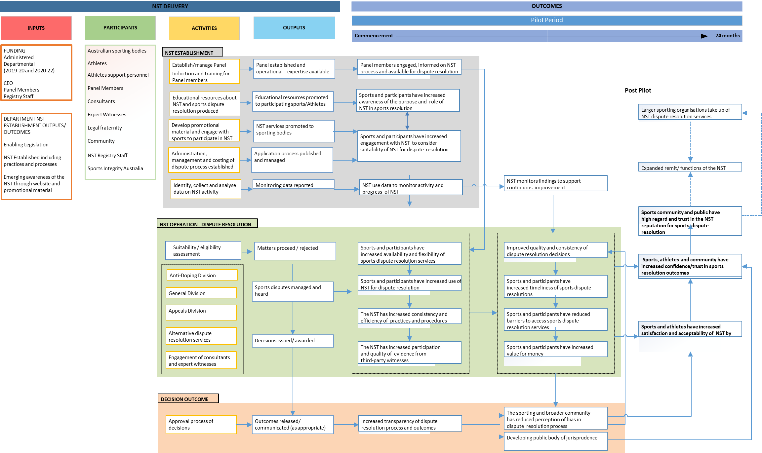

# Appendix C – Integrity in sport: Overview

## National Sports Tribunal

### Origins of the National Sports Tribunal

The Review of Australia’s Sports Integrity Arrangements (the Wood Review)[36] was commissioned in 2017 as part of the work being done by the Australian Government to develop the National Sport Plan.[37] The Wood Review articulated a growing global threat to the integrity of sport – and recognised that a fair, safe and strong sport sector free from corruption is inherently valuable to sports participants, sporting organisations and the 14 million Australians who participate in sport annually.

Among the range of sports integrity threats identified by the Wood Review was the lack of consistency in dispute resolution arrangements across the sports sector, and a need for a clear, consistent and cost-effective forum for all sports. The Review reported highly variable dispute resolution processes and responses across the sporting sector. While members of the Coalition of Major Professional and Participation Sports (COMPPS) employed internal tribunal and appeal mechanisms, constituted by experienced lawyers with expertise in sport and sport medicine, smaller sports were found unable to resource effective in-house responses. The review noted that fragmented approaches lead to inconsistency and unpredictability in outcomes for issues that require resolution for breaches of integrity policy.

The Wood Review made 52 recommendations including 12 relating to the establishment and remit of an NST. The NST would provide an expert, central hearing body that can supplement the work of sports’ current internal dispute resolution arrangements and provide a dispute resolution forum for the smaller sports.[38]

The Australian Government agreed to establish a national sports tribunal, and allocated funding for an initial two-year pilot to ‘establish demand, costs, effective operations, and types of cases it will deal with.[39]

The Wood Review also recommended the establishment of a National Sports Integrity Commission (to become Sport Integrity Australia, (SIA)) to cohesively draw together and develop existing sports integrity capabilities, knowledge, and expertise, and to nationally coordinate all elements of the sports integrity threat response including prevention, monitoring and detection, investigation and enforcement and policy and program delivery (including education, outreach and development).

**Legislative instruments**

In 2018, the Department of Health established the Sport Integrity Review Taskforce to lead the development of legislation, conduct stakeholder consultations and set up the NST Advisory Group. The Advisory Group was convened to guide the development of legislative and policy mechanisms to support the NST. The Group met periodically and was made up of representatives from NSOs, Sport Australia, the Australian Sports Anti-Doping Authority (ASADA) and the (then) Anti-Doping Rule Violation Panel, the Australian and New Zealand Sports Law Association, the legal profession, and academia. The Advisory Group still meets from time to time, with similar composition (noting that ASADA has now been subsumed within Sport Integrity Australia).

The *National Sports Tribunal Act 2019* (the NST Act) was passed on 19 September 2019 with the purpose of providing “an effective, efficient, independent, transparent and specialist tribunal for the fair hearing and resolution of sporting disputes” (s3, cl1). The NST Act provides the statutory foundation for the NST. Operational aspects of the NST are guided by the National Sports Tribunal Rule 2020 (the Rule), as amended in 2021. The Rule prescribes matters required or permitted by the NST Act outlining the kind of disputes for which an application can or cannot be made, how a matter is suspended or terminated alongside details related to application fees, how the overall cost can be determined, and management of protected information.[40]

Additional administrative and procedural arrangements are also outlined in the National Sports Tribunal Practice and Procedure Determination 2021 which outlines (inter alia): the process for providing and requiring information; management of witnesses; NST Member allocation processes; hearing conduct and directions on how decisions are published.[41]

The mandate of the NST is to provide sports, athletes and athlete support personnel with a cost-effective, independent forum for the timely determination of disputes through private arbitration, mediation, conciliation or case appraisal.[42]

#### Scope and structure of the NST

The NST is comprised of three divisions:

* **General:** relating to sports related disputes around the rules of the sport.
* **Anti-doping:** relating to matters of sport anti-doping rules.
* **Appeals:** to deal with appeals from the anti-doping division, the general division and decisions from sporting bodies/other sporting tribunals.

The Tribunal Rule specifies the type of matters that the NST can hear. These are summarised in Table 29 in the following.

Table Scope of each division of the NST

| General | Anti-doping | Appeals |
| --- | --- | --- |
| Any dispute that may arise under the rules of a sport, or an agreement between a person and a sport where the person is bound by the rules of the sport. | Any breach of the anti-doping rules of a sport. | Any appeal from the General or Anti-doping division or from a sporting body’s tribunal. |

Source: National Sports Tribunal (2020), <https://www.nationalsportstribunal.gov.au/about-us>

The NST can hear disputes that arise under the constituent documents of a sporting body. The Rule stipulates the kinds of disputes that cannot be heard, including ‘field of play’ and any disputes in which damages are sought. The types of disputes, methods and divisions are depicted in Figure 5.

Figure NST’s divisions, types of dispute and methods

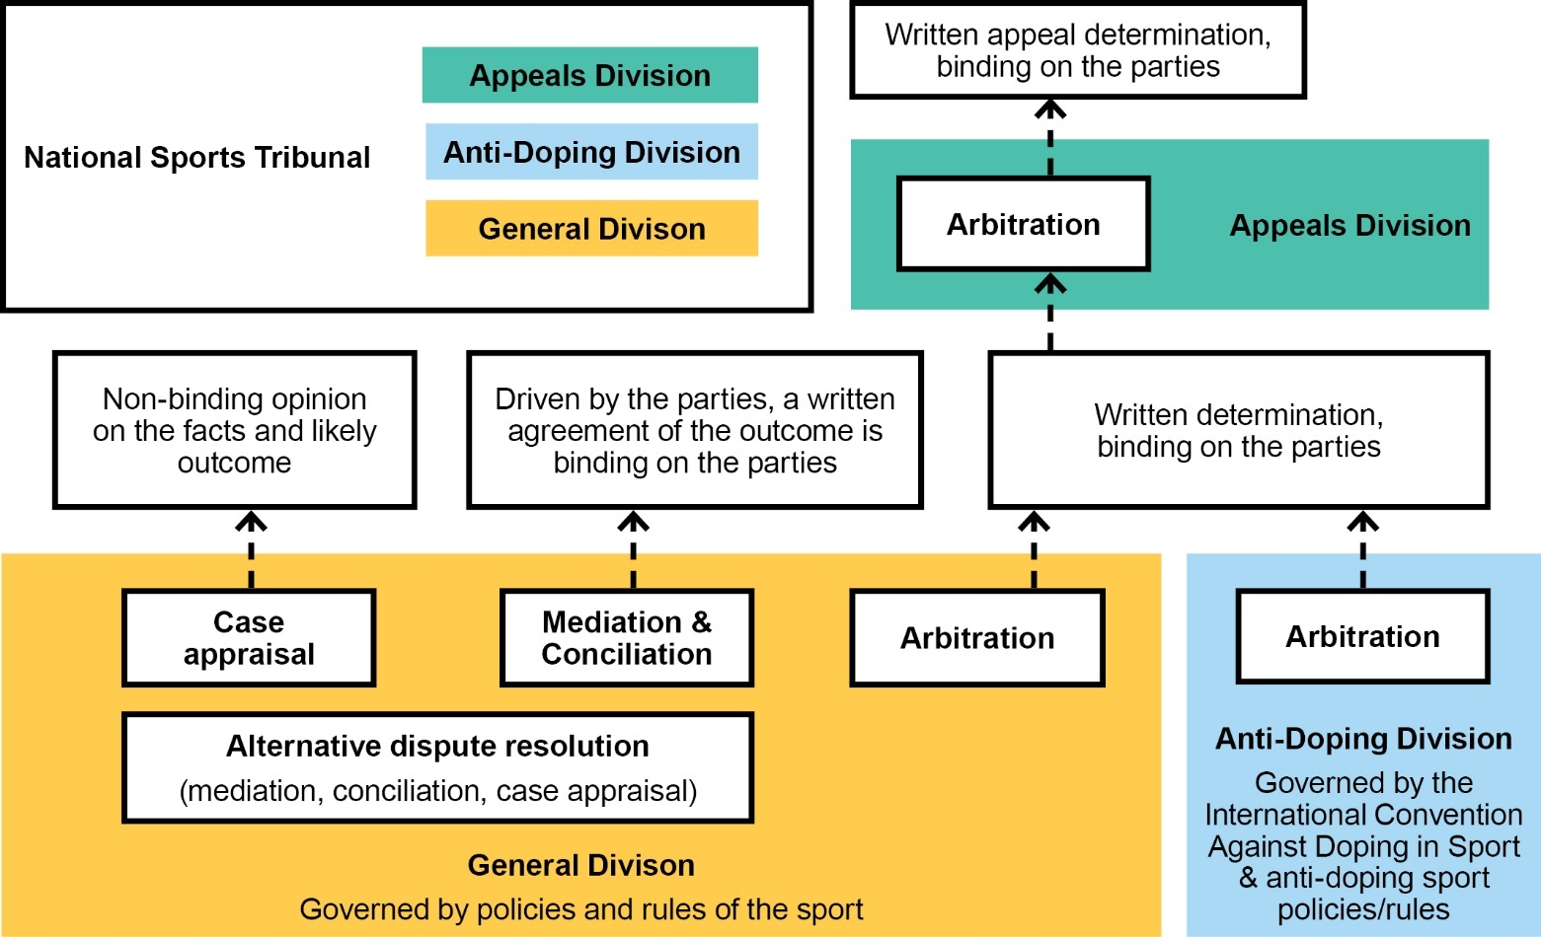

Source: Urbis

The NST publishes all determinations for anti-doping matters unless the party committing the violation is under the age of 18 or legally incapacitated, or the tribunal decides no violation had occurred. For other types of matters, the NST provides a summary of the determination on its website. The summary does not identify the parties involved. The CEO may also publish a full determination (with any necessary redactions) if the parties agree, or if the CEO and the NST Member(s) form the view that the case provides valuable rationale that will be useful for future disputes.

The NST (Practice and Procedure) Determination 2021 was registered on 22 July 2021 and brings into force the following changes:

* allows for a support person to accompany a party (distinct from a legal representative)
* amends the required contents of an application response or appeal brief
* confirms the CEO’s power to hold a preliminary conference
* clarifies the Tribunal decision-making process on whether a witness must give oral evidence under oath or affirmation
* adds a note on implied obligations of confidentiality
* clarifies the mediator, conciliator or case appraiser appointment process.

The NST Amendment Rule 2021 was registered on 17 September 2021 and formally gives effect to the extension of the NST pilot until 18 March 2023. The revised Rule makes a number of amendments to the operation of the NST. In particular, the revised Rule:

* provides the CEO with the power to consult with parties about a prospective application, and as to how the dispute will be resolved
* simplifies and clarifies the types of dispute in respect of which an application can be made to the General or Appeals Division of the NST
* removes employment and contractual matters from the list of types of dispute that cannot be dealt with in the General or Appeals Division
* reduces the application fee for mediation, conciliation, and case appraisal so that it is consistent with the application fee for arbitration
* allows the CEO of the NST to refund application fees where the Tribunal does not have jurisdiction.

#### Fees for service

The NST charges application and service fees based on the division and type of dispute resolution service. The costs comprise of both an application fee and a service charge that are assessed at a rate that covers most of the cost of providing the service.[43]

Estimated service fees are negotiated/discussed between the CEO (or delegate) and the parties at the Preliminary Conference (a meeting between the NST Registry and parties to confirm, pursuit and discuss NST process and next steps) and are finalised at the conclusion of a matter. This depends on the complexity of the case, estimated duration and number of NST Members appointed to resolve the matter. A summary of charges is outlined in Table 30. The NST’s overall financial model is not intended to be fully cost recoverable and seeks to cover variable costs (such as fees for Panel Members).

Table NST service fees: Anti-Doping Division

| Dispute resolution service | Application fee | Application to join existing arbitration | Service fee |
| --- | --- | --- | --- |
| Arbitration | $0 | $250 | None for most sports |

Source: National Sports Tribunal (2022), Cost of using NST service, <https://www.nationalsportstribunal.gov.au/dispute-resolution-services/cost-using-nst-services>

Table NST service fees: General Division

| Dispute resolution service | Application fee | Application to join existing arbitration | Service fee |
| --- | --- | --- | --- |
| Arbitration | $500 | $250 | Negotiated with CEO at Preliminary Conference and after finalisation (if required) |
| Mediation, conciliation or case appraisal | $500 | N/A | Negotiated with CEO at Preliminary Conference and after finalisation (if required) |
| Case appraisal – additional fee for written opinion | $500 | N/A | N/A |

Source: National Sports Tribunal (2022), Cost of using NST service, <https://www.nationalsportstribunal.gov.au/dispute-resolution-services/cost-using-nst-services>

Table NST service fees: Appeals Division

| Dispute resolution service | Application fee | Application to join existing arbitration | Service fee |
| --- | --- | --- | --- |
| Anti-doping | $1500 | $250 | $0 |
| Other appeals | $1500 | $250 | Negotiated with CEO at Preliminary Conference and after finalisation (if required) |

Source: National Sports Tribunal (2022), Cost of using NST service, <https://www.nationalsportstribunal.gov.au/dispute-resolution-services/cost-using-nst-services>

#### Resourcing to implement the NST and complaints handling

The NST is managed by a statutorily appointed CEO, supported by a Deputy CEO and Registry Staff (Department of Health and Aged Care employees) who have been incrementally on-boarded during the pilot period. Registry Staff provide case management and administrative support to parties, and to NST Members.

In December 2020, the Australian Government announced the NST will receive $3.6 million to extend its pilot program for a further 12 months, until 18 March 2023, following the significant disruptions from the COVID-19 pandemic.[44]

The Australian Government also announced funding of $10.1 million to SIA to introduce an independent complaints handling process at all levels, as set out in the NIF, noting that:

“this complaints handling process will be complemented by the independent dispute resolution mechanism provided by the NST…This investment in SIA and the NST underpins the implementation of this framework and continues the work towards a stronger and fairer sporting sector across Australia.”[45]

SIA commenced implementation of an independent and cost-effective assessment and treatment model for integrity complaints from 2021 onwards. The funding will also support expanded SIA education and awareness work, policy development, co-ordination, and compliance programs.

#### Enlivening the NST’s jurisdiction

The NST is an arbitral tribunal. Its jurisdiction (for arbitration and for other services like mediation and conciliation) is enlivened by agreement between the parties that the NST will be the entity that resolves a dispute between them.

The NST’s jurisdiction is most effective when it is ‘embedded’ in the rules of a sport – where, for anti-doping or disciplinary disputes for instance, the relevant rules, policy or by-law of a sport specifically provides that disputes will be managed by the NST. In these circumstances, the ‘agreement’ of the parties required to enliven the NST’s jurisdiction is the membership agreement, or contract for services, that stipulates members’ (or contractors’) obligations to comply by relevant rules/by-laws of a sport.

Alternatively, and importantly in the establishment and early operational phase, where a sport has not yet managed to ‘embed’ the NST’s jurisdiction in their rules, the NST can also deal with disputes where all the parties to the dispute specifically agree. While this way of enlivening the NST's jurisdiction is important – particularly in the early stages – it is not ideal as it requires parties to agree on utilising the NST after the dispute has arisen.

The NST is available to assist sports who wish to amend their rules to include the use of the NST.

Sporting organisations below the national level (for example, a state association) can only use the NST if the dispute arises under the rules of the national-level sporting body, and the national-level sporting body agrees to refer the dispute to NST and to be a party to the dispute.

# Appendix D – Economic Analysis and case studies

## NST case study – Badminton Australia

### Context

**About the sport:** Badminton Australia (BA) is the national sports organisation for badminton in Australia recognised by the Australian Sports Commission, Australian Olympic Committee, Commonwealth Games Australia and Paralympics Australia. It has responsibility for the management and development of the sport domestically, and manages relations with the global governing body, the Badminton World Federation.

**Size of sport:** BA has eight staff, and nearly all governance activities are handled by the CEO. BA has reported they have 300 clubs and close to 20,000 members and full active participants, and there are 311,058 badminton participants nationally.

**Implementing NIF:** The BA board has agreed to adopt the NIF and implement NST template policies.

**Integrity issues:** BA indicated that around two or three matters raised with them recently may eventually be heard by the NST.

### Pre-NST processes

**Internal processes:** BA largely relies upon the dispute resolution processes laid out in its Member Protection Policy and its constitution. Disputes tend to be managed at the level they occur, with more serious matters elevated to BA. BA staff emphasised that the workforce at the club level, in particular, are not well-equipped to handle complaints, and this can result in the complaint being elevated to the national level as the complainant feels their matter has not been handled effectively. Criminal matters are referred directly to police.

BA have a legal advisor that is paid a retainer and additional legal fees if extra time is needed.

BA estimates that managing complaints occupies 2.5% of time for two senior staff.

**Use of volunteers:** At a grass roots level, complaints are generally managed by volunteers at the club or State level. Victoria and Western Australia have paid staff whereas all other States are operated by volunteers.

### Current NST processes

**Use of the NST:** BA has recently used the NST for a selection appeal related to the Commonwealth Games.

**Internal processes:** BA has encouraged members to complete Sport Integrity Australia training. BA estimates that as awareness and knowledge of complaints processes increases, it is likely there will be an increase in complaints.

**Use of volunteers:** BA indicated that where matters are referred to the NST, there will be less reliance on volunteers.

**Costs and benefits:** Internal capacity building of complaints handling processes is expected to be significant, and is time and resource-intensive.

Without additional funding for a staff member to manage complaints, BA expect that their workload may increase to unmanageable levels as they implement new policies while along educating their members and managing complaints.

Time and resource pressures from increased complaints can arise from assessing complaints, such as removing false or vexatious complaints, and managing complaints, which is often a very complex process. Existing external processes to manage this, such as appointing an independent investigator, can avoid perceptions of conflict of interest but is very costly – (ranging from $5,000 to $25,000), which is unaffordable for a small sport.

Internal processes may have lower financial costs, such as appointing a tribunal comprised of volunteers with legal backgrounds, but have historically produced poorer outcomes in badminton, and create a substantial opportunity cost with respect to time and effort to manage this process.

If matters are heard by the NST, BA expect there will still be similar time commitments due to the communication and liaison between complainants and the NST. There will also still be time preparing documentation for the NST to establish the matter and recommendations for penalties, if applicable. There is also the risk that not all parties will agree to have the matter heard in the NST, and so BA would continue to have to form an internal tribunal.

BA anticipate the NST process is more independent and will produce more consistent outcomes than other internal processes.

## NST case study – Equestrian Australia

### Context

**About the sport:** Equestrian Australia (EA) is the peak body for the administration of Equestrian Sport in Australia.

**Size of sport:** EA have 17 operational staff, 11 high performance staff and two volunteers.

**Implementing NIF:** EA are gradually implementing the NIF but still intentionally have many policies that sit outside the NIF. They are accessing the NST through mutual agreement by parties, rather than having the NST written into their internal policies and processes.

**Integrity issues:** Historically, EA has had some disputes related to Member Protection, Code of Conduct and Social Media Policy. In 2020, EA held limited human and financial resources, while its legal frameworks and processes were deemed outdated and insufficient. NST staff begun working with the EA in May 2020 providing EA with administrative and legal support to successfully navigate through the NST tribunal process.

### Pre-NST processes

**Internal processes:** EA conducted tribunal hearings, investigations and mediation to resolve disputes. EA indicated that not all policies clearly delineated whether matters should be heard at a club, state or national level – this was determined on an ad-hoc basis depending on the matter. In the case of mediation, EA would engage their own mediators to resolve the dispute. This involved staff time to manage the complaint and the dispute resolution process, which could continue for years, as well as incurring investigation and legal fees for the sport.

At a similar time to the introduction of the NST, EA employed a staff member whose role involved aligning internal processes, including integrity and complaints. The majority of complaints are now handled at the national level, in recognition that club or state-level bodies rarely have the knowledge or experience to manage dispute resolution.

**Use of volunteers:** Volunteer Member Protection Information Officers (MPIO’s) were used to support the complaints process. MPIOs were trained at a club and state level, to assist with advising members about the complaints process.

### Current NST processes

**Use of the NST:** To date, EA have referred nine matters to the NST. Three matters were heard by the NST’s General Division. Two matters were resolved through arbitration and one matter was resolved through case appraisal.

**Internal processes:** EA has indicated that it will initially assess complaints internally, but the NST will be a priority point of referral if the complaint falls within the NST’s jurisdiction.

**Use of volunteers:** EA will rely less on volunteers in the complaints process as they are not part of the processes within the NIF. However they may be used as part of EA policy.

**Costs and benefits:** EA staff identified the administrative work and management of complaints is expected to be reduced for EA under the NST, as the administration of complaints would transfer to the NST. EA identified the possibility that the NST providing a fair and independent outcome may reduce the overall number of complaints, with complainants only submitting one complaint that is heard to their satisfaction, rather than lodging multiple complaints until they feel they have been heard which have to be managed by the sport.

Further, EA indicated that disputes or integrity issues, which were handled in-house, had historically been poorly managed by the organisation. This had negative implications for the reputation and credibility of the sport. While the NST has not been fully adopted by EA, the NST has provided advice and resources as well as enabled a more structured process for complainants and respondents. The NST also offers a wider range of dispute resolution mechanisms, as EA previously lacked the capacity to conduct conciliation or arbitration which can be accessed through the NST.

EA was unable to pinpoint the time saved or workload reduction the NST provided, but stressed the impact of complaints on staff focus and wellbeing is likely to be reduced when disputes are referred to the NST.

## NST case study – Gymnastics Australia

### Context

**About the sport:** Gymnastics Australia (GA) is the national governing body for gymnastics in Australia.

**Size of sport:** GA has approximately 45 staff engaged in the delivery and management of gymnastics in Australia. In 2021, GA had 226,115 registered athletes and over 800,000 Australians engaged in the sport of gymnastics.

**Implementing NIF:** On 4 April 2021, GA adopted the National Integrity Framework and its associated policies.

**Integrity issues:** Historically, the sport of gymnastics has experienced integrity issues predominately around both member protection and child safety issues. Following the global release of ‘Athlete A’ in 2020, a Netflix documentary highlighting instances of historical child sexual abuse of elite gymnasts in the United States, several Australian athletes joined other athletes around the world in expressing their negative experiences in the sport.

### Pre-NST processes

**Internal processes:** Disputes in gymnastics were generally dealt with at the level at which they occur (i.e. club or state level) unless it needs to be referred to law enforcement. Accordingly, GA does not hear many complaints relative to the total complaints in the sport, which mostly occur at the club and state levels.

GA had two options for dispute resolution where it would have to make a finding: firstly, there was CEO discretion to impose sanctions, which has rarely been used. Secondly, GA could appoint an internal tribunal consisting of a barrister or another person with legal experience, sports expertise or knowledge of the specific discipline within gymnastics to which the dispute related to.

With respect to instances of child maltreatment, dispute resolution processes would have been dealt with under the member protection policy or the standalone child protection policy.

**Use of volunteers:** GA does not have great visibility over club-level dispute resolution, however, staff noted this process is led by volunteers with limited time and experience. This means it is likely complaints are managed with varying effectiveness and efficiency.

### Current NST processes

**Use of the NST:** GA has referred five matters to the NST, four of which were heard. Two of these matters were general disciplinary matters, one of which was resolved through arbitration and the other which was intended to be resolved through arbitration but was withdrawn. One was a general matter that was resolved through conciliation, and one was a general bullying/harassment matter intended for mediation that was terminated. Gymnastics Australia also worked with the NST to develop a Supplementary Complaints process while an independent review of the sport was undertaken by the Australian Human Rights Commission.

**Internal processes:** Separate from the NST, GA identified a governance issue around managing child sexual abuse that drove policy change. Disputes were previously heard at the level they originated, but GA has since centralised its policies and strengthened the communities understanding regarding this issue. Now, every complaint is referred to GA and is assessed and managed at the national level. This has seen an estimated tenfold increase in caseload under management by GA, and the hiring of three new staff.

**Use of volunteers:** Internal tribunals are generally composed on the basis that individuals provide the work pro bono, making a direct cost comparison difficult. However, GA acknowledges the dispute resolution outcome provided by the NST is superior as it is independent, while the internal tribunal will always be clouded by perceptions of bias.

**Costs and benefits:** Fourteen of GA’s 103 complaints between March 2021 and March 2022 were NST-eligible. Of these, four respondents exercised their right to raise the complaint with the NST, while the remainder were unsubstantiated.

GA has indicated the publicly available findings of the NST have improved transparency in the sport and have been well-received by members. GA is optimistic that greater transparency and accountability within the sport will eventually translate into improved participation numbers. This is largely due to an increase community confidence.

GA identified that policy re-development following the Athlete A documentary would likely have needed to be developed with legal counsel, potentially costing in the tens of thousands of dollars. Assistance with policy development and the templates provided by the NST have accelerated when these policies can be affected within gymnastics, providing a community benefit sooner than anticipated.

## NST case study – Tennis Australia

### Context

**About the sport:** Tennis Australia (TA) is the governing body for tennis in Australia. TA’s main functions are to promote the sport and participation, player development, stage local and international events relating to tennis and, investment in tennis facilities nationwide.

**Size of sport:** It is estimated TA have over 500 employees across the country. Tennis had 1.53 million participants in the 12 months to June 2021.

**Implementing NIF:** TA are not implementing the NIF.

**Integrity issues:** TA have had an internal integrity function in operation for a considerable time. TA did not indicate they had managed or were managing any major integrity issues, but estimated they had 5 or 6 complaints under management that could potentially be heard by the NST.

### Pre-NST processes

**Internal processes:** TA have national, sport-wide policies that establish a disciplinary framework and a centralised complaint handling process. Matters were heard by an independent tribunal (for member protection, child safety, anti-doping and anti-corruption matters) comprised of volunteers external to TA. These tribunals were convened on an ad hoc basis. A disciplinary review panel comprised of internal staff hears on-court behavioural issues. This panel meets every week. If there was an appeal for these matters this was either heard through TA or in the Court of Arbitration for Sport.

**Use of volunteers:** TA have an Integrity and Compliance team comprised of five full-time employees, with administrative support as required. Along with the Director of this team, TA have two experienced senior investigators, a lawyer, and an educator.

The disciplinary review panel is staffed by volunteers that are external to TA.

### Current NST processes

**Use of the NST:** TA have had six matters referred to the NST. Three enquiries are still active, and one case has been heard by the NST. This was a general bullying/harassment matter, resolved through mediation.

Internal processes: Since the introduction of the NST, TA’s internal policies and processes have continued to be the preferred mechanism to resolve all disputes. However, if this initial attempt is unsuccessful, TA refer all eligible matters to the NST. TA concluded the NST was most effective for the sport as an important second pillar that offered complementary services to what TA already have in place internally.

Since the introduction of the NST there have been changes to workload for the Integrity and Compliance team but these have been due to internal restructuring, rather than related to the NST. The team is experiencing an increased workflow, but this is not specifically related to integrity caseload. It is more reflective of the team being more proactive in the integrity space (ie education, compliance, etc).

**Use of volunteers:** TA indicated their tribunals and disciplinary review panel sessions tended to be less formal than what would be expected of an NST hearing. TA indicated having the NST was helpful in the event that volunteers for tribunals could not be found or for matters that were particularly acrimonious. However, many of the matters heard by TA relate to on-court issues, which are not within the NST’s remit.

TA recognise the NST as being an important backstop in the event volunteers were not available to staff tribunals. In the instance that TA could not find volunteers, the NST would represent far better value for money than to establish a disciplinary tribunal made up of paid tribunal members.

Costs and benefits: TA noted the role of the NST was less prominent in their sport, compared to smaller sports. TA identified the main benefit of the NST as its independence. TA go to great lengths to ensure its internal panels are independent and well-staffed with volunteers that have suitable experience in law, psychology and tennis. But even TA involvement in organising the panel can compromise its independence in the eyes of the parties, particularly so for highly contested matters. Taking the matter to the NST, by way of being an independent body, removes the appearance of a conflict of interest.

TA identified that there could be considerable resources dedicated to managing parties disgruntled by the lack of independence in internal proceedings. TA identified these matters, and matters they were unable to resolve themselves, were often the most serious, complex, and time-consuming. The ability to refer such matters onto the NST removes this burden from staff, enabling them to focus on more proactive activities associated with administering the sport, such as education. While some time is still spent managing NST matters, it was estimated the presence of the NST had saved approximately 10 to 12 hours per week across the team from protracted disputes.

TA also identified a reputational benefit to the sport from independent dispute resolution, and that it may assist in retaining direct financial support and sponsorship.

## NST case study – Motorcycling Australia

### Context

**About the sport:** Motorcycling Australia (MA) is the governing body of motorcycle sport in Australia. MA’s core business is to develop and apply the rules and regulations of motorcycle sport in Australia and represent its members. MA is affiliated with the international governing body, Fédération Internationale de Motorcyclisme (FIM).

**Size of sport:** MA has less than 50 employees nationwide and approximately 25,000 members. As a federated sporting body, it has 60 directors across the federation. MA sanctions around 5,500 events per year, and motorcycle sport has an estimated 200,000 participants each year.

**Implementing NIF:** MA were an early adopter of the NIF. A centralised complaints system is in place at the national level, but state bodies have been slower to align their processes so the integrity framework can be consistent through the whole federation.

**Integrity issues:** MA has faced reputational issues relating to the governance of motorcycling and conflicts of interest, particularly at a state level where the interests of a board member’s club may gain precedence over the interests of the sport as a whole. MA’s focus on transparency has driven its adoption of the NIF, and its recognition of the NST’s jurisdiction and its role in bringing dispute resolution out of into the open.

MA estimate that around 20 disputes are brought to the national level annually, although they do not have oversight of matters that close at the state level with many matters not moving beyond this point. There are potentially even more matters that are resolved at club level. Many of these matters are not within the NST’s remit. Pre-NST processes

### Pre-NST processes

**Internal processes:** MA appointed an internal tribunal to resolve disputes at a national level, which was convened by an experienced barrister based in Victoria. This judicial member (either sitting alone or with one or more ‘experts’) would hear appeals from the decisions of state bodies, appeals under the MA General Competition Rules (GCRs), and complaints made directly to MA under the MA constitution. One dispute can take up a significant amount of time for MA. Documenting and making an initial assessment of an application, and preparing the judicial brief might take up between 2 to 3 hours of the Legal & Insurance Manager’s time.

MA identified that members of motorcycle sport clubs often fulfil multiple duties within the sport at different levels, providing the opportunity for conflicts of interest. For example, it is plausible in motorcycling that one individual may have a role coordinating an event and also sit on the State controlling body. If a dispute arises from that event, that individual may also hear the appeal at a State level, creating a conflict.

**Use of volunteers:** State boards are comprised entirely of volunteers, therefore their dispute or disciplinary determinations are the determinations of volunteers. In many cases these were the same people volunteering as key officials (e.g. clerk of course or steward) at events and would therefore be responsible for administering the rules of the sport at those events, including taking disciplinary action against members or hearing protests therefrom. These would be the same people sitting on boards to which an appeal from a steward’s protest determination was made.

The MA judicial member acted on (a modest) retainer.

### Current NST processes

**Use of the NST:** MA are using the NST and were the first NSO to bring a matter to the NST. They have referred five matters to the NST, two of which were heard. Both were general disciplinary matters. One case was resolved through arbitration, the other through conciliation.

**Internal processes:** Under the new NIF (which MA has adopted and is implementing with effect from 1 June 2022), complaints under a NIF policy are made directly to Sport Integrity Australia. Non-NIF disputes and complaints (such as appeals under MA’s GCRs or under the MA Social Media Policy) are made to MA’s Complaints Manager who, if the matter is an NST-eligible matter (as defined in the MA non-NIF Complaints Resolution Policy), refer the matter to the NST. MA has parallel processes in place to deal with non-NST eligible matters, including a re-constituted tribunal panel comprising expert legal personnel from across the country. The MA tribunal will act on a pro-bono basis and will either sit alone or with one or more experts.

**Use of volunteers:** The use of volunteers under the current processes involves far less use of volunteers, and completely removes the use of volunteers with a connection to any club or state body.

**Costs and benefits:** MA identified the NST has streamlined the complaint application process and improved its transparency, with the NST providing greater authority to NSO complaint assessment processes. For example, the NST can offer an opinion about whether the matter is NST-eligible, giving the NSO reasons to provide to the complainant about why their complaint was advanced or not.

One MA staff member estimated a matter that went to arbitration in the NST would cost them approximately 30 to 40 hours, and that this was similar to pre-NST internal processes. MA estimated the time investment to satisfy the NST may even be greater than the time invested should the matter be heard through internal processes, but expressed that this was appropriate and acceptable given the improved transparency and independence provided by the NST. This also has reputational benefits for the sport, which are anticipated to become more valuable as sponsorship grows.

MA identified the requirement for NSOs to be party to all matters regarding their sport as being burdensome. MA staff indicated they had invested four or five hours into one matter being heard by the NST, where they were not party to the dispute but were involved in their capacity as the NSO. This time included interim hearings, directions hearings, and preparing and sharing documents.

MA expressed general satisfaction with the timeliness of NST processes.

## NST case study – Paddle Australia

### Context

**About the sport:** Paddle Australia (PA) is the peak sporting body for paddling and paddle sports in Australia, such as canoeing and kayaking.

**Size of sport:** It is estimated PA have 10 staff in their national office, and many more coaches and high performance staff. PA estimate there are over 300,000 active paddlers around Australia.

**Implementing NIF:** PA is currently working to implement the NIF. Currently educating clubs around the NIF and its implications, including dispute resolution processes offered by the NST.

**Integrity issues:** PA has not had any large-scale integrity issues, but has had isolated disputes. These tend to be around selection or people involved with the sport behaving poorly, and the latter has raised questions over whether these constitute sporting issues.

### Pre-NST processes

**Internal processes:** PA would generally establish a tribunal comprised of volunteers to handle disputes in-house.

**Use of volunteers:** Internal dispute resolution was handled almost exclusively by volunteers. Independence was identified as a challenge for smaller clubs and it was difficult to find volunteers independent of all parties. Another issue was also competency, as volunteers tended not to have expertise in dispute resolution. Finding appropriate volunteers with regards to competency and independence was even difficult at a national level for PA. Matters could drag on for quite some time, even for multiple years, as their hearing was subject to volunteer availability or would have to be dealt with at a higher level (i.e. at a state or national level within PA). On average, PA estimated that each volunteer involved in disputes contributed 8 to 10 full days to resolve it.

### Current NST processes

**Use of the NST:** To date, PA has referred eight matters to the NST and six matters been heard. Two cases have been resolved (both mediation) and four cases were withdrawn (all arbitration). Both resolved cases were heard in the NST’s General Division - one resolved case was a bullying/harassment matter, and one case was an eligibility and/or selection dispute.

**Internal processes/use of volunteers:** PA still deal with many disputes at a club or state level, which would likely involve volunteers, but moving forward will try and refer matters onto the NST at the earliest possible opportunity. This is more likely for matters at the national level.

**Costs and benefits:** Under the pre-NST system, the number of hours provided by volunteers towards dispute resolution was significant. Further, volunteer availability impacted the timeliness of dispute resolution.

While comprehensive data on the costs of pre-NST processes are not available, PA believe the cost of lodgement and having the dispute heard by the NST provide a net benefit to the sport. PA staff noted that the administrative effort and time involved in operating an internal process, is relatively similar to using the NST, however, the outcome from the NST is superior in terms of the quality of the process, outcome and its independence.

There is a significant opportunity cost for NSO staff who are managing disputes, as it becomes their primary focus and detracts from their core functions of administering the sport. The NST process is considered by PA to be much faster than an internal, volunteer-led approach, reducing the amount of staff time on resolving disputes. Longer-term, PA identified the volunteer-led approach may be unsustainable given the potential unwillingness of volunteers to resolve more complex disputes and face potential liability concerns.

While it is difficult to quantify, PA noted there were significant benefits to sport associated with the independence and transparency of the NST. There would also be efficiency savings associated with the NST specialising in sport dispute resolution, as opposed to PA attempting to establish this process themselves.

Paddle Australia also identified a significant potential benefit due to the improved dispute resolution outcomes provided by the NST as opposed to in-house processes. For external stakeholders, such as current or potential sponsor expectations, the NST provides credibility that disputes are in line with rigorous integrity standards. Within the sport, the polarising nature of some disputes can mean NSOs are in conflict with their Members or those within the sport are in disagreement with damaging implications for the sport.

# Appendix E – Survey results

## NST users survey results

This survey was conducted in November 2021 and 27 NST users participated. Of these, four users’ (15%) matter did not proceed past the application phase and 23 users (85 per cent) had their matters dealt with by the NST. As not every NST user responded to all questions, the response rates change per question.

### NST users

Of the 27 users, 11 had their matters heard in 2020 and 12 had their matters heard in 2021. The role of the users and the type of matters heard by the NST are displayed in the figures below.

Over half (52%), had an individual role in the NST matter, followed by 31% with a sporting body role and 17% with a legal representative role.

Figure Role in NST matter (n=23)

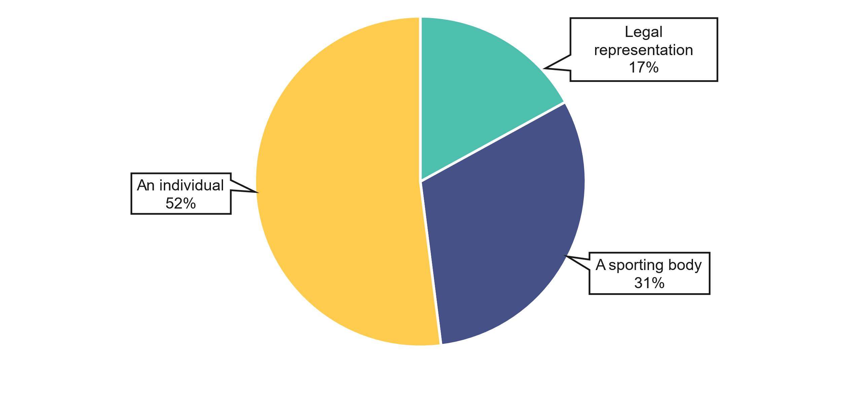

Note: ‘an individual’ also includes respondents who were there to support the person involved.

Just under half (48%), of matters were in the general division and 13% each were in anti-doping and appeals. A quarter did not know what division their matter was in.

Figure Division of matter (n=23)

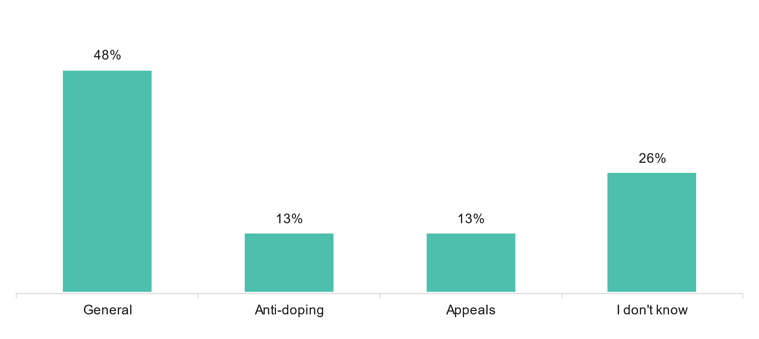

### Demographics

Thirteen users reported their gender, five identified as female, four identified as male, and four preferred not to say. All users reported that they spoke English at home. Only two users reported that they were Aboriginal or Torres Strait Islander. The age, location, and annual income levels of the users are reported in the figures below.

Most respondents were aged 45 years and over (60%), 33% were 44 years and younger and 7% preferred not to say.

Figure Age of respondents (n=15)

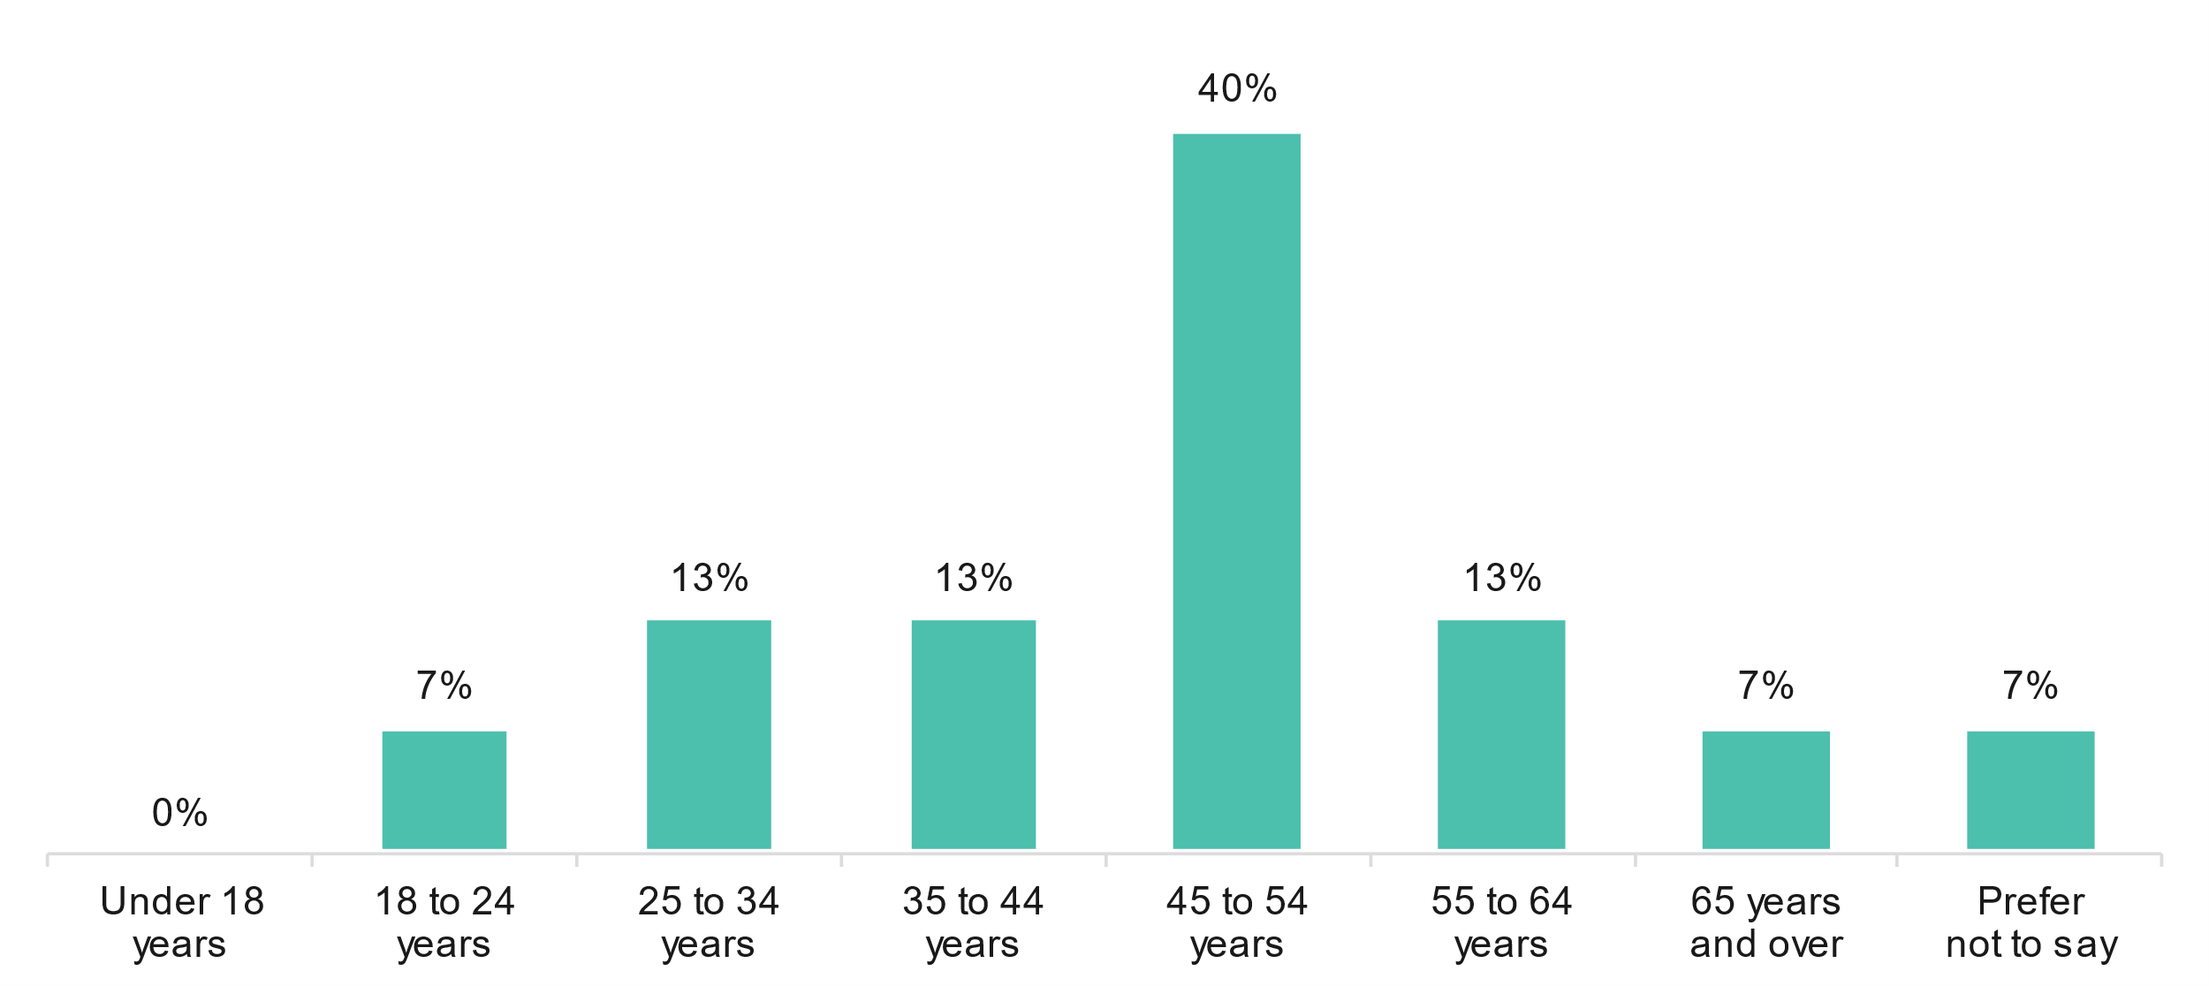

Nearly three-quarters (64%) were located in major cities of Australia, followed by inner and outer regional Australia (21%).

Figure Location of respondents (n=14)

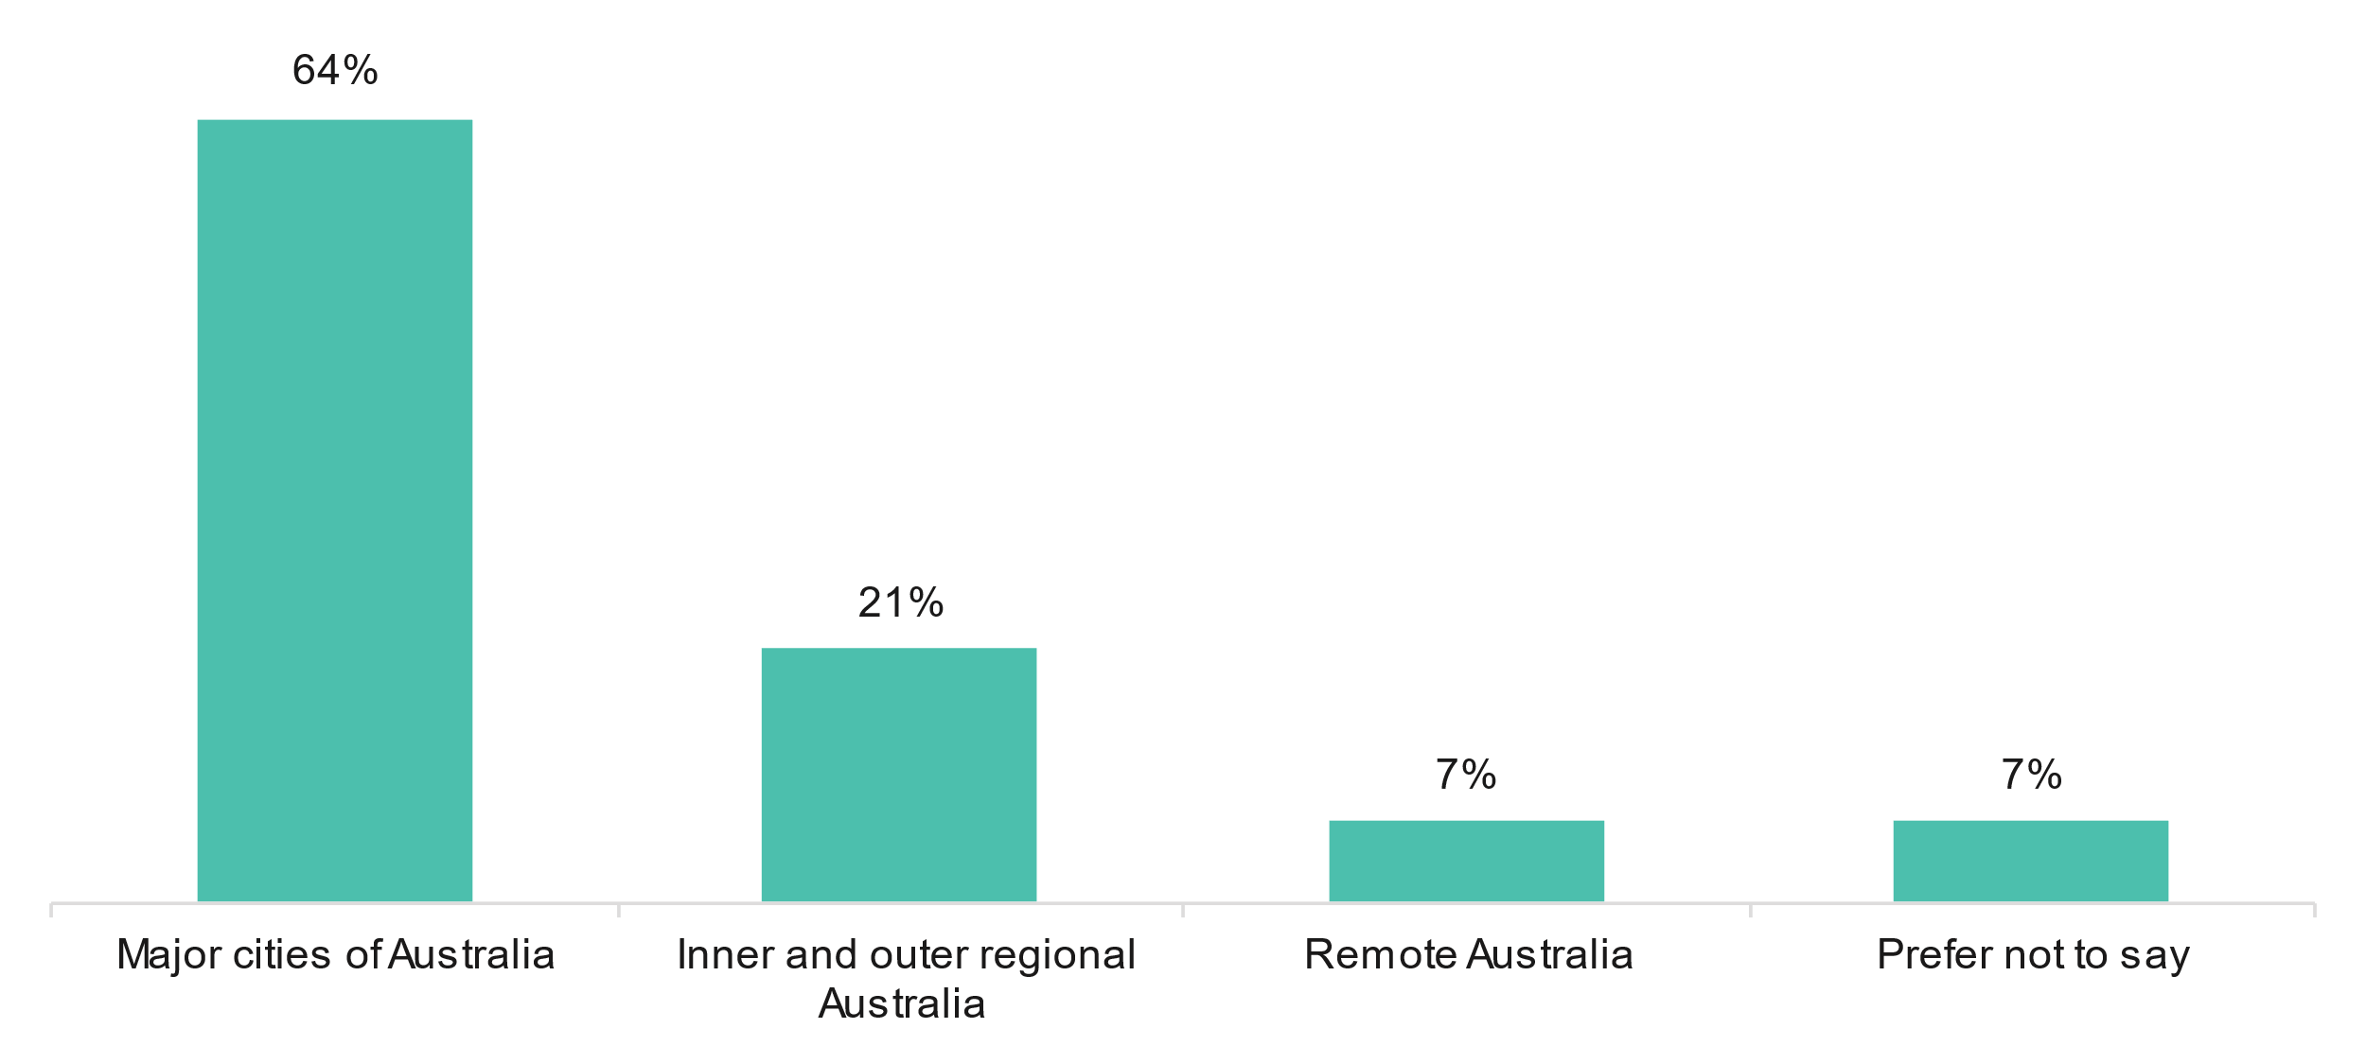

Four in ten (43%) of respondents chose not to report their income.

Figure Annual household income (n=14)

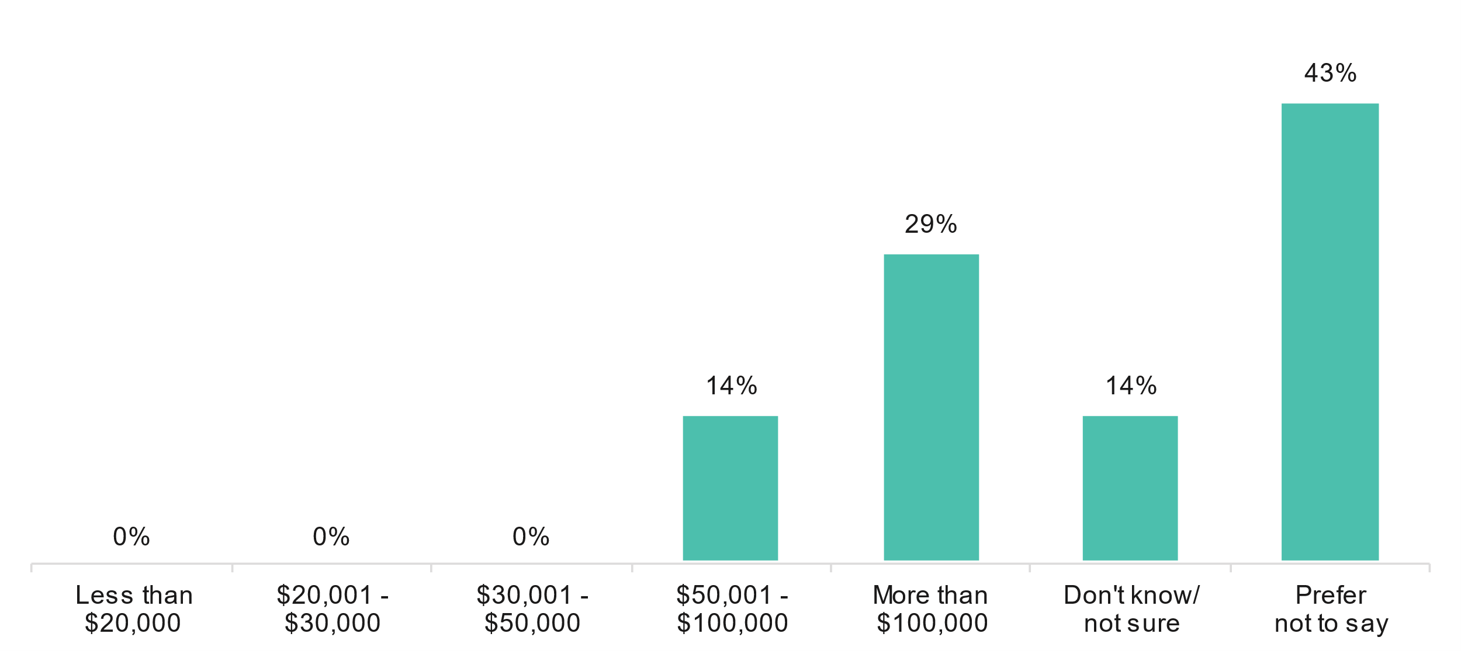

### Experiences of respondents who matter did not proceed past application

The matters for four users did not proceed though the NST. This was due to: the NST finding the matter was not eligible (n=1), the process was too long or inconvenient (n=1), and the parties involved in the matter decided not to proceed with the NST (n=2).

Despite not proceeding, most of these users reported that they were satisfied with their overall experience with the NST.[46] Their feedback regarding the registry staff is displayed below.

Figure Feedback on NST registry staff (n=4)

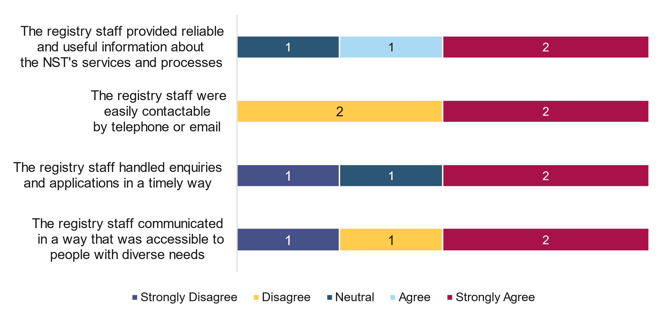

### Experiences of respondents whose matter went to the NST

Figure 12 in the following shows the feedback from the 23 users whose matter went to the NST. This feedback relates to the cost associated with NST and the application process as well as experiences with NST register staff and during the hearing.

Responses are ordered by total agree (‘strongly agree’ and ‘agree’ responses summed).

NST users were most positive about the information registry staff provided (65% total agree), followed by NST member appointed were independent experts (56% total agree) and the conduct of the hearing was fair (57% total agree).

Figure Feedback on NST components (n=23)

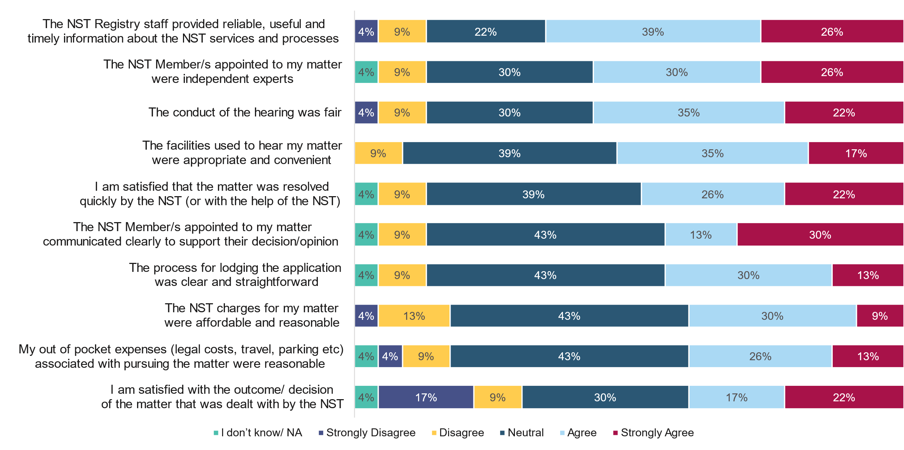

Respondents who used the NST were asked to detail who paid the charges and costs of their matter. Eight respondents provided an answer. Four respondents indicated the NSO or sporting body bore the costs, another respondent indicated there were no costs for the NST at the time, and one respondent indicated they were shared between the parties. One respondent indicated the applicant bore the cost of the matter (unknown if this was an individual or a sporting body).

One respondent indicated they bore the costs of their matter as an individual. This respondent described their experience as “totally unfair” given they were the victim in this matter. The respondent explains: “I gave permission for the sporting body to take a member protection complaint to the NST. They told me it would not cost be anything. Instead the sporting body were not required to have any legal representation and I had to have a personal lawyer who I paid for who effectively represented the sporting body -totally unfair as I was the victim” (sic).

### Reflections on NST operations

Respondents were asked to reflect on what was working well about the operation of the NST. Nine respondents provided a comment about what was working well. Seven respondents provided positive comments about the NST. Of these comments, respondents identified that the following aspects of the NST were working well:

* The NST’s independence (n=4)
* The communication from the NST, particularly about NST processes (n=3)
* NST staff being responsive and skilled (n=2)
* The NST application process (n=1)
* Flexibility in meeting people’s schedules, including meeting after traditional work hours (n=1)

Two respondents provided negative comments about the NST. One comment simply stated “not much” in response, while the other comment described the NST as “next to useless” due to the NST’s perceived inability to challenge Sport Integrity Australia, and that it protected Sport Australia from scrutiny.

Respondents were also asked about what could be improved about the operation of the NST. Eight respondents provided a suggestion for how the NST could be improved. Of these comments, respondents identified the following aspects of the NST could be improved:

* Three respondents perceived the NST as having a lack of follow-through for some matters. This was particularly with regards to not being able to compel parties to see the matter through, meaning parties can withdraw. Respondents identified this resulted in sunk costs for parties, a lack of resolution, or the matter returning to the sporting body for resolution
* A perception the NST treats smaller, grassroots issues as unimportant (n=1)
* NST processes meaning the victim in a matter needs legal representation, but the sporting body does not (n=1)
* The NST setting a poor precedent (n=1). This respondent referenced a specific anti-doping matter decided on by the NST (that they were not a party to), noting “it has made the doping regulations a joke as all you have to do now is use the NST case as an example to get off a doping charge”
* More guidance through the NST process for users (n=1). This respondent reported it had been their first experience with a particular method of dispute resolution, and acted with the expectation that all matters would be discussed in the hearing. This meant they did not respond to correspondence from the other party prior to the hearing so as not to confuse matters in the hearing, and were subsequently painted as unresponsive
* More flexibility for the NST to deal with matters in the most appropriate way given the circumstances (n=1)
* One respondent suggested the NST in its current form be abolished, and replaced it with a “tribunal, ombudsman or ICAC type entity which has teeth and can tackle big issues”

## Sport sector survey results

The survey was sent to 299 sport sector representatives in March 2022 and among those 16 emails bounced. In total, 66 respondents confirmed that they are aware of the NST and participated in the survey. Based on this, the response rate is 23%.

The response rates varies per question, as not all respondents provided an answer to all questions. Where appropriate, responses are ordered by total agree or likely responses (‘strongly agree’/ “very likely; and ‘agree’ /’likely’ responses summed).

The following sections outline sport sector respondent characteristics, sport sector adoption of the NST and NIF, experience of the NST, NST operations, likelihood to recommend the NST, future use, NST comparison to other services and other comments.

### Sport sector respondents

How respondents heard about the NST, the national sporting body they were associated with, and their role within the sporting body are detailed in the following.

Table Number of respondents associating with each sporting bodies

| Sporting body | Number of respondents |
| --- | --- |
| National Sporting Organisations (non-COMPPS) | 57 |
| State or Territory Institute of Sports | 3 |
| NSOs among the Coalition of Major Professional and Participation Sports | 2 |
| Other sports organisations* | 4 |
| **Total** | **66** |

* Note: the n=4 other sports organisations were comprised of the Australian Sporting Alliance for People with Disability, the National Institute Network, Commonwealth Games Australia, and the Women’s Professional Golfers’ Association (WPGA) Tour.

Within their sporting body, two in four respondents (40%) were the CEO, 22% were the Integrity Manager and 9% were the Legal Counsel. Other roles (29%) included operations, secretary, executive, General Manager and board member.

Figure Role within sporting body (n=66)

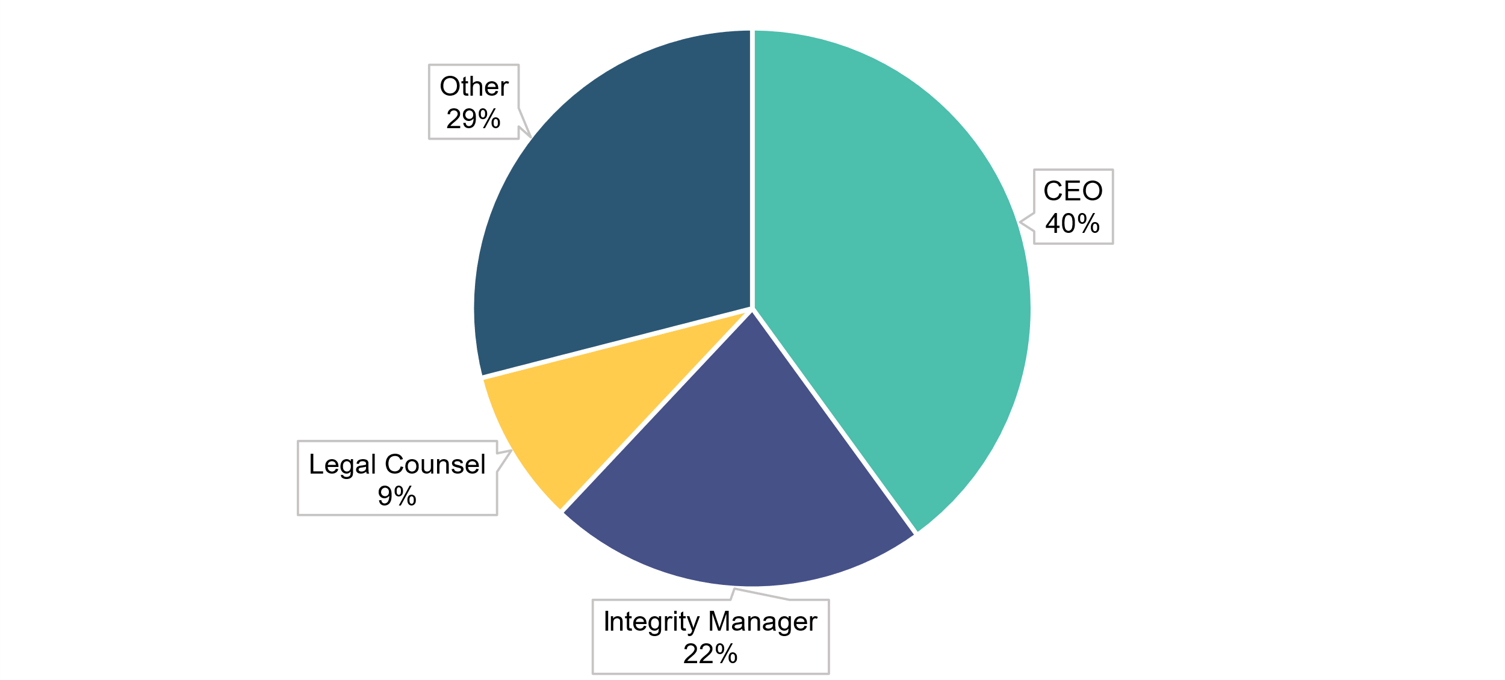

Most respondents (76%), heard about the NST from the NST directly, 20% heard about the NST from another sporting body and 6% from a legal representative. Other sources (21%) included Government, Sport Australia, Sport Integrity Australia, NIF and through an advisory group.

Figure How respondents heard about the NST (n=66, multiple responses)

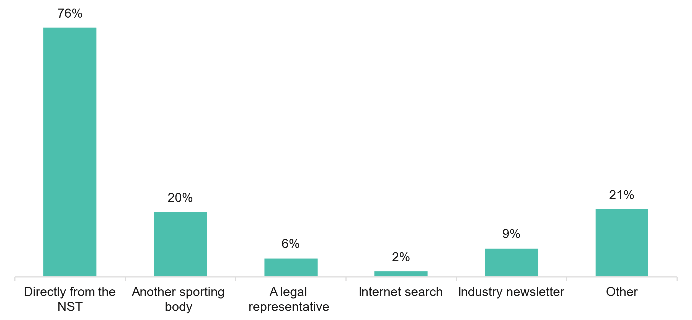

### Sport sector adoption of the NST and NIF

Sport sector respondents were asked if their sporting body had included the NST as a mechanism for resolving disputes in any of the following rules/by-laws/policies, if they had adopted the National Integrity Framework or will, the types of interactions had with the NST and the nature of the disputes. Respondents’ answers are displayed in the charts below.

The most common types of rules, laws and policies that adopt the NST as mechanism for resolving disputes were anti-doping (38%), member protection (38%) and disciplinary/ Code of Conduct (37%).

Figure Types of rules, laws and policies that adopt the NST as mechanisms for resolving disputes (n=66)

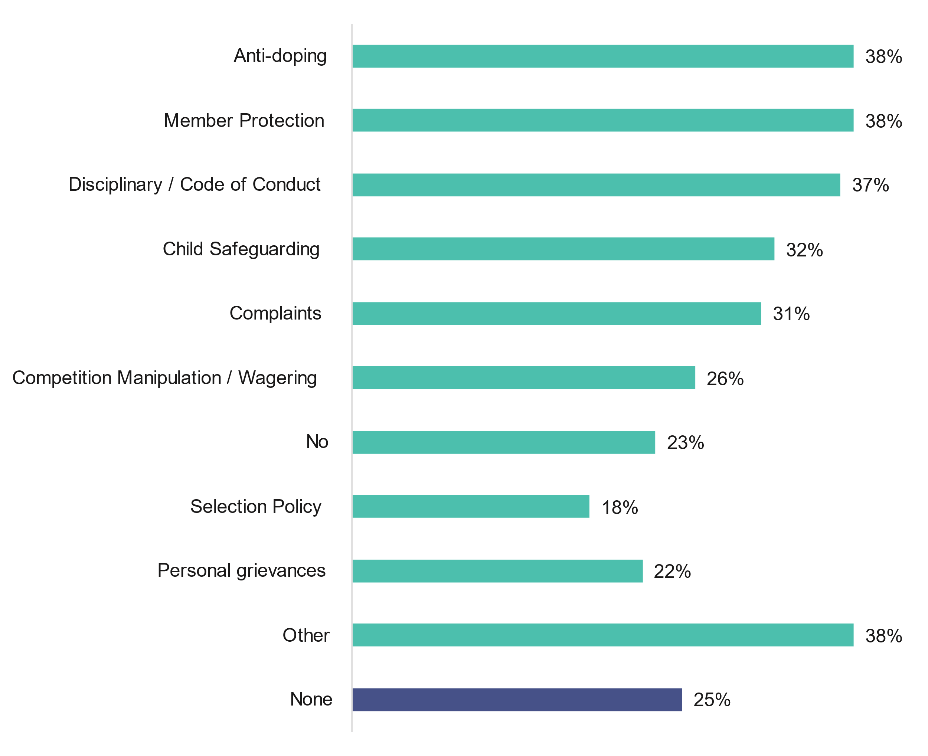

Note: Total does not add up to 100% due to multiple responses

Over half (58%) of sporting bodies had adopted the National Integrity Framework and 38% had not.

Figure Percentage of sporting bodies who have adopted the National Integrity Framework (n=66)

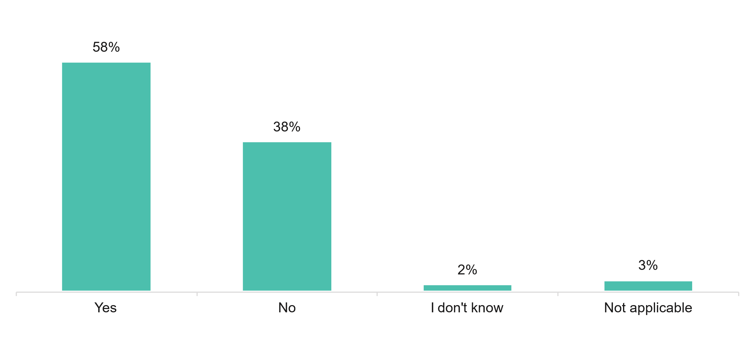

Of those who had not adopted the National Integrity Framework, 12% said they would in the next 12 months and 60% said it was not applicable to them.

Figure Likelihood to adopt the National Integrity Framework in the next 12 months if not already adopted (n=25)

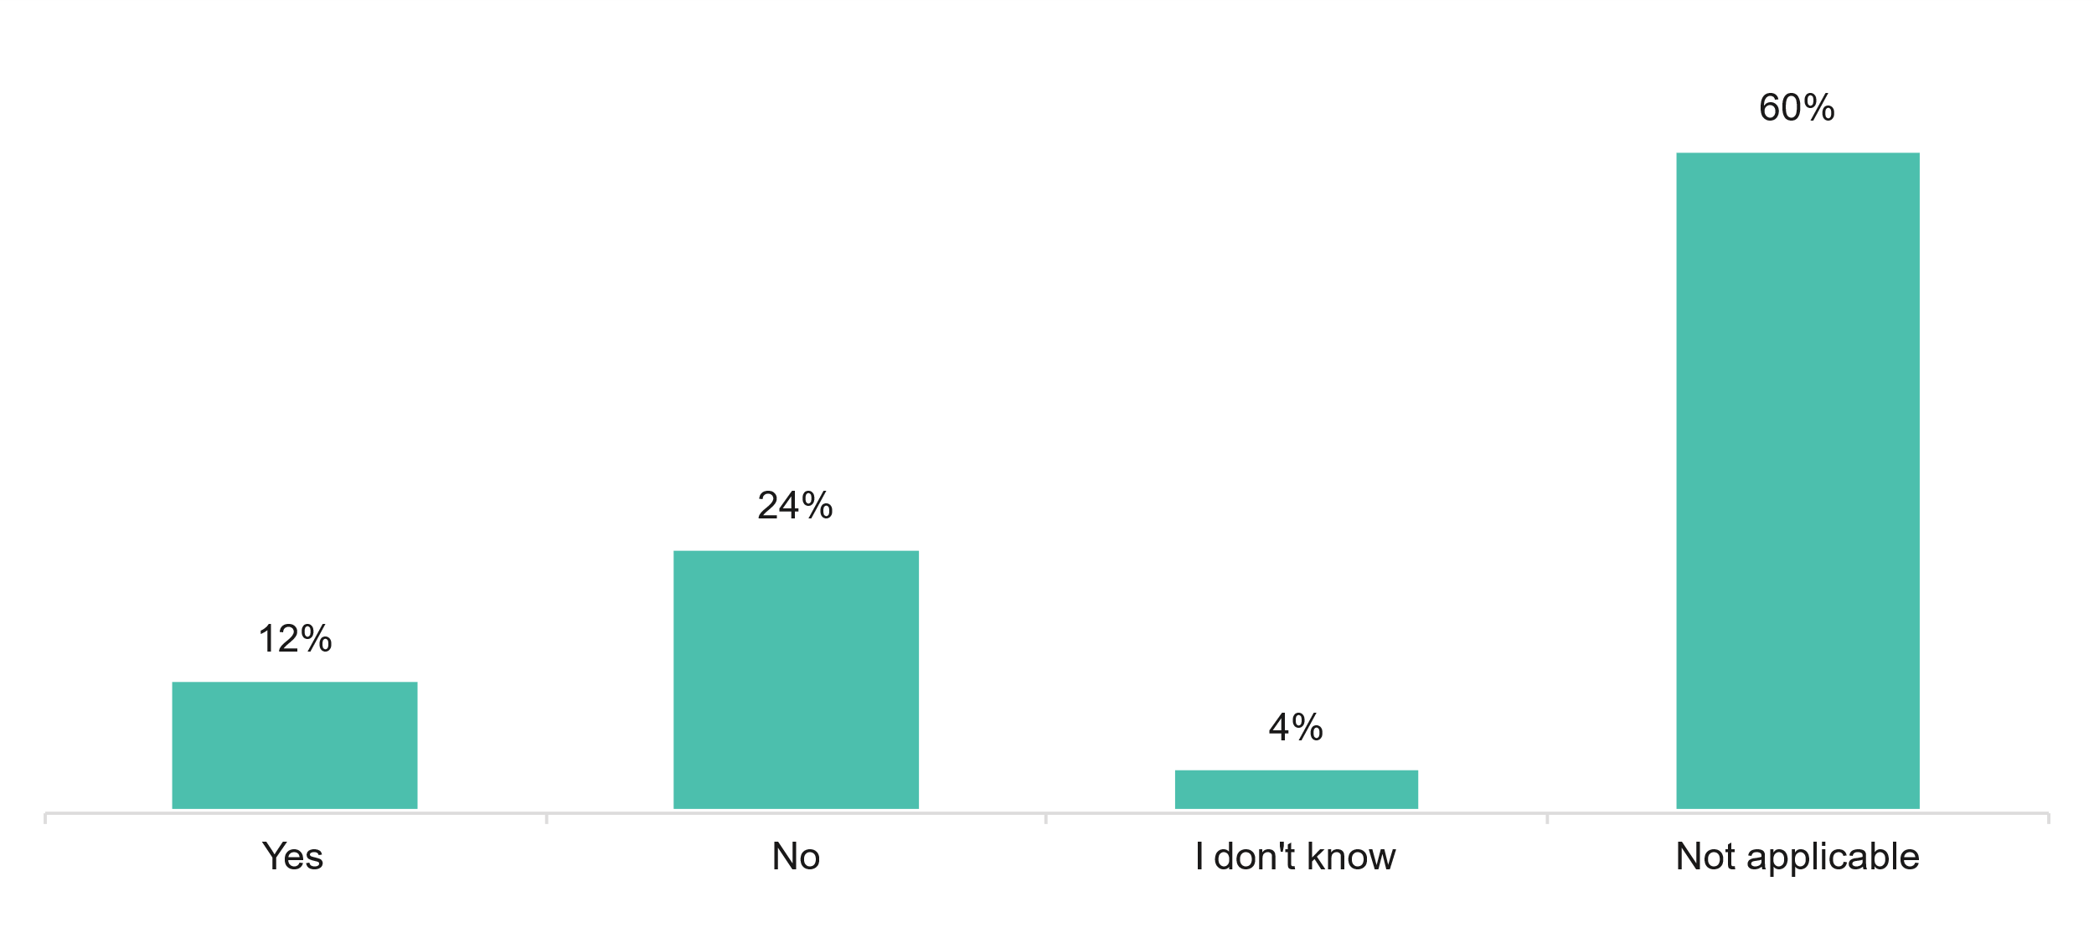

Sport sector respondents most commonly interacted with the NST through information on the NST’s website (64%), followed by email (62%) and a presentation or briefing (47%). Other interactions (11%) included updates, emails, templates and working groups.

Figure Types of interactions with the NST (n=66, multiple responses)

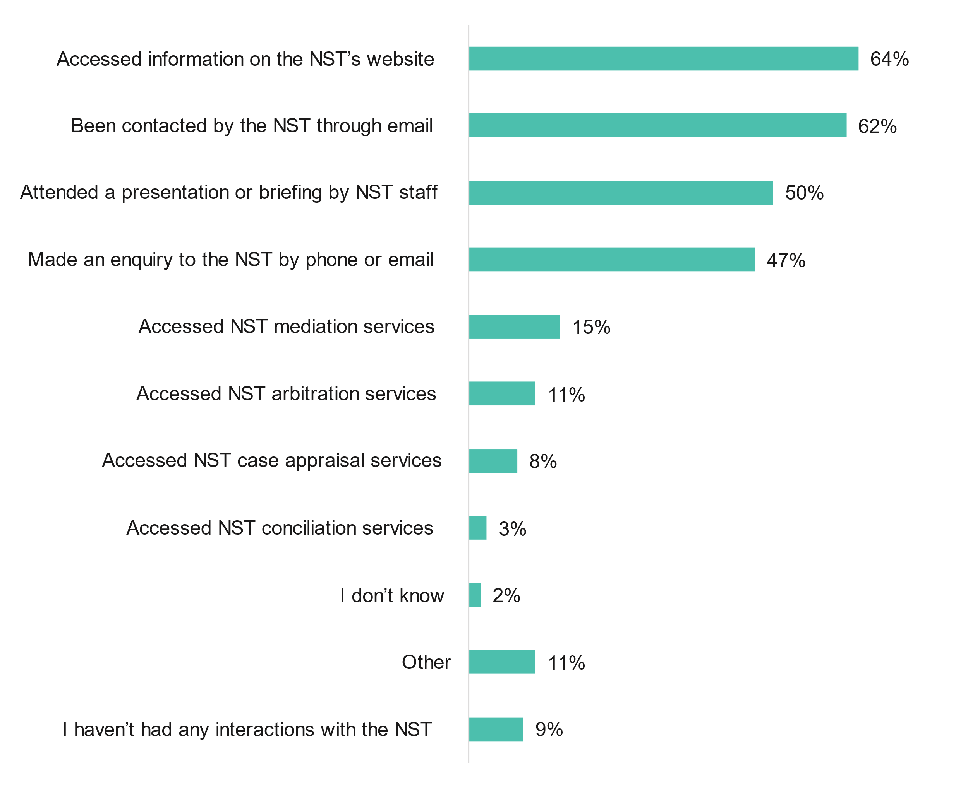

Note: Total does not add up to 100% due to multiple responses

From Figure 18, 15 individuals (23%) accessed the NST’s dispute resolution services (mediation, arbitration, case appraisal and/or conciliation services).

Of those that has used services, they were most commonly for member protection (73%), complaints (53%) and disciplinary / code of conduct (47%).

Figure Nature of the disputes (n=15)

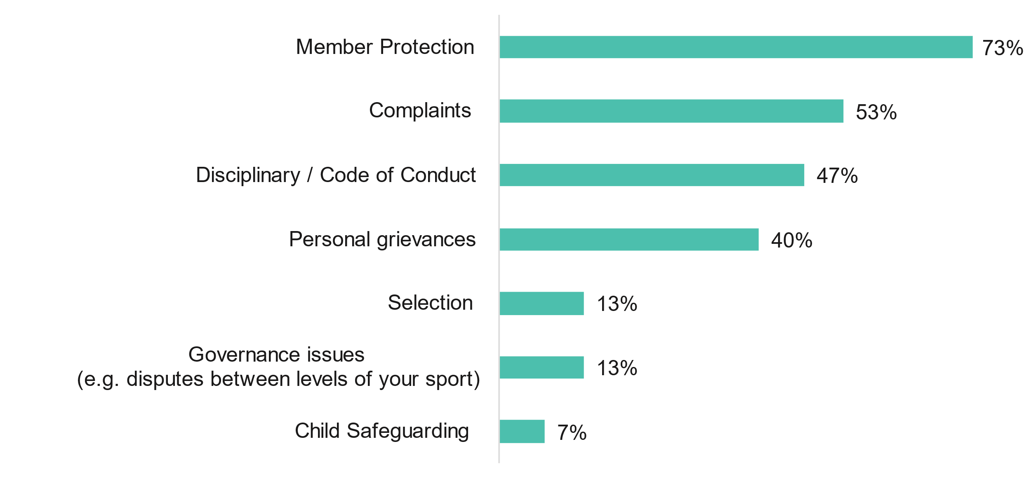

Note: Total does not add up to 100% due to multiple responses

### Experiences of sport sector respondents

Respondents were asked how familiar they were with NST dispute resolution services and their experience with their most recent matter. Respondents were then asked about their experience with a range of NST areas.

A third of respondents were very familiar (score of 9 or 10) with NST resolution services followed by 58% that were moderately familiar (score of 6 to 8).

Figure Familiarity with NST dispute resolution services (n=66)

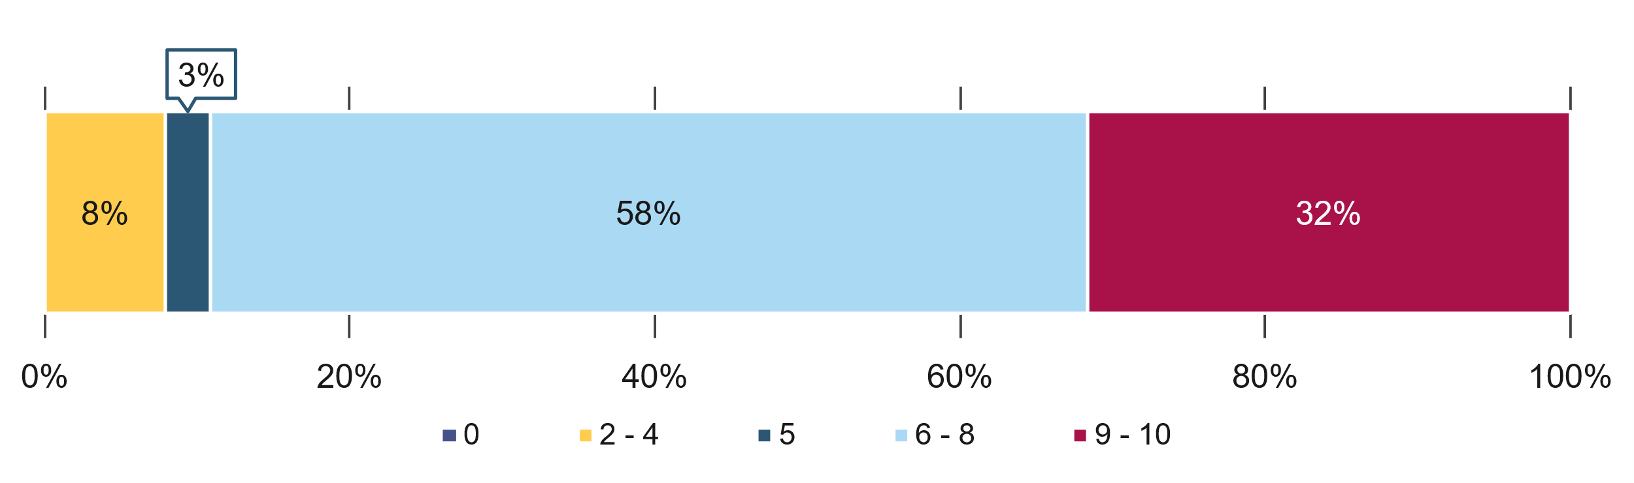

Note: 0 was ‘not at all familiar’ and 10 was ‘very familiar’.

Nearly half of respondents were extremely satisfied (score of 9 or 10) with their most recent NST matter, followed by 33% that were moderately satisfied (score of 6 to 8).

Figure Satisfaction with most recent NST matter (n=15)

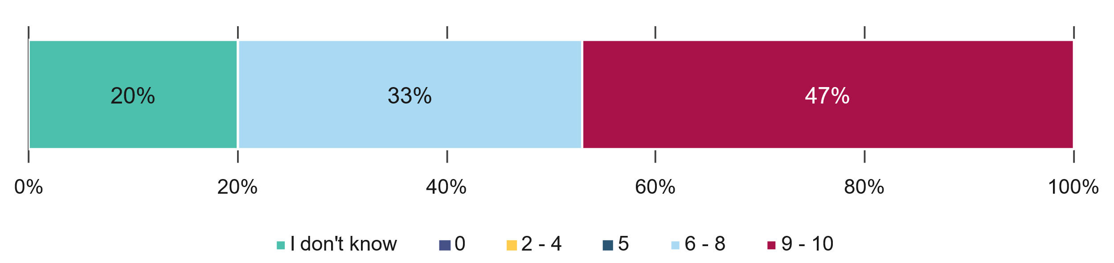

Note: 0 was ‘extremely dissatisfied’ and 10 was ‘extremely satisfied’.

Just over a third of respondents (36%) were extremely satisfied (score of 9 or 10) with the NST overall, followed by 49% at were moderately satisfied (score of 6 to 8).

Figure Satisfaction with overall experience of NST (n=59)

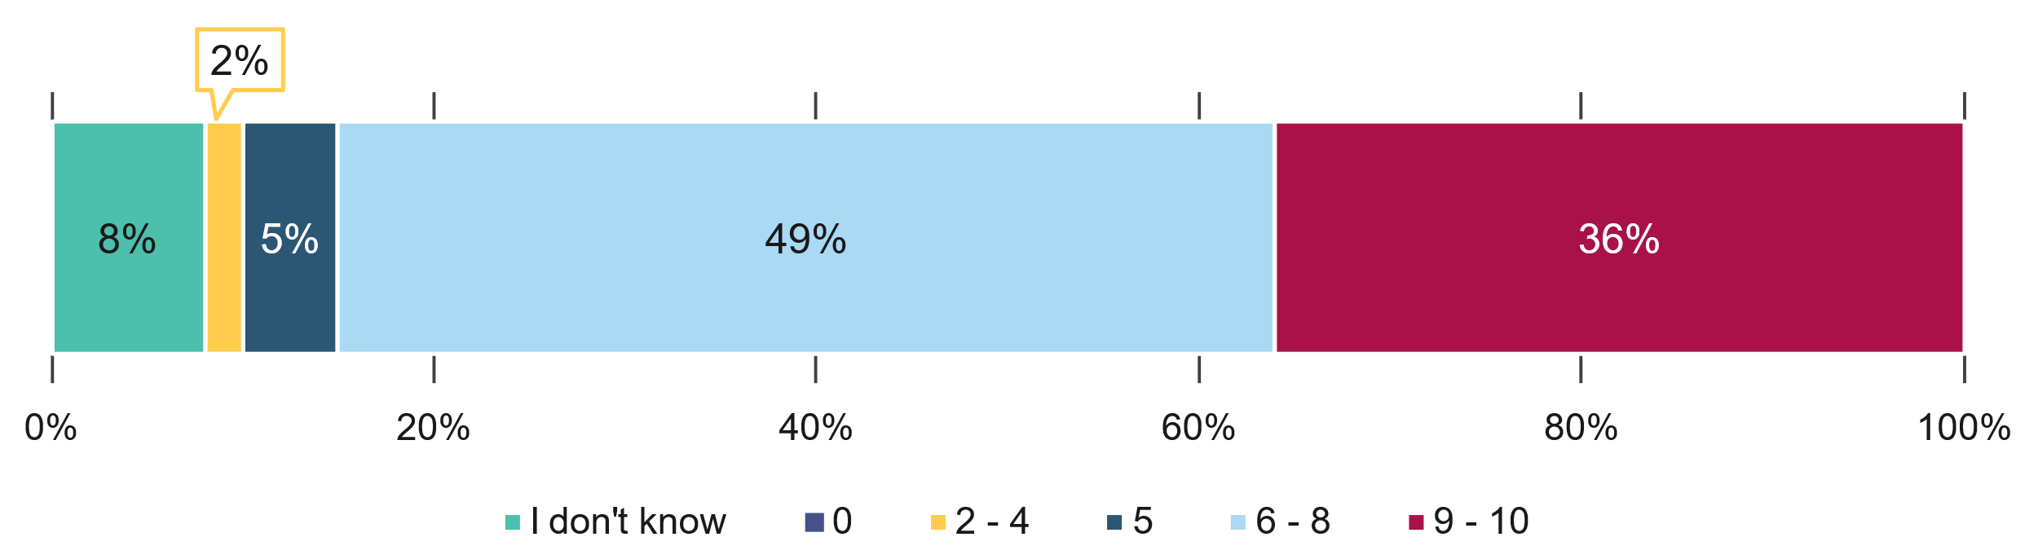

Note: 0 was ‘extremely dissatisfied’ and 10 was ‘extremely satisfied’.

Sport sector respondents were most likely to agree NST services are appropriate for people who have experienced trauma (56% total agree), followed by people with a disability (57% total agree).

Figure NST services

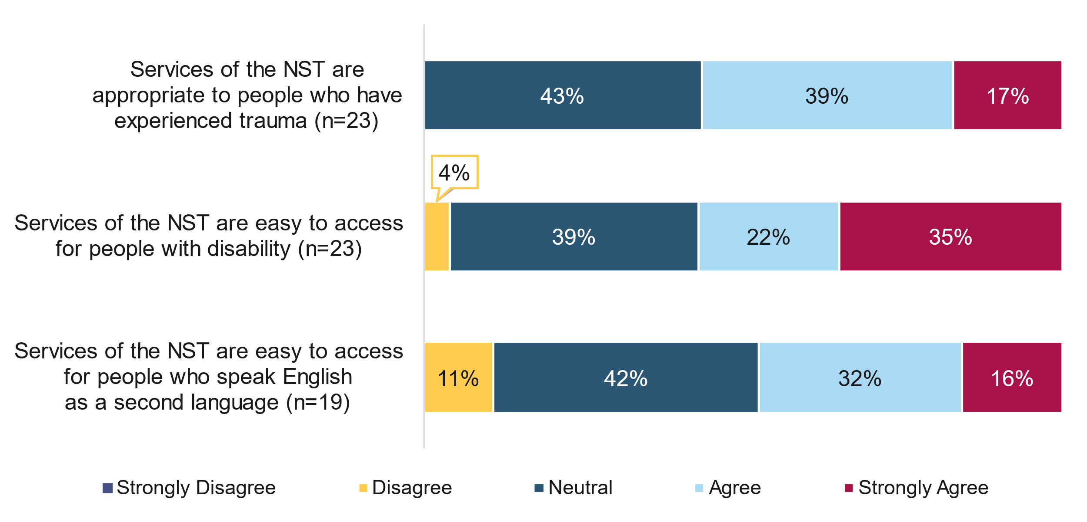

Respondents were most likely to agree that the NST administration staff are knowledgeable (91% total agree) and professional (91% total agree), and the arbitrators/ mediators have appropriate skills (87% total agree).

Figure NST’s administration staff and information

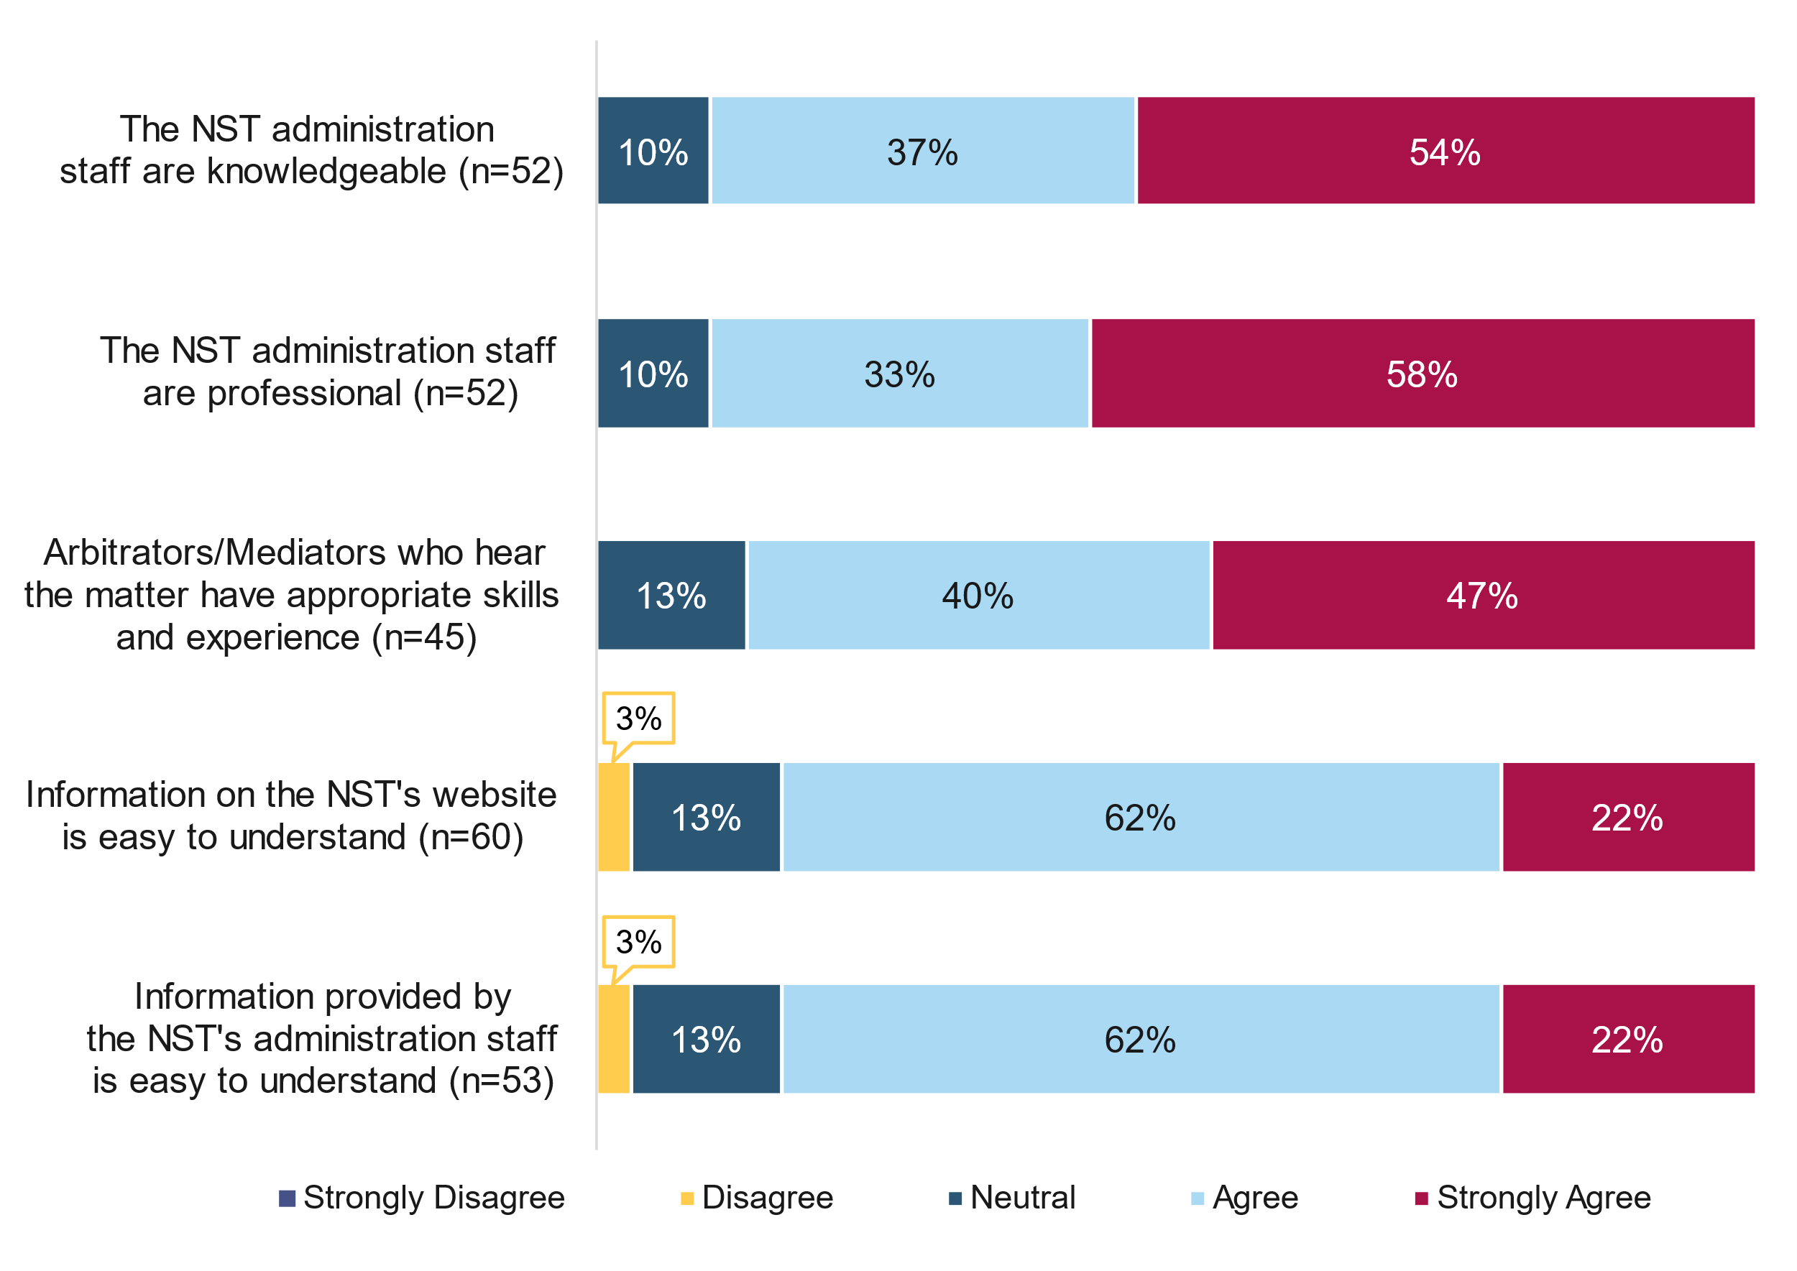

Nearly two thirds agreed that the NST fees are affordable (62% total agree) and 59% agreed the NST fees are proportionate to the nature of the proceedings.

Figure NST fees

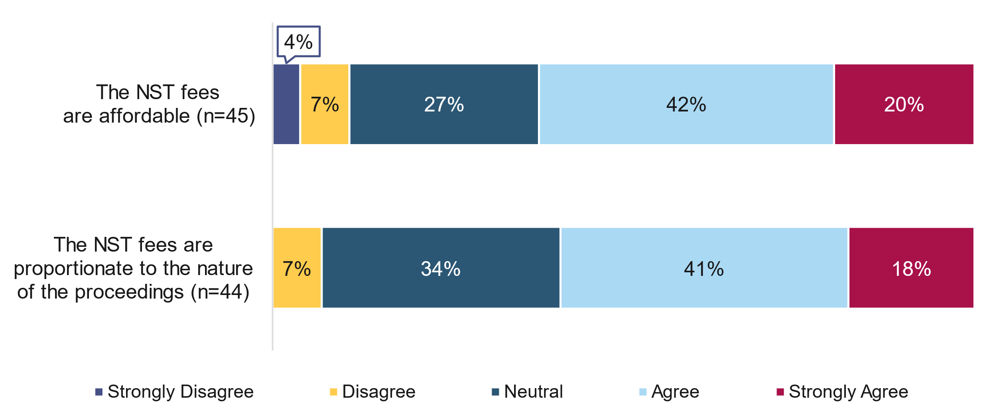

Nearly all respondents (95% total agree) agreed the NST is independent and 91% agreed the NST provides a fair process.

Figure Views of NST

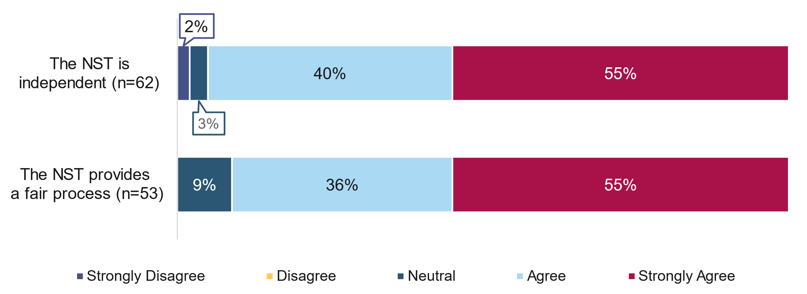

### NST operations

Respondents were asked to provide feedback on what was working well about the operation of the NST. Among the 29 respondents who left a comment, the most common themes were:

* The importance of the NST to sport as a national, independent body for dispute resolution in sport (n=12)
* Communication with sports and building awareness among sports of NST activities (n=9)
* NST’s administration staff and leadership (n=9)
* Independence of the NST (n=7)
* NST’s work in policy development with sports, particularly with respect to complaints handling processes (n=7)
* The efficiency and timeliness of NST processes and outcomes (n=6)
* The support and help provided by the NST to sports (n=6)
* Useful information shared by the NST for sports, including publishing some of its findings (n=5)
* Reducing the burden on sports to handle complaints internally (n=4)
* The NST’s engagement and consultation with the sports sector (n=3)
* The cost effectiveness of the NST (n=2). However, there was also n=1 negative comment that the NST was too expensive for small NSOs
* Other comments (n=2), including that the NST provides a wide range of dispute mechanisms and its approachability for all users.

Respondents were asked what could be improved about the operation of the NST. Among the 29 respondents who left a comment, the most common themes were:

* The NST has scope to improve communication with sports (n=7), including explaining to sport the breadth of disputes it hears, a need to build further awareness, and to be more discerning in the type of information that is shared so it is not overwhelming for smaller sports
* Cost (n=6), including feedback that costs are too expensive or the need for more transparency
* Confusion about the integration of the NST with the broader sport integrity landscape (n=5)
* Timeliness of NST outcomes, with respondents noting that some cases can drag on (n=4)
* Simplified processes or resources that are less “legalistic” and more accessible for sports administrators (n=4)
* More resources including case studies of how sports use the NST, and more education resources about the NST suitable for club and regional level of sports (n=4)
* Some respondents indicated they were satisfied with NST to date (n=3).

### Likelihood to recommend

Participants were asked how likely they were to recommend the NST to a colleague or another sporting body and results are shown below. The Net Promoter Score (NPS), a widely used market research metric, was calculated to assess commitment to the NST. A NPS score above 30% is considered a very good result and that there are more satisfied sport sectors than dissatisfied.

Nearly half (48%), of respondents were promoters that might talk positively about the NST to others. Only a small percentage were detractors (9%) that might talk negatively of the NST. This gives an NPS score of 39% which is considered a very good result.

Figure Likelihood to recommend the NST (n=56)

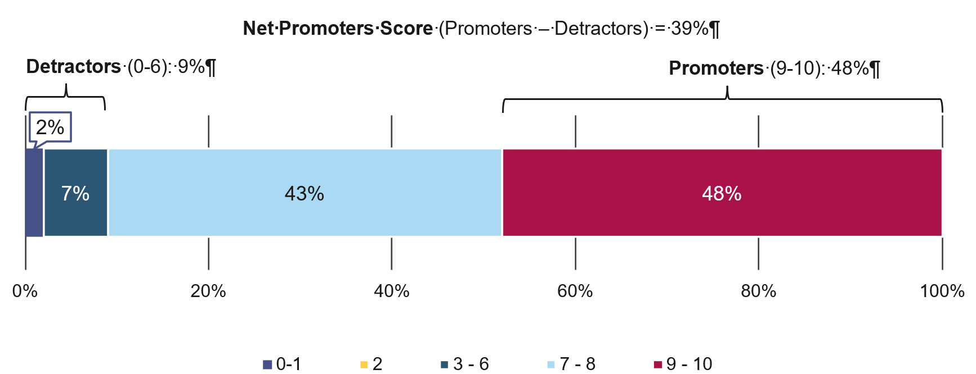

### Future use of the NST or other services

Respondents were asked how likely their sport sector was to use a range of NST and other services in the next 12 months. Findings are displayed in the charts below.

In the next 12 months, respondents were most likely to use NST services to seek advice from the NST to resolve disputes, followed by services for other types of issues and disputes (40% total likely), and for disciplinary issues (35% total likely).

Figure Likelihood to use NST services in the next 12 months

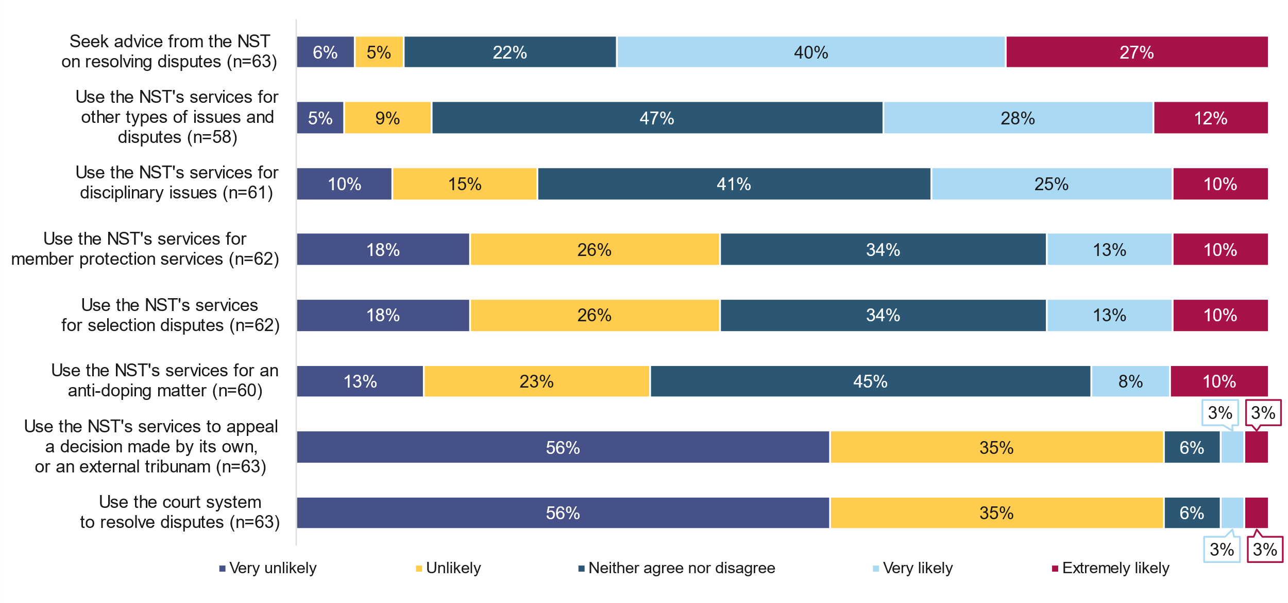

In the next 12 months, respondents were most likely to use their own internal dispute resolution mechanisms/ tribunal to resolve disputes (61% total likely) and were not very likely to use external resolution services other than the NST (10% total likely).

Figure Likelihood to use other services in the next 12 months

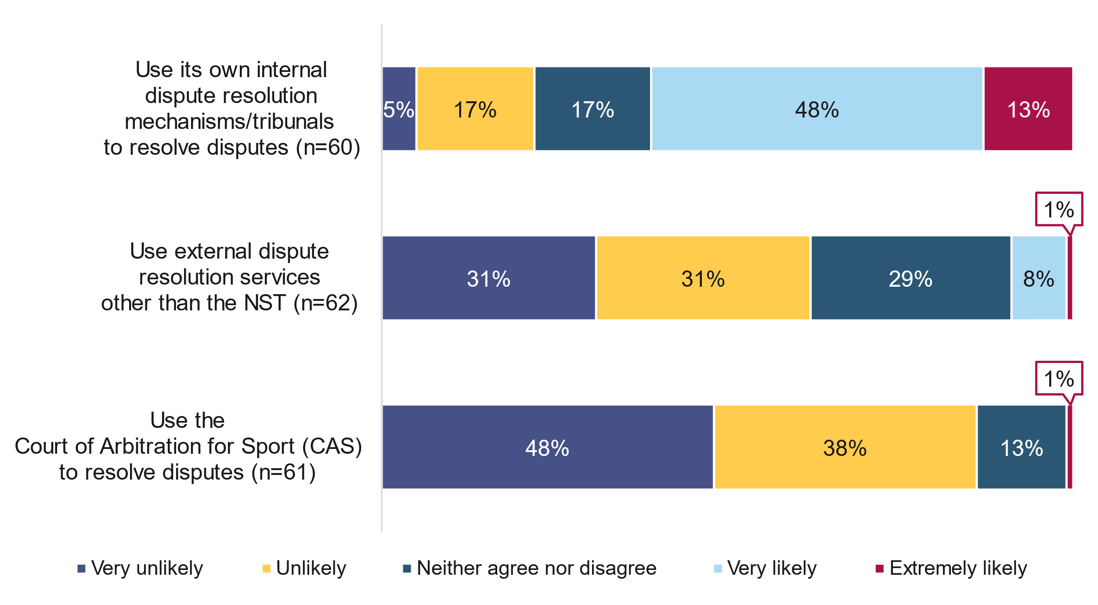

### NST comparison to other services

Respondents were asked how they thought the NST compared with other dispute resolution services. Of the 24 respondents who provided a comment, the most common themes were:

#### Among respondents that indicated NST services are better (n=17)

* Independence of the NST providing a fairer outcome for parties (n=5)
* The NST as being more fit for purpose and sport-specific (n=4)
* Expertise of the NST, including the NST staff and members (n=4)
* Cost-effectiveness of the NST compared to other services (n=3)
* The NST as being superior to internal NSO processes, in process and outcomes (n=3)
* Accessibility of the NST (n=2)
* Transparency of NST processes (n=1)
* Consistency of NST communication to parties (n=1)
* NST is better in general (n=1).

#### Among respondents that indicated NST services are the same (n=6)

* Respondent has not had enough interaction with the NST to judge (n=2)
* Whether the NST is better is dependent on the matter/sport, with other mediation and dispute resolution services having a place for some other sports in different contexts (n=2)
* The cost of the NST as being greater than internal processes (n=1)
* Internal processes are sufficient (n=1)
* The NST is similar to other processes in general (n=1).

#### Among respondents that indicated NST services are worse (n=1)

* This respondent indicated that the NST cost was too great, and the internal dispute resolution processes in place at the NSO were sufficient (n=1).

Respondents were also asked to compare the costs of the NST compared to the cost of other dispute resolution services used previously. Among the 24 respondents who left a comment, the most common themes were:

#### Among respondents that indicated they didn’t know / were unsure how much the NST costs (n=14)

* Respondent has not experienced the NST or dispute resolution (n=10)
* Respondent wanted greater clarity on NST costs (n=3)
* Other – NST needs to better consider how it deals with young people that have matters before the NST (n=1).

#### Among respondents that indicated NST services are less expensive (n=5)

* Other options for dispute resolution were more expensive than the NST (n=2)
* The NST’s costs can be shared among parties rather than being primarily absorbed by the NSO (n=1)
* Lower administrative costs when the NSO uses the NST (n=1)
* The NST has better legal fees for the access and expertise on offer (n=1)
* Preferable if there were no fees for using the NST (n=1).

#### Among respondents that indicated NST services are more expensive (n=4)

* Internal processes using volunteers are cheaper than the NST (n=4), including that the requirement for NSOs to be a party to matters increases the cost of use
* One respondent indicated services were about the same price.

### Other comments

Respondents were provided an opportunity to leave other comments about the operation or establishment of the NST. Of the 12 respondents who left a comment, the most common themes were:

#### Positive comments (n=7)

* The NST is crucial for sport (n=6), including the cost of unresolved issues for sports both financially and on the health of sport employees, and that the NST is a massive improvement for sports governance
* Positive feedback for specific NST staff (n=1)
* The costs of the NST should be more heavily subsidised for sports (n=1).

#### Negative comments (n=2)

* The NST overlooks smaller NSOs (n=1)
* One respondent indicated they supported the establishment of the NST, but did not support the establishment or operation of SIA, and that the link between the SIA and the NST is regrettable.

#### Neutral comments (n=3)

* The need for more clarity on the NST’s alignment to other sports integrity bodies, particularly SIA, as the link between the two and their roles in the integrity landscape are confusing for some sports to understand (n=2)
* Recommendations for improvements to NST processes (n=2), including practical examples of how having matters heard through the NST has improved things for the NSO, and that matters should be brought to a preliminary conference as soon as possible.

## Member survey

This survey was conducted in March 2022 and 15 Members participated in the survey among the population of 39 NST Members. The response rate is 38%.

The following sections outline the NST member respondent characteristics, experiences of NST members, most valuable NST services, improvements to NST operations, other dispute resolution services and improvements to the NST.

### NST member characteristics

Respondents were asked what expertise they bring to the NST and how many matters they had been allocated to. This is charted below.

Nearly three quarters of NST member respondents brought expertise from legal – sports law (11 of 15), nine brought expertise from tribunal experience and eight brought mediation/conciliation experience.

Figure Expertise brought to the NST (n=15, multiple responses)

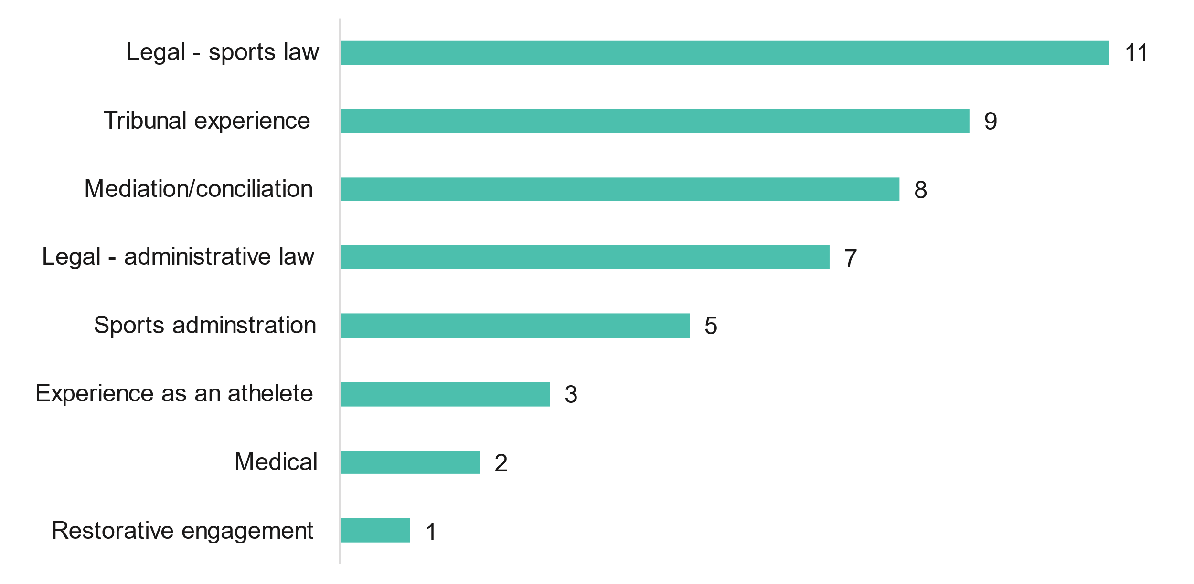

Most NST member respondents had been allocated to only the one matter (9 respondents), three respondents had been allocated two matters and two respondents had been allocated three matters.

Figure Number of matters allocated to NST members (n=15)

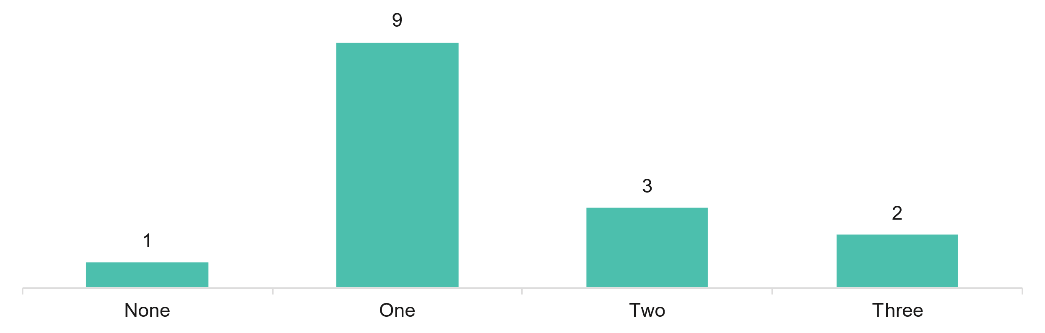

### Experiences of NST members

Respondents were asked about their experience with the NST through a range of agree/disagree statements as well as their overall satisfaction. Responses have been ordered by total agree (the sum of ‘agree’ and ‘strongly agree’). All NST members (15) agreed the training and induction processes were appropriate to their role. Nearly all (14 respondents for each), agreed the communication received kept them updated with news, changes and developments, NST’s processes are effective in dealing with Members potential conflicts and the NST provides a fair process for all users.

Figure Experience with NST (n=15)

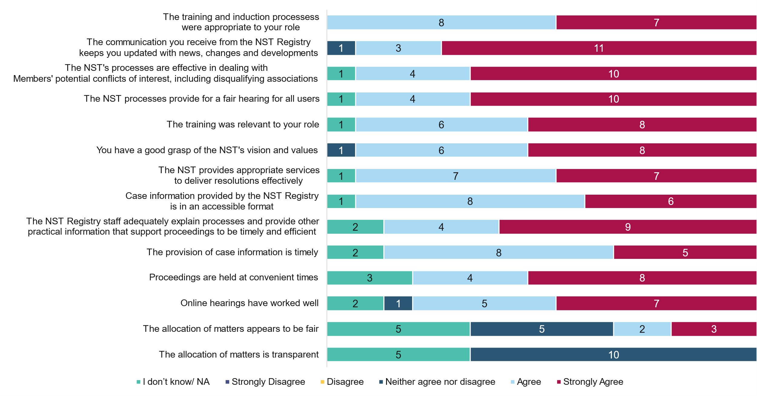

Nearly half of respondents (7 out of 15), were extremely satisfied (score of 9 or 10) and a further seven respondents were moderately satisfied (score of 6 to 8) with their overall experience of the NST.

Figure Satisfaction with overall experience of the NST (n=15)

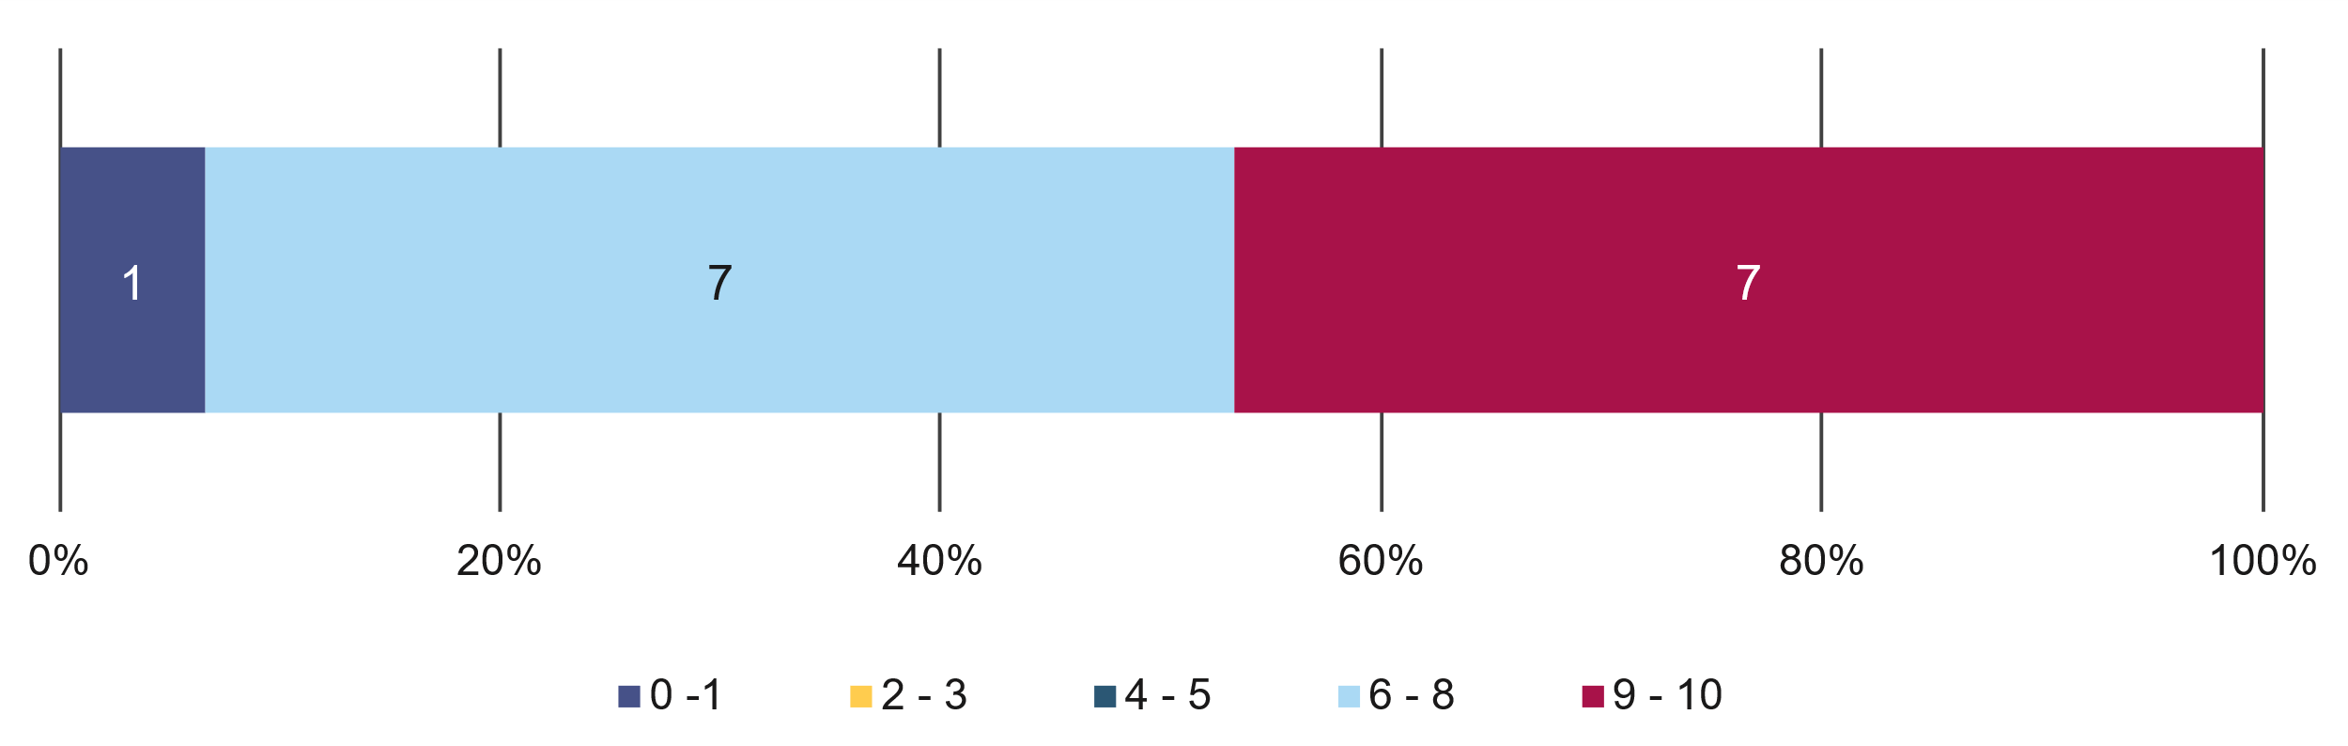

Note: 0 was ‘extremely dissatisfied’ and 10 was ‘extremely satisfied’.

Respondents were asked to provide reasons why they gave this score. Only respondents that indicated general satisfaction (scores between 8 and 10) with the NST provided a response. Of these respondents, the most common themes were:

* excellent NST staff (n=4)
* general positive comments about NST (n=3)
* NST’s importance to sport (n=2)
* effective dispute resolution the NST provided (n=1)
* NST handled the pandemic well (n=1).

### Most valuable NST services

Respondents were asked about the most valuable aspect of services provided by the NST. 14 respondents provided comments, of which the most common themes were:

* independence of NST (n=5)
* cost effectiveness of NST (n=4)
* the support NST provided for sports, with the NST easing the burden for resolving dispute resolution on sports (n=3)
* importance of the NST to the sporting landscape through independent and effective dispute resolution (n=3)
* expertise of NST staff in sport and dispute resolution (n=3)
* efficiency (n=2)
* timeliness of NST in resolving disputes (n=2)
* don’t know (n=1).

### Improvements to NST operations

Respondents were asked what could be improved about the operation of the NST. Nine respondents that left a comment, of which the most common themes were:

* minor changes to systems/processes, including increased face-to-face meetings, set time periods for submissions, and improving NST IT systems (n=3)
* publishing more information, such as summaries of outcomes or even a monthly NST newsletter (n=2)
* remuneration, including that the current remuneration for members is quite modest and the need for more transparency in pay rates (n=2)
* stronger engagement with sporting bodies to build awareness (n=1)
* other – reducing the frequency the NST logo appears in documents to reduce printer toner costs (n=1).

### Other dispute resolution services

Respondents were asked if they had been involved with any other dispute resolution services and, if yes, they were asked how the NST compares.

Most NST members (13 out of 15) were involved in other sport resolution services.

Figure Involved in any other sport dispute resolution services other than the NST (n=15)

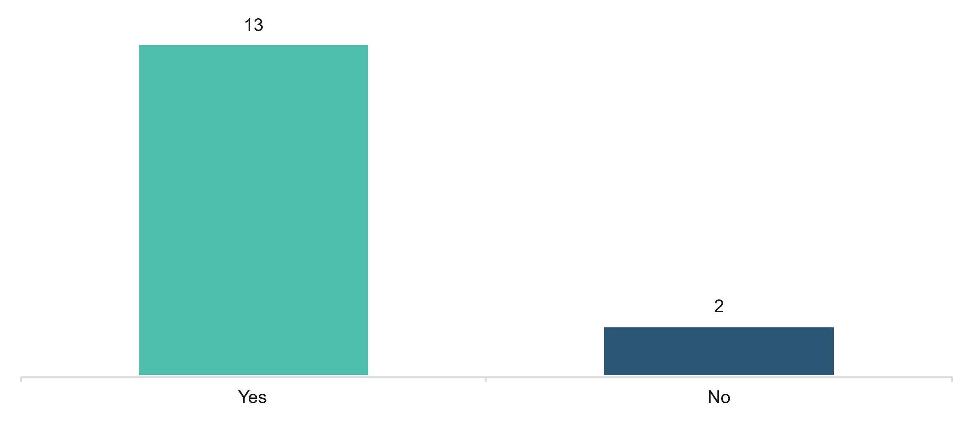

The majority of NST members (10 out of 13) reported that the NST’s processes were better than other dispute resolutions services.

Figure Comparison of NST services with other sport dispute resolution services (n=13)

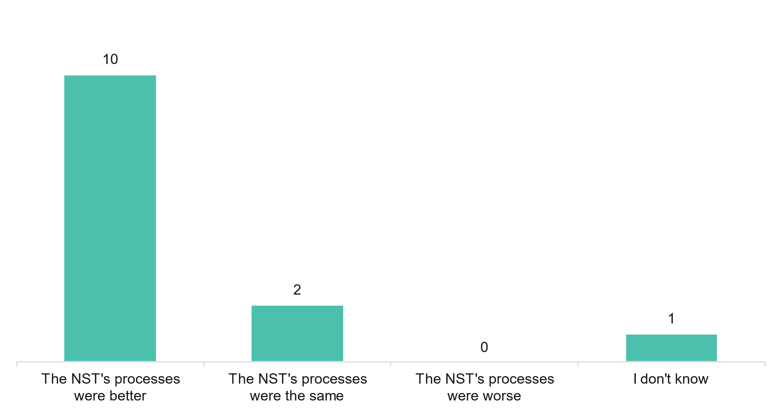`

Respondents were asked to provide reasons why they gave this response. Among respondents that indicated the NST’s processes were better (n=10), answers included:

* timeliness of NST processes and outcomes (n=5)
* independence of the NST (n=4)
* excellent NST staff and leadership (n=3)
* general comments that the NST provides a better process (n=3)
* NST is more cost-effective (n=1)
* the administrative support provided by the NST (n=1)
* better resources (n=1).

Among respondents that indicated the NST’s processes were the same (n=2), answers included:

* NST has similar processes (n=1)
* NST should consider providing summaries of outcomes (n=1).

### Improvement to the NST

Respondents were asked about other services or processes they thought there was value in the NST offering. Among the eight respondents who left a comment, the most common themes were:

* no improvements to suggest (n=5)
* hear state-level matters from State Sporting Associations (n=1)
* a greater role in anti-doping (n=1)
* more publicity about NST services and its decisions (n=1).



1. Council of Australasian Tribunals, available from: <https://coat.asn.au/publicationitems/tribunals-excellence-framework/>
2. Synergy, NST Financial Modelling. Page 26
3. Note: social discount rates are used in economic evaluations to consider the future value of both costs and benefits at an annual discount to account for their reduced value in the future ($100 in one years’ time is worth less than $100 today)
4. The Report of the Review of Australia’s Sports Integrity Arrangements (Wood Review) was presented to the Australian Government in March 2018. The Review examined key Australian and international threats to the integrity of sport. Five key themes of the recommendations related to match fixing, regulation of sports wagering, enhancing anti-doping capability, and the development of a NST and a National Sports Integrity Commission.
5. Released in 2018, the National Sports Plan sets out strategic priorities and targets for participation and improved health and well-being of Australians by 2030.
6. Department of Health (2018), Report of the Review of Australia’s Sports Integrity Arrangements, p.ii
7. Department of Health, (2019) Safeguarding the Integrity of Sport – the Government Response to the Wood Review, p.8.
8. National Sports Tribunal (2020), Legislative framework, <https://www.nationalsportstribunal.gov.au/about-us/legislative-framework>
9. National Sports Tribunal (2020), Legislative framework, <https://www.nationalsportstribunal.gov.au/about-us/legislative-framework>
10. Mediation, conciliation or case appraisal are categorised as alternative dispute resolution (ADR).
11. National Sports Tribunal (2021), Cost of using NST service, <https://www.nationalsportstribunal.gov.au/dispute-resolution-services/cost-using-nst-services>
12. Minister for Sport, media release, 17 December 2020, available from: <https://www.health.gov.au/ministers/senator-the-hon-richard-colbeck/media/137-million-to-further-strengthen-integrity-in-australian-sport>
13. Minister for Sport, media release, 17 December 2020, available from: <https://www.health.gov.au/ministers/senator-the-hon-richard-colbeck/media/137-million-to-further-strengthen-integrity-in-australian-sport>
14. Wood, J (2018). Report of the Review of Australia’s Sports Integrity Arrangements. Department of Health. pp 11-12.
15. Wood, J (2018). Report of the Review of Australia’s Sports Integrity Arrangements. Department of Health. p 5.
16. Wood, J (2018). Report of the Review of Australia’s Sports Integrity Arrangements. Department of Health. pp148-9.
17. *National Sports Tribunal Act 2019* (Ch) s 3.1.
18. Australian Law Reform Commission (2016). Traditional Rights and Freedoms—Encroachments by Commonwealth Laws (ALRC Report 129). pp393-4.
19. *National Sports Tribunal (Practice and Procedure) Determination 2021* s 22
20. *National Sports Tribunal (Practice and Procedure) Determination 2021* ss 14, 16
21. *National Sports Tribunal Principles for Allocating a Member to a Dispute 2020*
22. *National Sports Tribunal (Practice and Procedure) Determination 2021* s 25.
23. *National Sports Tribunal (Practice and Procedure) Determination 2021* s 20.
24. *National Sports Tribunal (Practice and Procedure) Determination 2021* s 20(3).
25. National Sports Tribunal (2021). Application Form. Form APPV3-112021. p 5.
26. National Sports Tribunal (2020). Bench Book – 2020.
27. Wood, J (2018). Report of the Review of Australia’s Sports Integrity Arrangements. Department of Health. p 152.
28. Sports Integrity Australia (2022). National Integrity Framework Template Policy.
29. *National Sports Tribunal Amendment Rule 2021* Schedule 1.
30. Sport Integrity Australia, Sports with an anti-doping policy, available from: <https://www.sportintegrity.gov.au/what-we-do/anti-doping/2021-world-anti-doping-code/sports-anti-doping-policy>
31. NST staff noted that some of the withdrawn matters were resolved without NST services, while for others the withdrawal represented the resolution.
32. Grounds for terminating an arbitration are set out in the NST Rule and mediators may terminate an ADR if there is no reasonable or likely prospect of settlement among other conditions.
33. Sport Integrity Australia, Australian National Anti-Doping Policy, 20 June 2022, available from: [https://www.sportintegrity.gov.au/what-we-do/anti-doping/2021-world-anti-doping-code/australian-national-anti-doping-policy#:~:text=The%20Australian%20National%20Anti%2DDoping,across%20all%20sports%20in%20Australia](https://www.sportintegrity.gov.au/what-we-do/anti-doping/2021-world-anti-doping-code/australian-national-anti-doping-policy%23:~:text=The%20Australian%20National%20Anti%2DDoping,across%20all%20sports%20in%20Australia).
34. Cost of using the NST, available from: https://www.nationalsportstribunal.gov.au/dispute-resolution-services/cost-using-nst-services
35. Fair Work Australia (2021)
36. The Report of the Review of Australia’s Sports Integrity Arrangements (Wood Review) was presented to the Australian Government in March 2018. In line with its terms of reference, the Review examined key Australian and international threats to the integrity of sport. The report made 52 recommendations across five key themes relating to match-fixing, regulation of sports wagering, enhancing anti-doping capability, and the development of a National Sports Tribunal and a National Sports Integrity Commission.
37. Released in 2018, the National Sports Plan sets out strategic priorities and targets for participation and improved health and well being of Australians by 2030.
38. Department of Health (2018), Report of the Review of Australia’s Sports Integrity Arrangements, p.ii
39. Department of Health, (2019) Safeguarding the Integrity of Sport – the Government Response to the Wood Review, p.8.
40. National Sports Tribunal (2020), Legislative framework, <https://www.nationalsportstribunal.gov.au/about-us/legislative-framework>
41. National Sports Tribunal (2020), Legislative framework, <https://www.nationalsportstribunal.gov.au/about-us/legislative-framework>
42. Mediation, conciliation or case appraisal are categorised as alternative dispute resolution (ADR).
43. National Sports Tribunal (2021), Cost of using NST service, <https://www.nationalsportstribunal.gov.au/dispute-resolution-services/cost-using-nst-services>
44. Minister for Sport, media release, 17 December 2020, available from: <https://www.health.gov.au/ministers/senator-the-hon-richard-colbeck/media/137-million-to-further-strengthen-integrity-in-australian-sport>
45. Minister for Sport, media release, 17 December 2020, available from: <https://www.health.gov.au/ministers/senator-the-hon-richard-colbeck/media/137-million-to-further-strengthen-integrity-in-australian-sport>
46. The four users had a median of 10 (representing extremely satisfied), the range was 4 to 10.